Iran War Costs Mount as Pentagon Requests Another $67 Billion
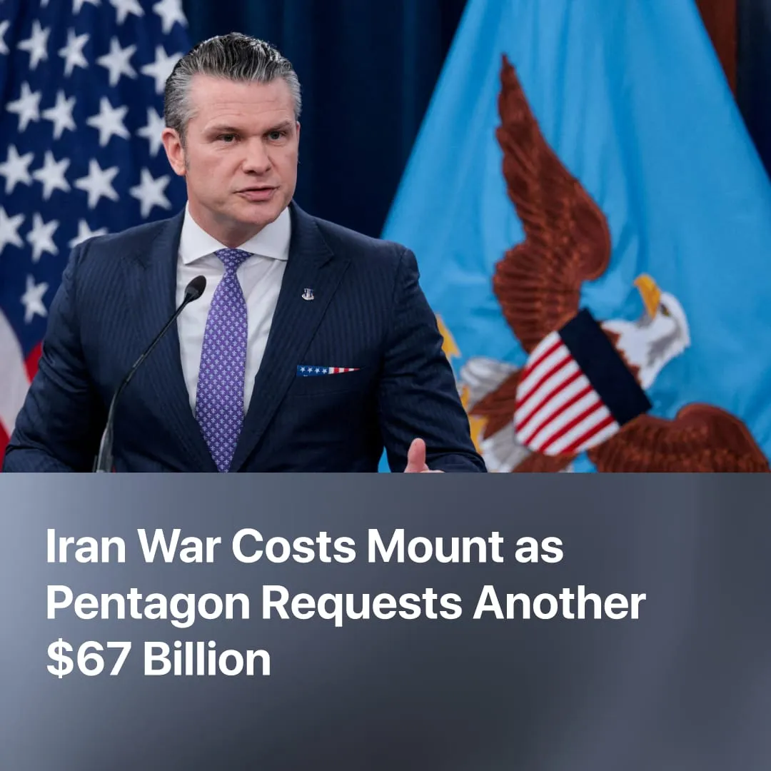

Original article
2026-08-01
1 min read

The Pentagon is requesting another urgent $67 billion for the Iran war. The last round already cost the average American household $750 in higher prices.
Details. On July 9, Trump declared the US-Iran ceasefire "over" after Iranian strikes on tankers in the Strait of Hormuz, with the US bombing over 90 sites in return. By July 21, the Pentagon was defending an urgent request for an additional $67.1 billion specifically for the war effort.
► Iran's blockade has cut off 20% of the global oil supply. The Houthis have reinforced this by closing the Bab al-Mandab passage, driving oil prices back up. The Strategic Petroleum Reserves released during the previous crisis are now severely depleted, leaving the US with far less capacity to cushion prices this time.
Context. The US-Iran war had already cost the US economy billions before the current flare-up. On July 21, Hegseth told the Senate the official Pentagon cost estimate stands at $37.5 billion, up from $25 billion in April. Reports citing three US officials suggest the Pentagon's internal estimate is $80-100 billion once base repairs, destroyed aircraft, and munitions replacement are included.
► The broader economic cost falls on workers. Estimates put the cost to US consumers and taxpayers at $132 billion so far, with the average household spending $750 more across higher fuel, food, and energy costs in the first 100-days alone. In April, food prices jumped 0.5%, the biggest monthly increase in nearly four years.
► In June, before the ceasefire broke down, a study estimated the war was already costing the global economy $2.2 trillion in annual GDP losses, rising to $3.5 trillion if the Strait of Hormuz remained closed and fighting resumed. The World Bank has cut its 2026 global growth forecast to 2.5%, the lowest since the COVID pandemic. This contracting economy will inevitably lead to job cuts.
► Meanwhile, the US House of Representatives has passed a $1.5 trillion military budget now awaiting Senate approval, with lawmakers planning to finance it through severe cuts to social safety nets, domestic programs, and energy assistance.

Original article

