Iranian Islamists Show Support For Western Pro-Palestinian Protests
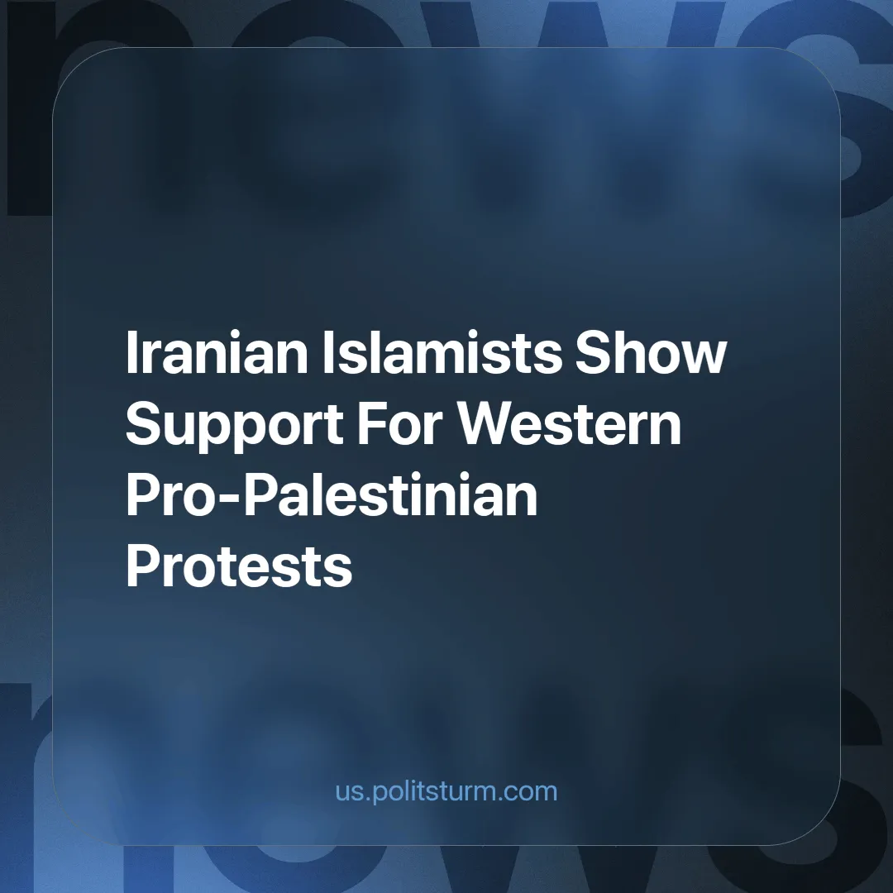

Original article
2024-07-13
2 min read

Referring to pro-Palestinian protests in recent months, IRGC commander Hossein Salami claims that Iran's "resistance" ideology has infiltrated universities in the United States and Europe.
Iran's official media has been quick to publish images and broadcast clips of encampments on Western campuses. They have sought to cynically exploit the sympathy of students around the world for the plight of the Palestinians.
Since its inception, the Islamic Republic of Iran has been committed to the slogans of false anti-imperialism. For example, Ayatollah Khomeini, the founder of the republic, broke off diplomatic relations with the apartheid regime in South Africa and refused to sell oil to it. [1].
This false "anti-imperialism" is not a new phenomenon; already in the 19th century, the Ottoman caliph, in line with pan-Islamism and pan-Turkism, used this call for the "emancipation" of the colonial Muslim and Turkic peoples from Western colonialism as a justification for his own imperialism in West and Central Asia [2].
Writing in 1920, Vladimir Lenin emphasized:
"the need to combat Pan-Islamism and similar trends, which strive to combine the liberation movement against European and American imperialism with an attempt to strengthen the positions of the khans, landowners, mullahs, etc" - Draft Theses on National and Colonial Questions.
These theses were adopted with minor changes by the 2nd Congress of the Communist International.
The 1st edition of the Great Soviet Encyclopedia pointed out the dangers of pan-Islamists, who covered their actions with words about “anti-imperialism” too:
"In the context of the general crisis of capitalism, which has increased the pressure of the imperialists on the colonies and dependent countries, the reactionary activities of the Muslim organizations are expanding even more. In particular, the crisis has even led to the creation of special organizations which, based on the principles of Islam, under the guise of 'charity', try to deceive the working masses through handouts and divert their revolutionary energy in the wrong direction... In general, the strengthening of reaction is always accompanied by the growing importance of Muslim organizations... The imperialism uses pan-Islamism, pan-Turkism, etc. in the countries where Islam is spreading. For example, British and Japanese imperialism used pan-Islamism in Xinjiang. There were similar tendencies in the joint actions of British imperialism and the Muslim clergy in Iraqi, Turkish and Iranian Kurdistan. Recently, the Muslim clerics, who are fighting against the growth of the revolutionary movement in the colonial and dependent countries, have painted the teachings of Islam and the actions of its founders in pseudo-communist tones".
The relationship between the Islamic Republic, the U.S. and the West Asian countries is essentially identical to the inter-imperialist struggles of past epochs; therefore, Tehran's resistance ideology is hardly distinguishable from the pan-Islamism of the Ottomans or the pan-Asianism of the Japanese Empire.
As 3 million child laborers struggle to survive on a daily basis, the Islamic Republic is significantly expanding its missile and drone production facilities [3] to not only supply the Russians but also to prepare itself for the coming imperialist carnage.
The emancipation of the peoples of West Asia will come exclusively through the mobilization of the only revolutionary class capable of real change, the working class. Neither pan-Islamism nor Khomeini's ideology of resistance will prevail, but proletarian internationalism, promoted by communists, who stand on the Marxist-Leninist platform.
Links: 1 | 2 | 3

Original article

