Europe Stops Discussing Sanctions Against Israel and Backs Its Strikes on Iran
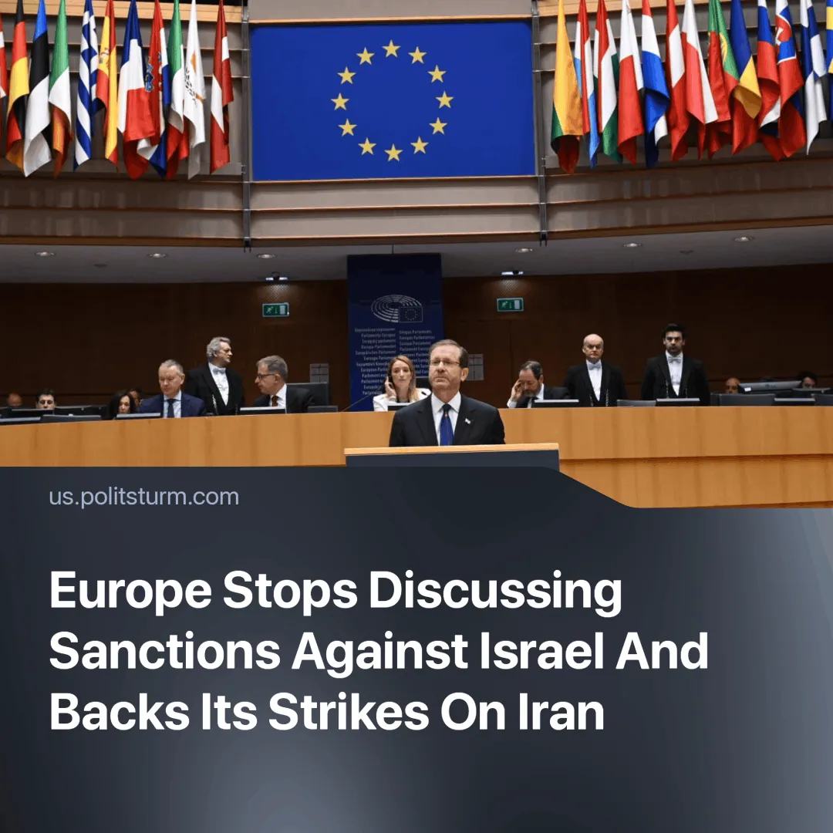

Original article
2025-06-17
1 min read

European countries have expressed support for Israel during the strikes on Iran. Previously the EU had planned to impose sanctions on Israel.
Details. European leaders, including French President Macron and British Prime Minister Starmer, joined US President Trump in declaring support for Israel following its “pre-emptive” strikes on Iran.
► European leaders stressed Israel’s “right to self-defence” and praised the success of its offensive. German Chancellor Merz, for example, wrote that Israel had “the right to defend its existence and its citizens,” despite his recent public criticism of operations in Gaza. The official EU statement blamed Iran but stopped short of endorsing the Israeli attacks, calling instead for a diplomatic solution.
► Macron stated the French military “would take part in protection and defence operations” to defend Israel from the Iranian counterattack, with French forces joining US destroyers to shoot down the incoming missiles.
► Starmer announced the deployment of Royal Air Force fighter jets to NATO airbases in the Middle East, along with support aircraft for long-range bombing operations, though he justified it only in vague terms: “contingency support in the region.” UK forces have not officially intervened.
► Trump continues to portray himself as a ‘peacemaker’ and says he wants a “deal” with Iran on its nuclear programme, but also remarked that “sometimes they have to fight it out”.
Context. We previously reported that the EU had recently sharpened its criticism of Israel’s offensive in Gaza. This was part of broader European efforts to pursue a more independent foreign policy, diverging from the US line. The EU bloc convened to review its ties with Israel and began promoting a more moderate pro-Palestinian diplomatic stance.
► EU member states were pushing for the bloc to adopt targeted sanctions against extremist Israeli settlers and cabinet ministers. President Macron declared his support for the Palestinian Authority and spearheaded European efforts toward Palestinian statehood.
► This week’s planned UN conference to discuss Palestinian statehood, which Macron was to preside over, has now been postponed indefinitely.

Original article

