Iran Allows Friendly Capitalists to Cross Hormuz
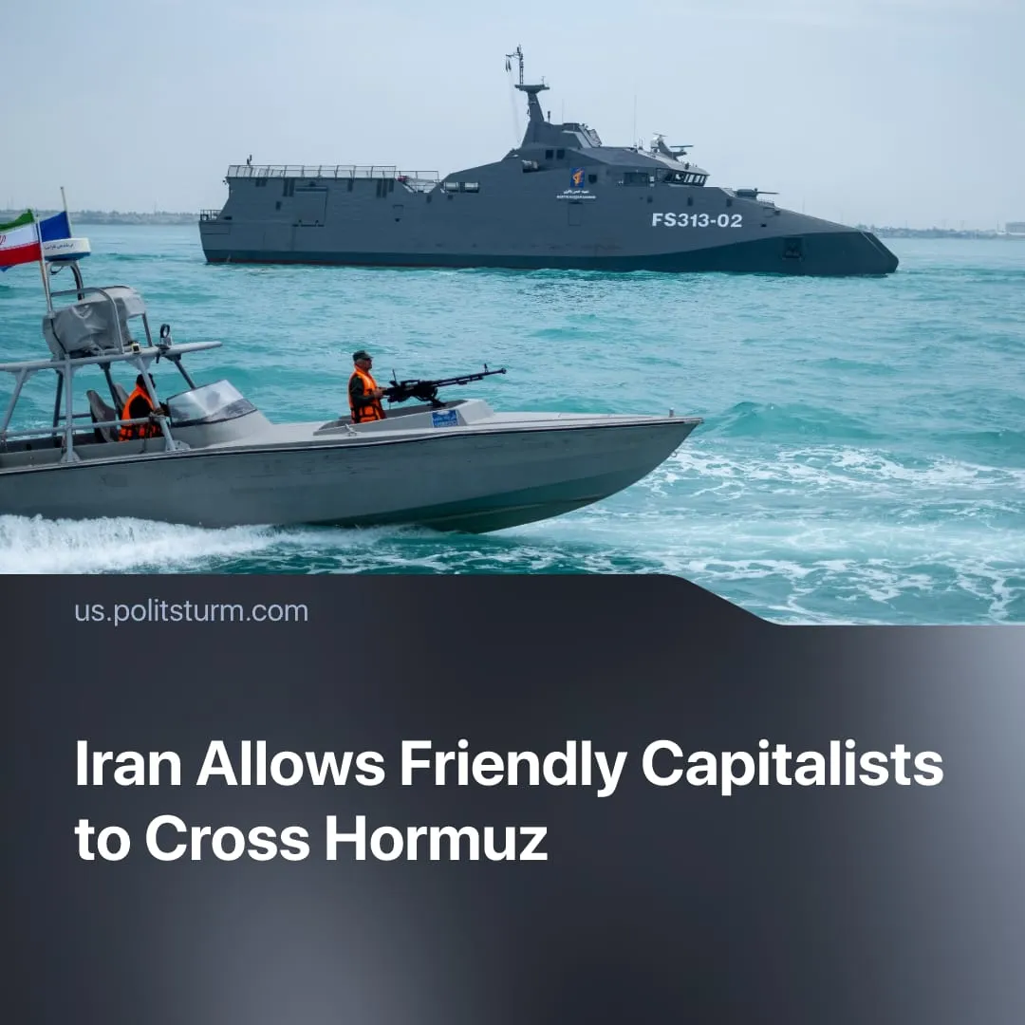

Original article
2026-03-25
2 min read

Iran claims to have closed the Strait of Hormuz, yet Chinese-linked ships are still passing through.
Details. Iran imposed a selective closure of the Strait of Hormuz through military threats against Western shipping, using drones, missiles and mines. Shipping through the strait has fallen by 90%, as insurers withdrew coverage and vessels avoided the route.
► However, the strait is not fully closed – ships can secure passage by identifying as Chinese-affiliated and coordinating directly with Iranian authorities, or by payment of a new $2 million toll. In the first two weeks of the blockade, at least 11 China-linked vessels crossed Hormuz safely, and roughly 12 million barrels of Iranian crude oil were shipped to China despite the war.
► Iranian officials reportedly plan to allow more foreign oil tankers to cross Hormuz safely, provided their cargo is traded in Chinese yuan currency instead of US dollars.
Context. The Strait of Hormuz is one of the central arteries of global capitalism, linking Gulf energy production to industrial economies worldwide, with 25% of global seaborne oil trade passing through this narrow, vulnerable corridor.
► Even the partial disruption of Hormuz has already pushed oil above $100–120 per barrel and sharply raised gas prices in Europe, marking the largest energy shock since the 1970s, while some Asian economies have cut industrial output due to shortages.
► For China, Hormuz represents a major structural dependency, with 40% of its oil imports transiting through this corridor, tying its industrial system and energy security to a route formally outside its control and now endangered by a US takeover.
Important to Know. The conflict over the Strait of Hormuz is part of the broader inter-imperialist struggle over control of strategic trade arteries, energy flows and global logistics. Key chokepoints are becoming instruments of economic and political pressure between competing capital blocs.
► Trump has declared that the US military will reopen the Strait of Hormuz – following US strategy to secure key global trade routes such as Bab el-Mandeb, push back Chinese capitalists’ influence in the Panama Canal, and control the Zangezur Corridor.
► Iran’s opportunistic usage of the Hormuz blockade to enforce oil trade settlements in Chinese yuan instead of USD showcases the de-dollarisation efforts of rival imperialists – seeking to replace America as the capitalist centre by instituting a new global reserve currency.

Original article

