Iowa Rolls Back Child Labor Laws
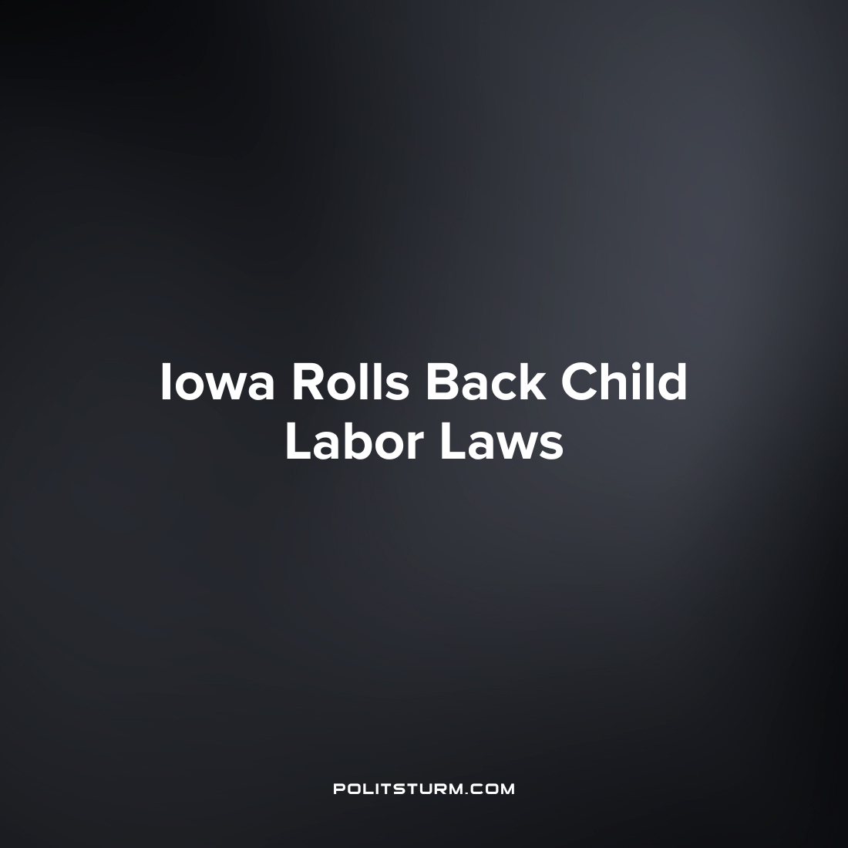

Original article
2023-07-04
1 min read

Iowa governor Kim Reynolds signed a bill into law that will roll back child labor laws in the state and expand the pool of low-wage labor available to the capitalist class. Many of the enacted changes to labor law within the state contradict the existing federal guidelines for child labor. For example, whereas federal law prohibits those under the age of 18 from performing light assembly work in facilities manufacturing explosives or articles containing explosive elements, Iowa law allows this labor as young as 16 years-old.
Other dangerous occupational work such as operating power-driven woodworking machines, metal forming and shearing machines, circular saws, and guillotine shears are allowable under Iowa law to those as young as 16. Iowa law allows such forms of child labor by branding them as “work-based learning programs” or or “school or employer-administered, work-related programs” which are approved by the state's internal education and workplace development agencies. Another noteworthy aspect of the changes is the duration of the work day which Iowa allows capitalists to employ children. The law allows for six-hour nightly shifts for 14 and 15 year-olds which exceed the Fair Labor Standards Act (FLSA).
Iowa joins a host of other U.S. states who have rolled back labor protections for youth employment. Arkansas Governor Sarah Huckabee Sanders recently signed HB 1410 which eliminated age verification for employment and parental permission. The capitalist class will work to expand the pool of labor available to them in order to drive down wages. The capitalists also struggle in their class interest for the lengthening of the working day in order to increase the profits they can extract from their workers.
Source: 1 2

Original article

