Interview with the International Secretary of the CP of Sweden
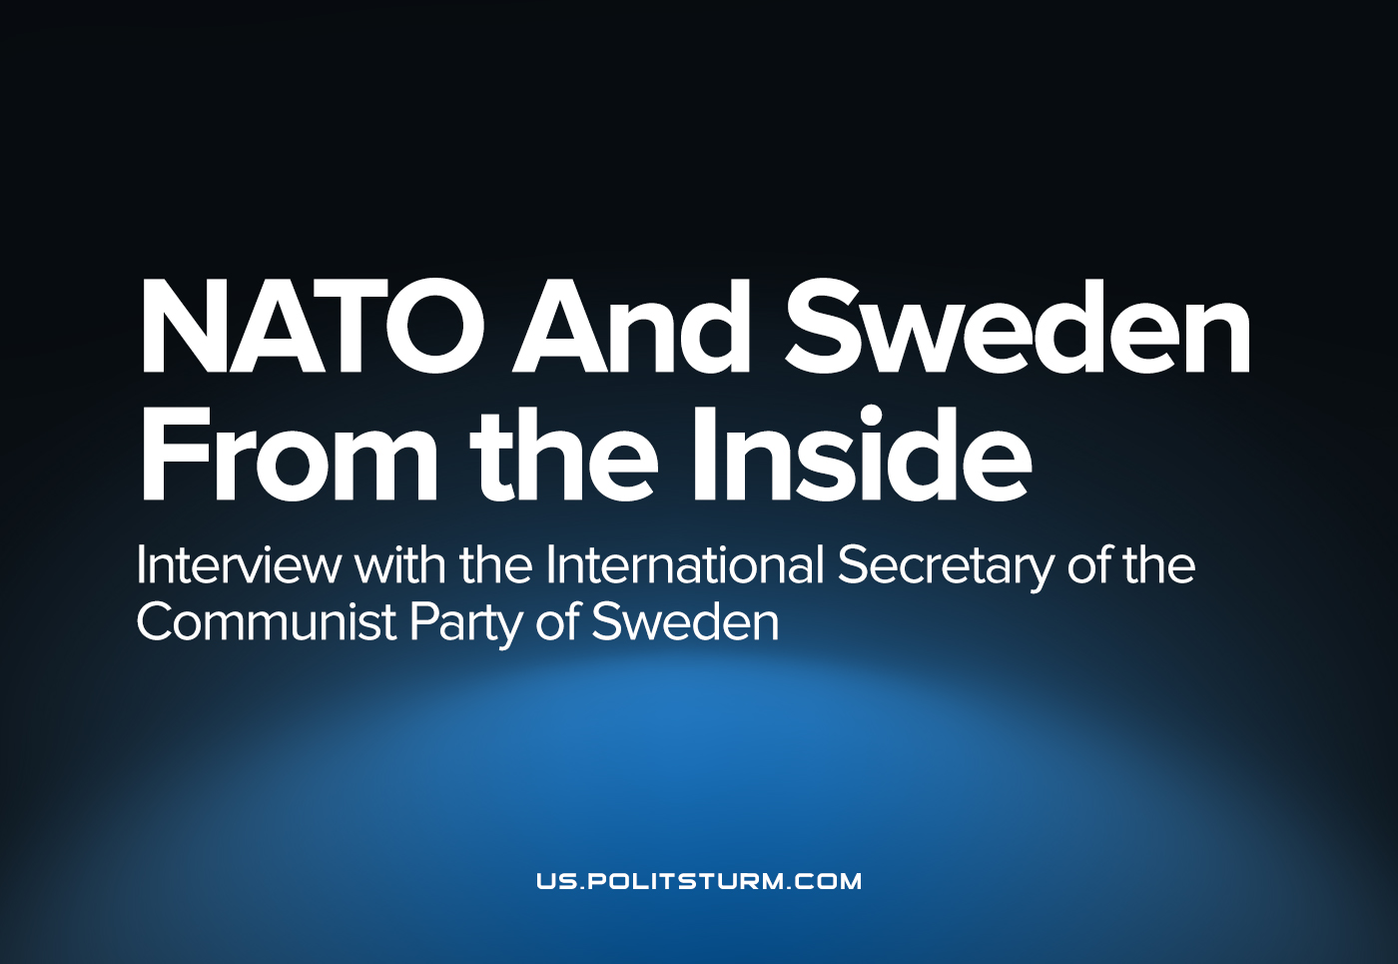

Original article
2022-07-20
10 min read
In recent months, the degree of military hysteria in Europe has sharply increased. Sweden and Finland are one step away from joining NATO. We have previously published a number of materials for our readers on modern imperialism written by the General Secretary of the Communist Party of Sweden Andreas Sorensen. In this case, we took a short interview with one of the leaders of this organization, Karl Gunnarsson.
Politsturm: How is it going in Sweden in general at the present moment? How can you characterize the state of the party at the moment?

Karl: Aside from Sweden’s bid to join NATO, which certainly seems like a done deal at this point, campaigning is ramping up for the coming elections in September. We will be participating in the elections on the parliamentary level and running candidates for several county councils and municipal assemblies. Participating in the elections will put our organizational capabilities to the test, as well as revealing how well we are able to apply the lessons learned in previous elections. Sweden has, to put it politely, a peculiar election system, which makes it very expensive for small parties, such as ours, to participate on a large scale, but the elections are an opportunity for us to raise the party’s profile, something which is a challenge when people can pretty much only hear from us, and about us, through our own channels and our social media accountAs I mentioned we are a small party, but we are growing, and I think that more people are becoming receptive to our message, however hard it may be to get it out. The attacks on workers’ rights have been ramping up in Sweden, with the right to strike having been all but abolished and the Employment Security Act set to be weakened later this year, this being accepted by major Social Democrat-controlled national unions. Thus what should have been the fighting organizations of the workers have taken on a pacifying role. We see the urgent need for a fighting organization that gathers radical workers, and people of other social strata whose interests align with those of the working class, to lead the struggle for workers’ rights on an anti-capitalist basis. This is a major aim of our organizational efforts, but we have much work ahead of us.
Politsturm: How Swedish people respond to the current events: rise of militarization all over the world, Sweden and Finland joining NATO? What are the main arguments of the government? Do you agitate against? What is the influence of your agitation?
Karl: The Russian invasion of Ukraine was a watershed moment with regards to Swedish views on NATO. For the first time an opinion poll showed that just over half those surveyed approved of a Swedish NATO membership. The Social Democratic Party, which has historically maintained that it is opposed, or at least skeptical towards NATO membership, rapidly switched its position and, as the governing party, set in motion the process for Sweden to become a NATO member.
The Social Democrats claim that with the invasion of Ukraine the security situation has been radically altered, requiring Sweden to seek assurances, such that only NATO can grant, to ensure its security. However, Sweden joining an imperialist military alliance is in itself an escalation and increases the risk of the Swedish people finding themselves at war. In pursuing a Swedish membership in NATO, the Social Democrats act in the interest of not the Swedish people, but as always the Swedish capitalist class, which sees the membership as a way to ensure its own competitiveness and to guarantee access to new markets, in particular for arms export.
There have been many demonstrations against Swedish NATO membership around the country and we have participated where we don’t have to abstain from presenting our own stance and analysis. This includes criticizing NATO opposition that is guided by bourgeois understanding and other incorrect ideas that cloud and distort the problem. We do not participate if that would require of us to sign or accept a joint statement with other participating organizations or groups, as such a statement would inevitably compromise our anti-imperialist opposition to NATO.
It is hard to gauge whether the general opposition to NATO is making any headway amongst the people. In the short run the government is set on its course of NATO ascension and it is not going to change it however the public opinion may develop. Sweden becoming a NATO member doesn’t in any way signal the end of our struggle against NATO and for peace. Through our protest and analysis we can highlight what forces are at work and persuade more people to join our struggle.
Politsturm: What are the opinions on the Ukrainian crisis among Swedish left? What are the positions of the major organizations? We’ve seen articles by your general secretary Andreas Sörensen about Russia and its place in the world imperialist system. You criticize your opponents from “Communist Party” as well. What is your opinion on those who stand on social-chauvinist and opportunist positions? Is it nothing but a single mistake, or a consequence of their views, strategy and tactics?
Karl: Even if the Swedish left may not perfectly reflect the global left, we can still see it as a subset of it with roughly the same range of opinions. Here too there are many who instead of standing with the peoples, and condemning both sides in an imperialist conflict, to some extent or other pick the “better” imperialist block to side with. The parties on the left in parliament all support the Ukrainian government, whatever their stance on NATO membership may be. I’ve already talked at length about the Social Democratic Party, arguably a part of the left, and among the parties in parliament that leaves the Left Party, which remains opposed to a Swedish NATO membership, although its arguments against it are not surprisingly thoroughly bourgeois. The Green Party, which can arguably be lumped in with the left, makes no pretenses towards being a workers’ party, so hardly warrants a mention here.
Much can be said on the topic of social-chauvinists and opportunists and it could easily be the topic of not an article, but a series of articles. The aforementioned Left Party has come a long way from its heritage as a founding member of the Comintern (Swedish “Left Party” is the former Communist Party of Sweden – Politsturm). Its current social democratic iteration is a result of a long process of opportunistic politics, which mainly trace its roots to the Popular Front doctrine. In that case we can see a major error affecting the long process that followed, but it cannot be condensed this easily into a simple answer.
I shall attempt to briefly explain the chauvinism that is rife amongst so-called communists and socialists in Sweden. The tendency to pitch Swedish workers against foreign workers shows, besides a lack of solidarity, an inability to think outside the frames of capitalism and act as a communist in demanding for the workers all that they deserve, need and have paid for with their work. It also reveals a deep confusion about the role of the capitalist state, that it somehow has a duty towards the well-being of the country’s workers and that it can better fulfill this duty if foreign workers, or migrants and refugees in general, are kept out. The roots of this are obviously opportunistic, in the way that they see a trend within the working class that is anti-immigration and anti-migration and jump on it in the hope of gaining support through it. The question in that case must be support for what? These chauvinists are acting as the tail of the working class rather than its vanguard.
At their height, parties which choose this route can become nothing more than social democratic, only with a more radical rhetoric – albeit one which merely criticizes “neoliberalism” rather than capitalism and imperialism – and a tendency towards making migrants and refugees into scapegoats. Through pitching worker against worker they serve no-one but the capital they avoid mentioning.
Moving on I must drive home the point that opportunism isn’t merely a question of a simple choice along the way, the little mistake that derails everything. Rather it is a failure stemming from a fundamentally incorrect worldview which leads to incorrect conclusions in every case. The Communist Party, often called the KP, has opposed Sweden’s NATO membership bid, but in its argumentation it fails to explain the imperialist forces at work, or even the class character of the Swedish state. When they, correctly, oppose Russia’s invasion of Ukraine, they do it on grounds of international law, a clearly bourgeois creation that usually is applied to suit the strongest imperialist block, and not on grounds of international solidarity. Even when they manage to arrive at the correct conclusion, they do so based on the wrong reasons.
Politsturm: What are the main consequences of Sweden joining Nato for the country and Swedish people? Is it possible to fight against military hysteria and chauvinism?
Karl: As I mentioned above, Sweden joining NATO is an escalation, not a move for peace. It will make it more likely that the Swedish people will find themselves at war, that young Swedes will have to fight in imperialist wars for the profit of Sweden’s monopoly capital. The Swedish military budget was already being increased before Sweden’s NATO bid, but with the Swedish state apparatus taking a more aggressive stance it is likely that expenditures will continue to rise, at the expense of vital services for the Swedish people, such as healthcare, education and so forth.
To fight against this can only be done along the lines of anti-capitalism and anti-imperialism, as these problems are deeply rooted in the imperialist system and will continue to exist as long as the system does. There is no question that the problems caused by capitalism can be fought and in fact vanquished. History has shown us as much. But for that struggle to be carried to victory it has to be conducted in a principled manner. Opportunism only leads to defeat for the people.
Politsturm: Thank you for your answers. What would you like to wish our readers?
Karl: For your readers I wish for success in organizing and in standing up for the working peoples and the popular strata. We must avoid the ditch that is national chauvinism, as that serves nobody but capital, and remember that our interests are common. The future is ours in international solidarity.
CP of Sweden site: https://skp.se/
“Riktpunkt” magazine: https://riktpunkt.nu/

Original article

