International Women’s Day
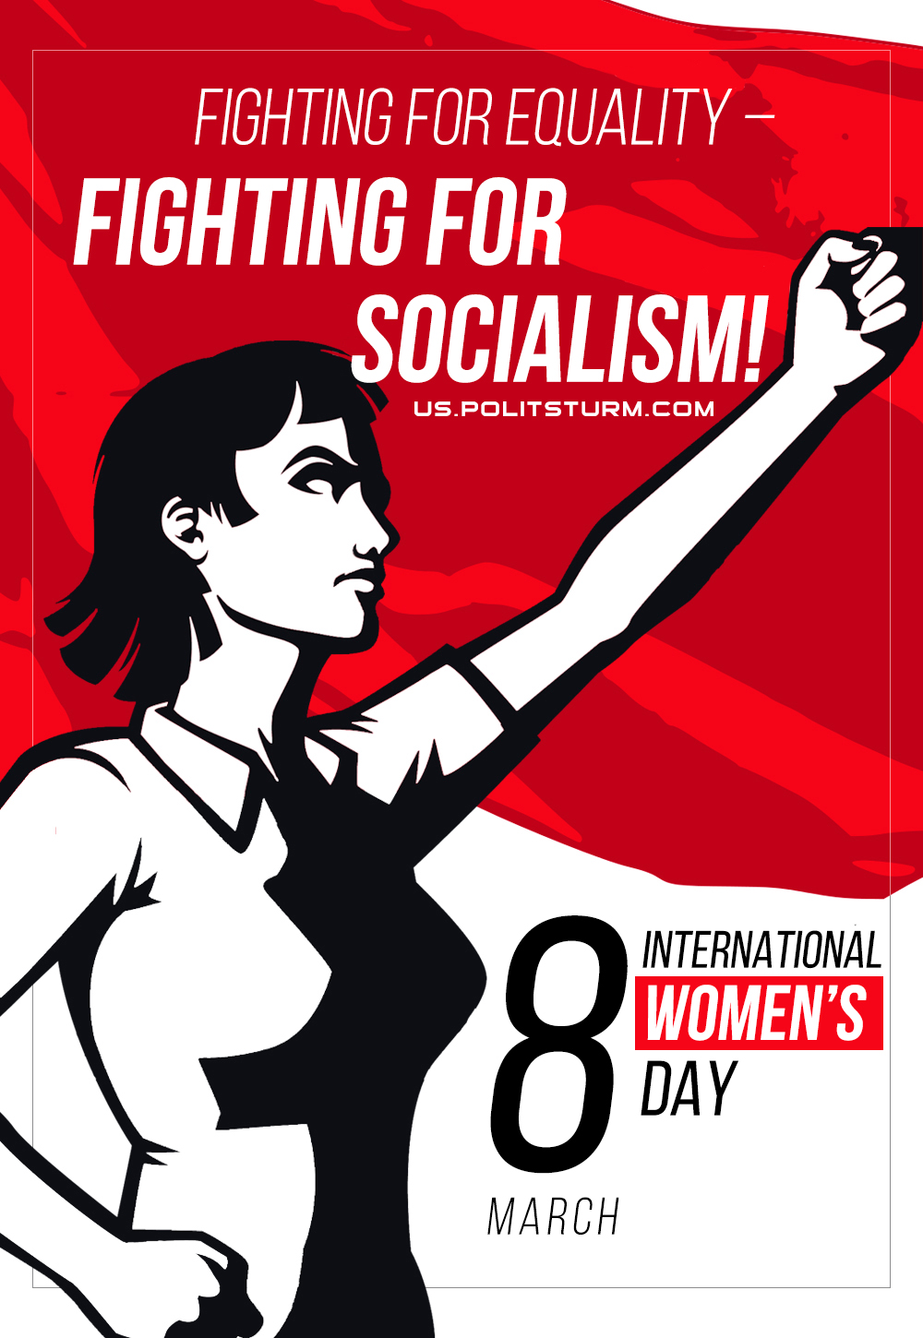

Original article
2022-03-08
1 min read

International Women’s Day is a special date for half of the population of all countries of the world. Most people perceive this date as an occasion for a gift and increased attention for women, but the original true meaning of the holiday is far from being in these appendages.
In our time, the working women would seem to work less, earn more, and technological progress has facilitated their role in the household. However, their position does not change much – the level of income is falling all over the world along with the standards of living after the defeat of the socialist bloc, the working day only formally lasts 8 hours, but in fact, processing and a six-day week are a ubiquitous phenomenon, which is why there is a lack time for raising children, fatigue from a huge number of responsibilities is growing, and the arbitrariness of the authorities, who use the “nature”, has not gone away.
“The cruel fate of the masses weighs with especial heaviness on the women, unless they happen to be appendages of the capitalist industrial magnates, dealers, speculators, profiteers, and usurers. There is no misery of the present day which is not felt by the women with double and multiple intensity.” – Clara Zetkin said 100 years ago.
The communists must fight against the vulgarization of this holiday on a par with the May 1, with relegating it to the simple “Day of all women”, including representatives of the bourgeoisie and its servants, emasculating the whole essence of this day. All holidays that have revolutionary origins are perverted today and turned into a “women day”, “mother’s day” or “holiday of spring”, which do not carry the true meaning defined by the history of the struggle of the working people.
Our collective congratulates all conscientious women of labour on the International Day of Solidarity of Working Women, and wishes the working women and communists good health, strength and ability to fight for socialism!

Original article

