Inflation Increases 8.6% Over the Past Year
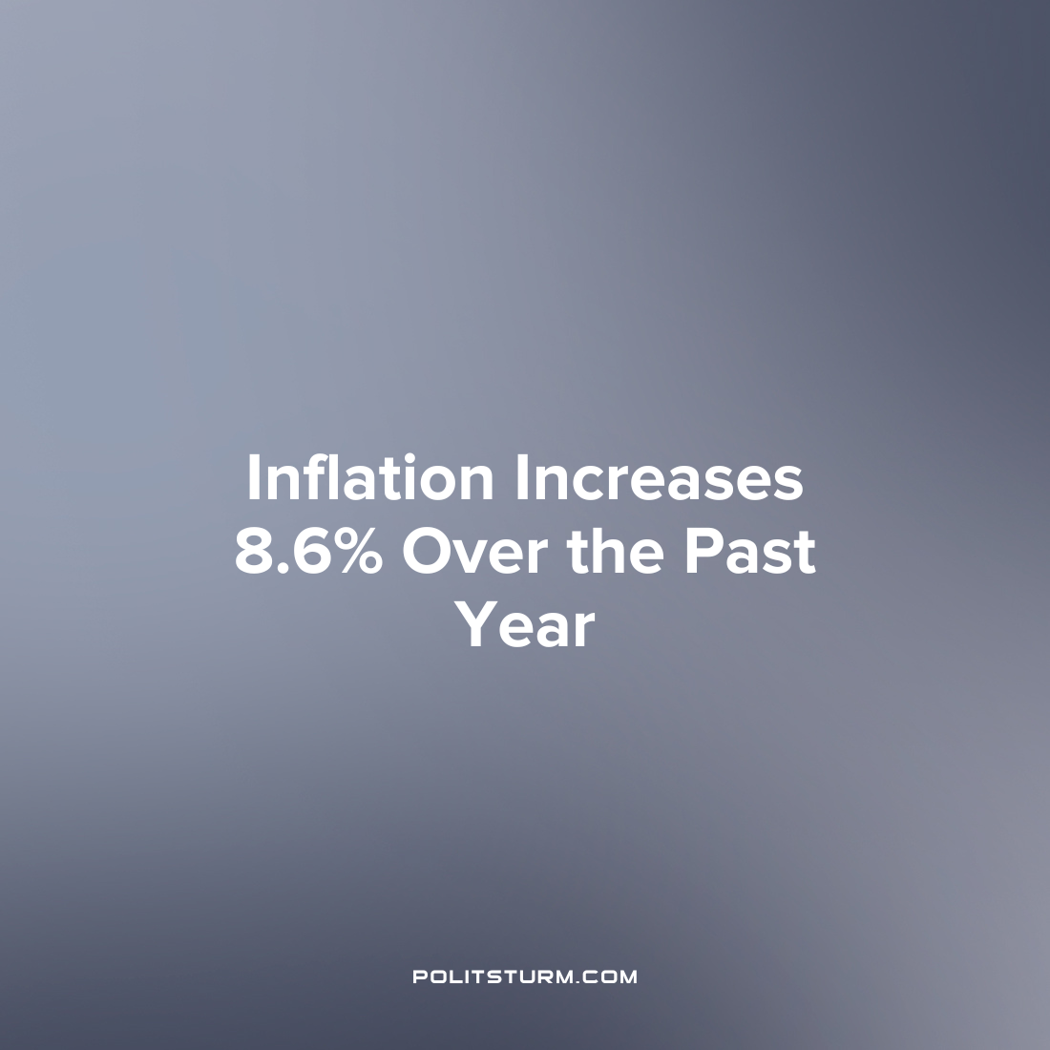

Original article
2022-06-10
1 min read

The Bureau of Labor Statistics (BLS) released the Consumer Price Index (CPI) summary which showed prices increasing at a rate of 8.6% over the past year before seasonal adjustment. The announcement has quelled any hopes that inflation would slow down in the near future.
The largest price increases were associated with shelter, gasoline and food prices. The food price index increased by 1.2% in May whereas the energy price index increased by 3.9% over the same period.
In the last 12 months alone the gasoline price index has increased 48.7%. An even more stark price increase is shown in the index for fuel oil which increased at a staggering rate of 106.7% which is the largest increase in the history of the data series which dates back to 1935.
Under the capitalist economic system the prices for the goods that workers consume are subject to rapid periodic fluctuation. While capitalists can simply increase the prices of the commodities they are selling, wage workers as the sellers of labor power are not in such a favorable position. While the capitalists continue to reap massive profits and enrich themselves, the real incomes of the workers struggle to keep pace with the rising prices which are out of their control.
Source: 1

Original article

