Inflation Drives Down Real Wages as Profits Soar
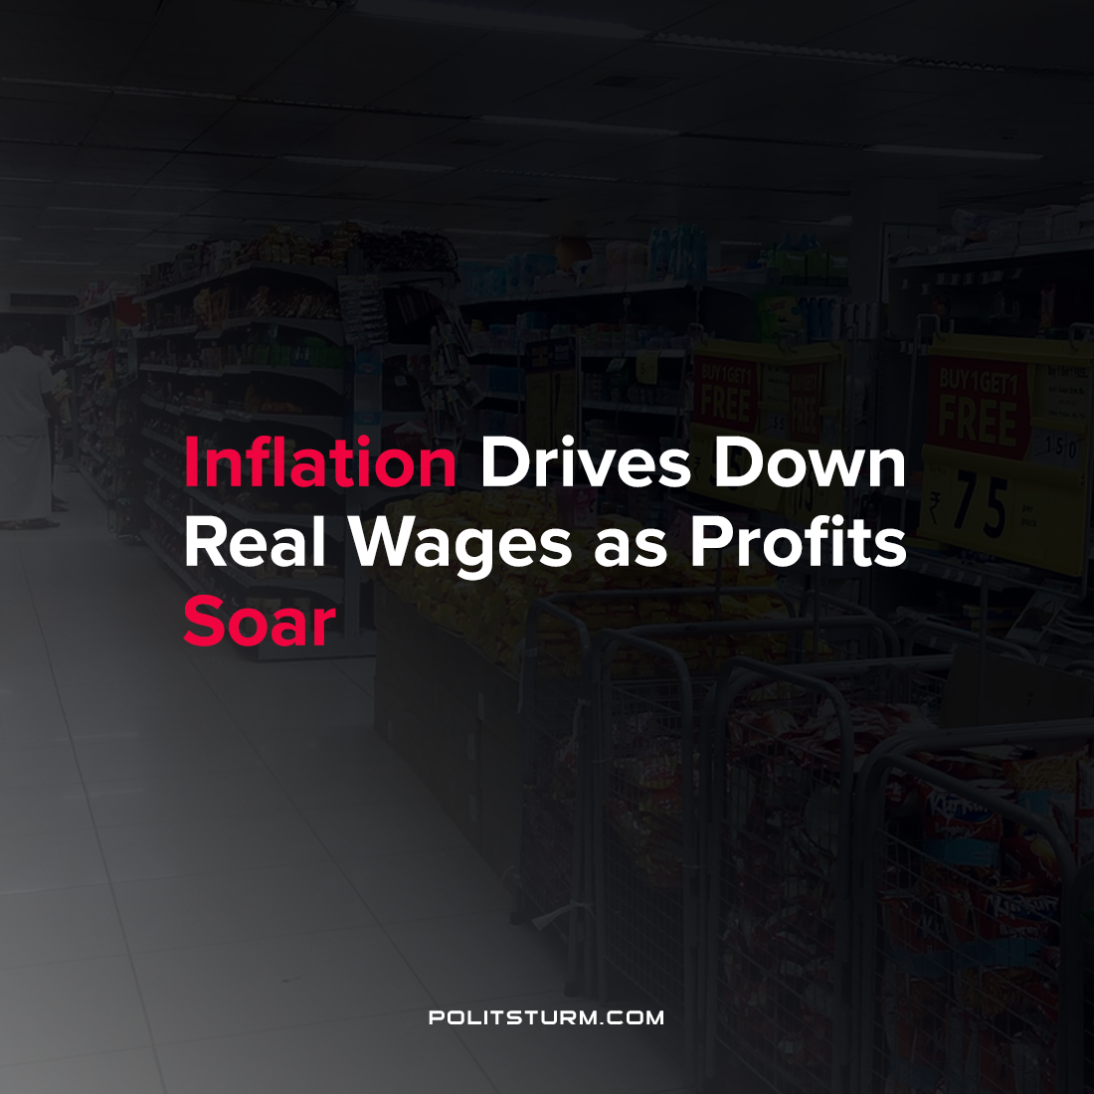

Original article
2021-08-11
1 min read

According to recent data released by the Bureau of Labor Statistics (BLS), real average hourly earnings have fallen 1.7% in the 12 months preceding June 2021. Despite claims of a labor shortage and unfavorable conditions in the labor market for employers, when adjusted for the increasing price level and other factors real wages declined. Even if wages increase, if the cost of household goods accelerates at a faster rate then the worker is in a worse position despite the higher nominal wage.
The decline in the real hourly earnings for workers occurs simultaneously with a rise in corporate profits which have recently soared. Corporate profits after taxes stood at $2.4 trillion in the first quarter of 2021, up from $2.1 trillion at the end of 2020. Thus even with an increase in nominal wages it is possible for the capitalists to increase the rate of exploitation of the workers. As the cost of goods that the workers consume increases faster than their wages it is possible for the workers to be less well-off over time.
The capitalist economic system is fundamentally based on the exploitation of the working class. The capitalists owners of the means of production strive for the maximization of profit which entails the greatest possible revenue over their costs, including labor costs i.e. wages. Only the elimination of the capitalist mode of production and its replacement with a socialist mode of production can end capitalist exploitation of man by man and its associated deficiencies.
Source: 1 , 2

Original article

