Inequality
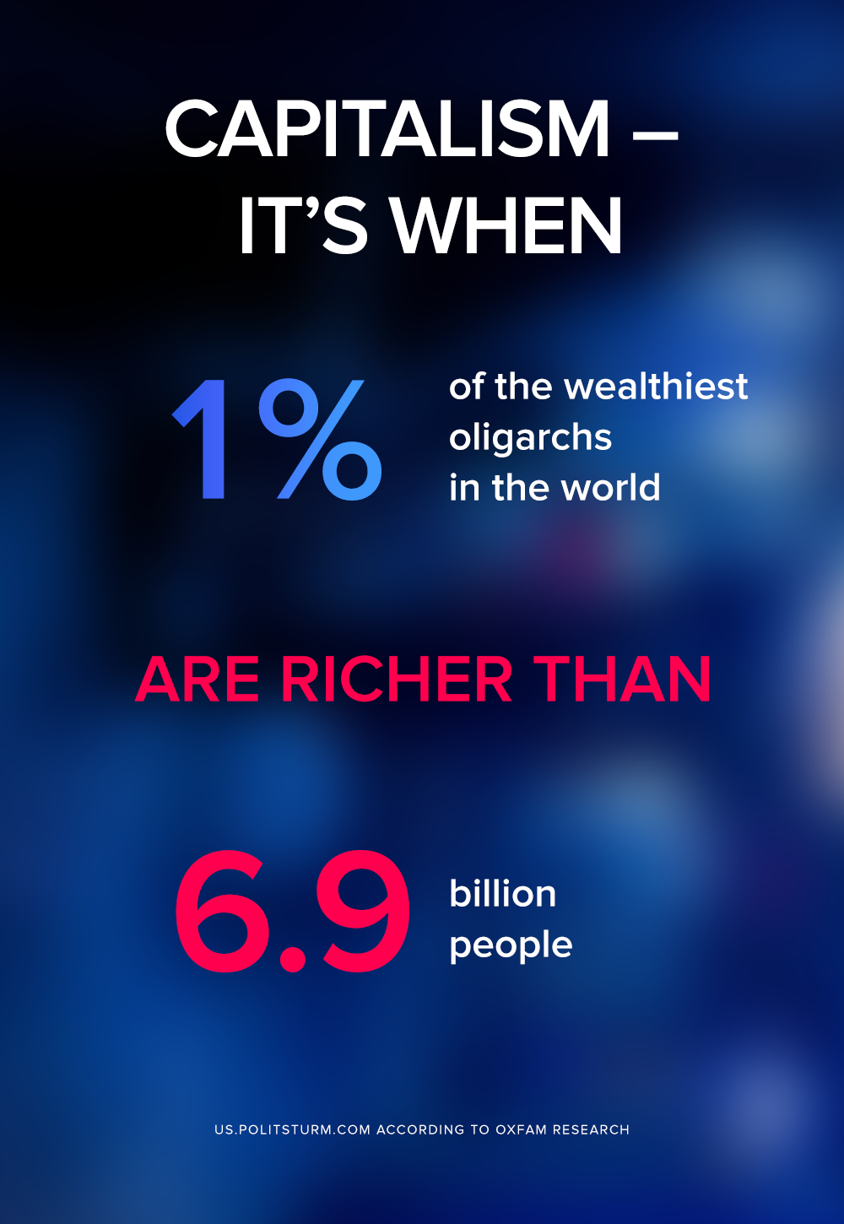

Original article
2020-01-27

How long can this go on?

Original article

