Capitalist Inequality will Plunge Further 250 Million into Poverty
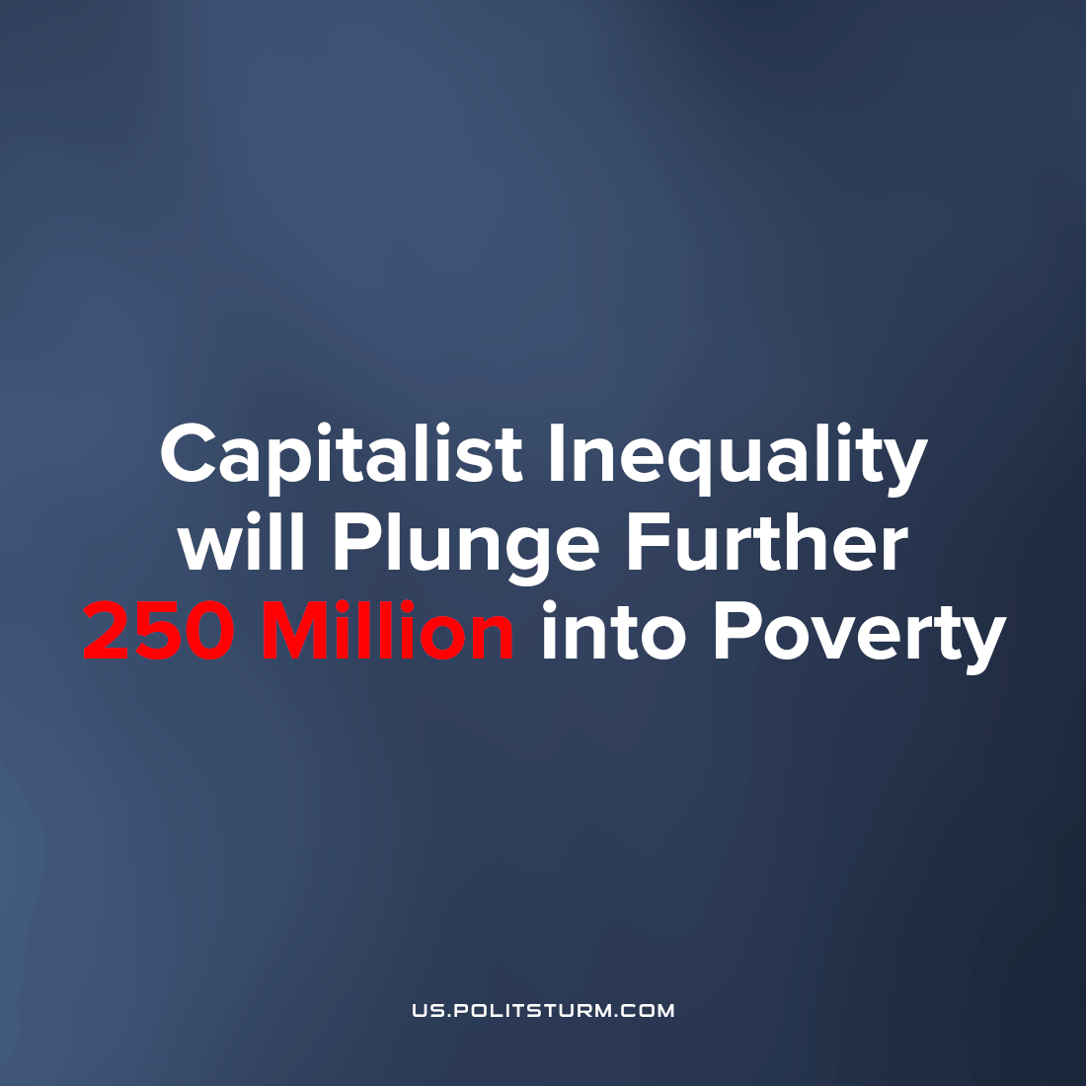

Original article
2023-05-03
3 min read

While the richest owners receive twice as much income as 99% of all the world's population combined — 250 million more people will, in the near future, be added to the population of almost 670 million living in "extreme poverty".[1] Despite the heartfelt promises of the super-rich, the world is not getting less poor under capitalism, but some people are getting richer.
Error loading image
Anthony Kamande, Oxfam Global Inequality Research Coordinator [2] reports that the COVID-19 pandemic plunged 90 million people into extreme poverty (judged by them to be $2.15 a day) in 2020, an increase of 12 percent compared to 2019. On the same day, 1% of the super-rich get richer by $2.7 billion.
But while all bourgeois media blames the trouble on COVID-19, war, global warming, etc., Oxfam researchers found that 95 food and energy corporations doubled their profits in 2022. They received $306 billion in windfall profits and paid 84%—$257 billion of that amount—to major shareholders. Super profits of corporations stimulated the growth of inflation in Australia, the United States and the United Kingdom, which is undermining the purchasing ability of many ordinary citizens of these developed countries.[3]
Analysts have also found that governments in Africa, Asia, Europe and America have lowered income tax rates for the richest people over the past forty years.[4] At the same time, they have increased taxes on goods and services, which the richest class does not feel, and which disproportionately effect the poorest people, exacerbating economic inequality and the rate of mass impoverishment.
"The number of people living in extreme poverty is higher today than four years ago," UN Secretary–General Antonio Guterres said in his report on April 25, 2023. The bourgeois official notes that if current trends continue, only 30 percent of all countries will achieve the set targets for combating poverty by 2030. Hunger indicators, according to the UN chief, have also increased and returned to the level of 2005.
With surprise, the UN chief notes the growing level of inequality in general – only 26 people own the same condition as half of the world's population. [5]
The poorest countries, for example, like Somalia, are already experiencing all the joys of the most just world economic system in the form of 43,000 people who died due to drought.[6]
Deaths are associated not only with dehydration — most of the victims die from malnutrition, as millions of livestock do not receive the proper amount of water and die from a lack of feed, which cannot be grown without a watering system.
Those who were able to find water to drink and some food are also not immune from death - dysentery and other diseases haunt Somalis who cannot maintain a sufficient level of hygiene without water.
All this is happening against the background of how the "civilized" governments of are spending hundreds of billions on inciting and funding military conflicts, tailoring the silk pants of bankers and other such important goals for mankind.
For example, the Fujairah seawater desalination factory [7] in the UAE produces 591,000 cubic meters of fresh water per day (1m^3=1000L). The cost of its construction was $2.8 billion. In the hot climate of Somalia, a person needs to drink 5 liters of water to maintain normal functioning. That is, one desalination plant per day can meet the needs of 118.2 million people. The population of Somalia is 18.9 million people.
A few such factories could provide water to the whole country, but will it bring profit? It is the great monopoly interests and forces which possess hoards of water for their own use in agriculture, in dams and farm storage, but whichever form water theft is accomplished ultimately private ownership comes at the expense of people's access to water. Small owners of livestock and small farms are financially ruined, annihilating the social basis of this class for resistance to capitalist political oppression, opening up their possessions of land to be sold on the world market, and the masses of people suffer in this competition. Capitalism is for everyone, happiness is for a few, and for the rest — death from dehydration, hunger and poverty.
Poverty in the world is the result of the exploitation of workers by the capitalist class, who are engaged in the appropriation of surplus value, forcing workers to sell their labor for a low price. This leads to an unequal distribution of wealth and an increase in social inequalities, and it is exactly this process, under the ownership and leadership of the ruling class of capitalists, which deepens the inequality and in fact relies on it. The problem of poverty can be solved only by creating a socialist society where workers control the economy and make decisions in the interests of the masses, not in the interests of the elite. Only such a system can organize the fulfillment of human needs, to develop public infrastructure and a stable economy without exploitation.
Sources: 1, 2, 3, 4, 5, 6,7

Original article

