India Removes Poor People for the G20 Delhi Summit
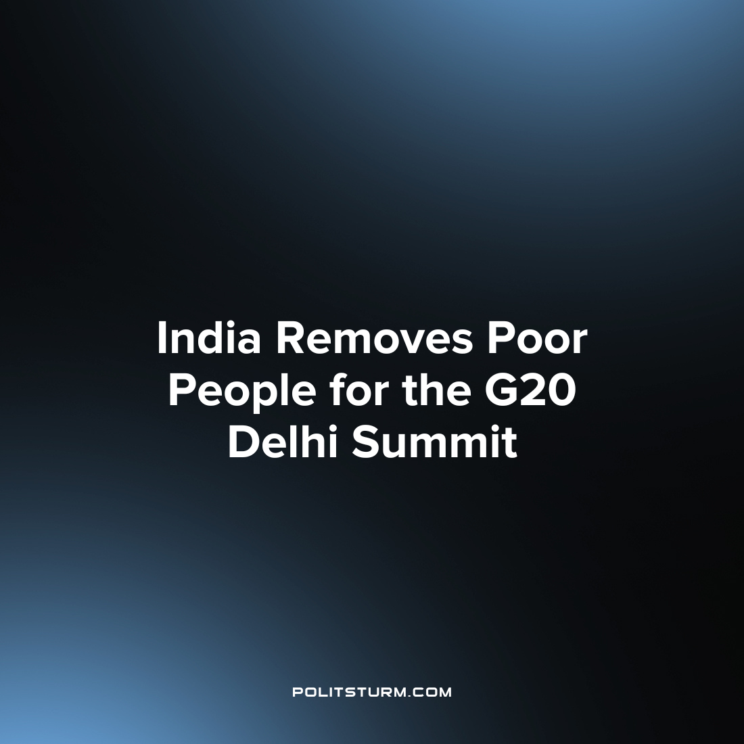

Original article
2023-09-16
2 min read

As India prepares for hosting the G20 summit, it tries to hide the poverty generally visible on the streets of its capital. The present Bharatiya Janata Party (BJP) government has spent millions of rupees to “beautify” the streets of Delhi for the coming G20 Summit. Hundreds of thousands of plants have sprouted along the roadsides, walls have been freshly built to hide rampant poverty in the nation’s capital. Police are detaining beggars and homeless individuals as part of an initiative to clear the streets and improve the city's appearance for visiting world leaders. Many such homeless individuals have been taken to temporary shelters outside the city and are being held there for the duration of the summit. These actions are not only limited to the homeless population but also to the poor sections of the working class. Many homes of such poor working-class people have been demolished which were on the path summit. Poor neighborhoods have been hidden behind the walls built to hide such scenes from the delegates of the summit.
As the present government claims to make India an economic “superpower”, such actions only show us the complete failure of our economic system, capitalism, to eradicate poverty and homelessness. Such action exposes the utter hypocrisy of India's government resorting to extreme methods to remove poor working-class people from the streets while millions more join the ranks of homelessness and people in poverty while capitalists continue to accumulate more and more wealth in their hands. Ever since the BJP’s crusade against the workers of India, the wealth inequality has only gotten worse. This is the reality of India and all other nations under capitalism where the working class would always be essentially second-class citizens on the whims of the capitalist class. Poverty and inequality are the results of capitalist accumulation and wage labor.
Only under Socialism, where all the means of production are under the hands of the working class, managed by a scientific plan can poverty and homelessness be really removed without removing the actual homeless people and detaining them. A socialist system production is oriented toward meeting the needs of the people such as housing, food, healthcare and jobs. Only under such a system can poverty be abolished as fast as the present government removes the poor people as it would be the basic objective of a socialist economy to fulfill the need of the working class and as it would abolish the material basis of inequality, homelessness and poverty.
Sources: 1 2 3

Original article

