In the First Half of the Year, Lukoil Received Half a Trillion in Profit
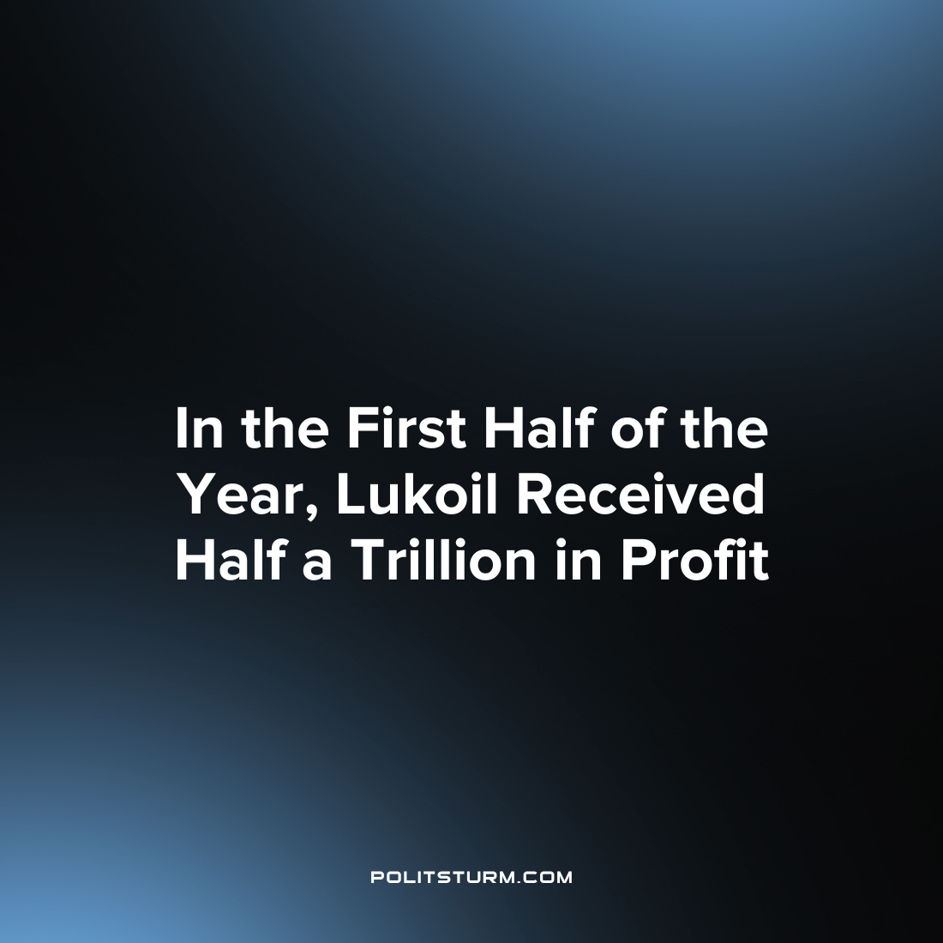

Original article
2023-09-17
1 min read

ccording to IFRS reporting, LUKOIL received 565 billion rubles in profit for the first half of 2023. Of these, 302.6 billion rubles were received in the first quarter.
This is Lukoil's first reporting since the end of 2021. With the introduction of sanctions due to the conduct of Russia's ‘Special Military Operation’, Lukoil, like many Russian companies, stopped publishing consolidated financial statements.
For the first quarter of 2021, Lukoil’s profit amounted to 302.6 billion, for the first half of the year – 348 billion. Revenue for the first half of the year amounted to 3.6 trillion rubles. The company has 1 trillion in cash equivalent on its balance sheet.
Lukoil is going to buy up to 25% of its own shares from non-residents whose securities were blocked in Russia in type C accounts. The amount of such a package is 1.16 trillion. rubles However, Lukoil plans to purchase it at a 50% discount.
Practice shows that the policy pursued by the Russian state creates favorable conditions for increasing LUKOIL's profits. However, profit is part of the unpaid labor of hired workers. Consequently, the state is committed to extorting surplus value from the working masses.
The situation could radically change with the transition of LUKOIL into public ownership. If the enterprise belonged to the workers, their exploitation for profit would not be possible. It is in the interests of the working class not to monitor changes in the ownership of a company, but to socialize it.
Source: Kommersant - “LUKOIL received 565 billion rubles of net profit in the first half of the year” From August 29th, 2023

Original article

