Imperialist Rivals Race to Secure Strategic Minerals
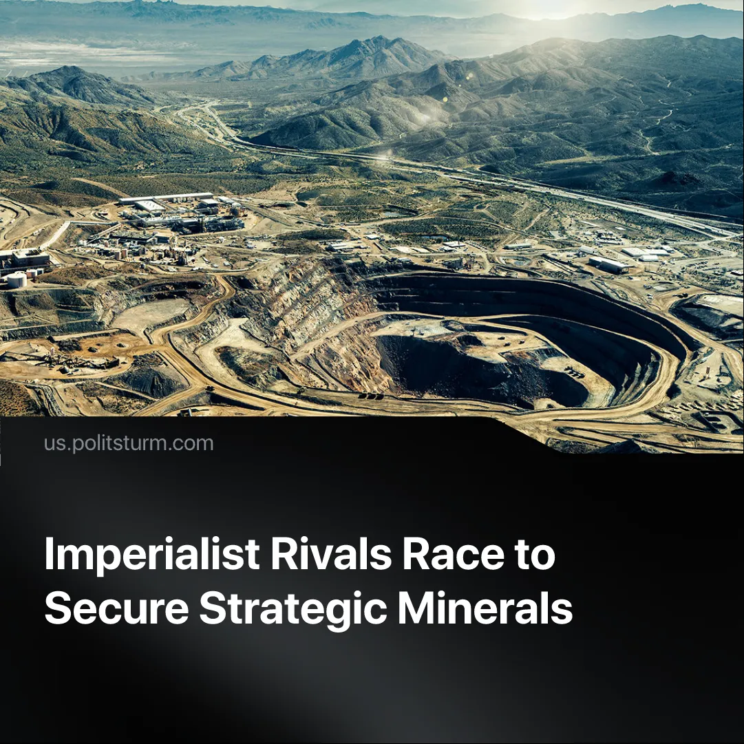

Original article
2025-08-11
2 min read

Major Imperialist states are pushing to free themselves from China’s monopoly on the global ‘rare earth’ mineral supply. These materials are vital for modern weaponry.
Details. The United States is investing in building out its own domestic ‘rare earth’ production. Simultaneously, Trump is securing mineral deposits overseas in dependent countries such as Ukraine and Congo.
► Capitalists of countries with high deposits, such as Brazil, are leveraging the increased demand for alternatives to expand their supply and thus multiply their profits. US and EU imperialists are clashing over Greenland’s untapped supplies, after Trump floated the idea of annexing the island.
► The EU’s recent Critical Raw Materials Act aims to make the bloc less reliant on China by 2030. The EU already possesses the only refinery outside of China which can refine all 17 rare earth minerals. Mines to feed this refinery are being expanded in the EU member state of Sweden.
Context. Rare earth minerals are crucial for modern technology, both for the consumer electronics industry and the defence industry. Advanced military equipment, such as F-35 fighter jets and navy warships, requires these materials.
► Presently, 70% of mining and 90% of refining happen in China, giving the country immense bargaining power over other nations. Notably, the US had to scale back its trade war with China due to its reliance on these materials.
Important to Know. The imperialist blocs are still interdependent due to global trade. Imperialist states cannot risk escalating to large-scale inter-imperialist conflict before securing their own supplies of strategic materials, which are crucial for waging modern warfare.
► Trump’s tariffs are part of the global ‘decoupling’, where rival imperialist blocs are attempting to cut economic ties with each other, trying to achieve economic independence in preparation for war. However, as we have previously demonstrated, the long-term political will to pursue decoupling is slowed by the painful economic consequences in the short term.
► The race to secure independent mineral supplies is part of the drive to global inter-imperialist war. This race is accelerating the super-exploitation of dependent countries. The pressure to control mineral deposits is escalating regional conflicts. American imperialists have stated outright that they are arming Ukraine in order to secure the “gold mine” of minerals in its soil.
► While China controls rare earth production, it remains dependent on Western markets to absorb its exports, without which it risks a crisis of overproduction.

Original article

