Imperialist Dog Trump to Withdraw Troops from Northern Syria
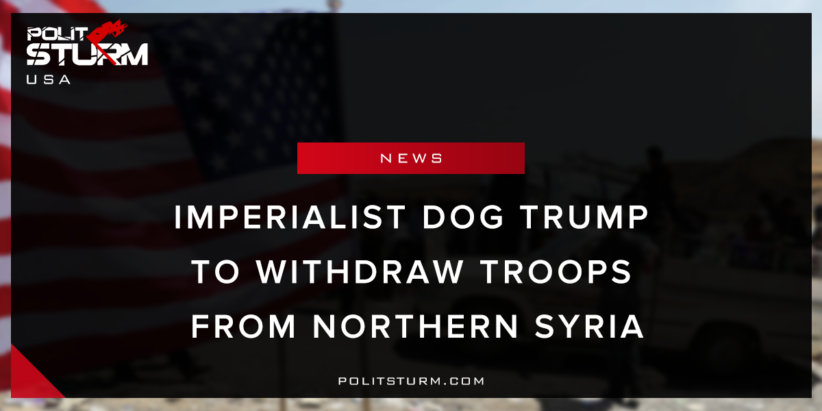

Original article
2018-03-31
2 min read

US President Donald Trump declared on Thursday that US forces would be removed from Syria “very soon”. Without offering any further details, he claimed that the US spends trillions in the Middle East but gets “nothing” in return.
“We will be coming out of Syria very soon. Let the other people take care of it now,” Trump stated at an Ohio rally.
Has Donald Trump and the American state suddenly grown a heart for the Syrian people and decided to end their illegal occupation? Not likely.
Most American troops are located in the north with Kurdish YPG forces, located in the 10 military bases in the Western cantons. Next door, in the eastern canton of Afrin, Turkey’s armed forces and terroristic FSA rebel army have succeeded in occupying the capital. Washington has denied reports that a deal has been reached concerning American troops in Kurdish city Manbij. Turkey, on the other hand, has stated that Ankara and Washington, did, in fact, come to an agreement on troops in Northern Syria and that it was waiting for its NATO ally to implement the deal.
French President Macron, meanwhile, has proposed to mediate talks between Turkey and the Kurds. The liberal hardliner, who acknowledges the growing populist revolt growing in France, further ignited from Middle Easterners settling in the country, may see the use of stopping the flow of refugees coming from the war-torn country. It has yet to be seen how sincere these feelings are.
Is it surprising at all or simply a coincidence that after four years of American intervention in Syria, the Americans only decide to withdraw from the fight after Turkey invaded and began the occupation of Afrin? This is by no means a sympathetic gesture to American troops, the Syrian people, or the mass of refugees. Like the Russian withdrawal from Afrin, this was a concerted effort to do away with any hopes for Kurdish liberation. We can see for all of the American criticism of the Turkish onslaught, all of their talk of maintaining “regional stability” means nothing. It’s amazing how a plan to remain in the region “for decades” to fight Daesh can come to a sudden about-face within weeks. The American state has decided to step aside and leave Rojava to the wolves.
Where is the outrage at this betrayal? Aside from the few socialist and pro-Kurdish groups manifesting in the streets, where is the sympathy that liberals once held with the “most progressive” force in the Middle East gone? Where are all the exploitative corporate media stories of Feminist YPG fighters struggling to liberate Syria from ISIS? An overall silence has loomed over both the Turkish invasion and the martyrdom of YPG fighters, both local and international.
The Turkish, Russian, and American national bourgeoisie all have rising contradictions with each other as the three powers attempt to mark out spheres of influence in the Middle East. While Erdogan’s interests have always laid in preventing an independent Kurdish state from appearing that could spur the Kurds residing in Turkey to press their own demands, the fake Western alliance of convenience with Rojava has only been in alignment as long as it furthered American goals of replacing the Assad regime with a Western-backed puppet regime.
Sources: 1, 2, 3,

Original article

