Immigrants Who Cannot Afford Healthcare Now Denied Entry to US
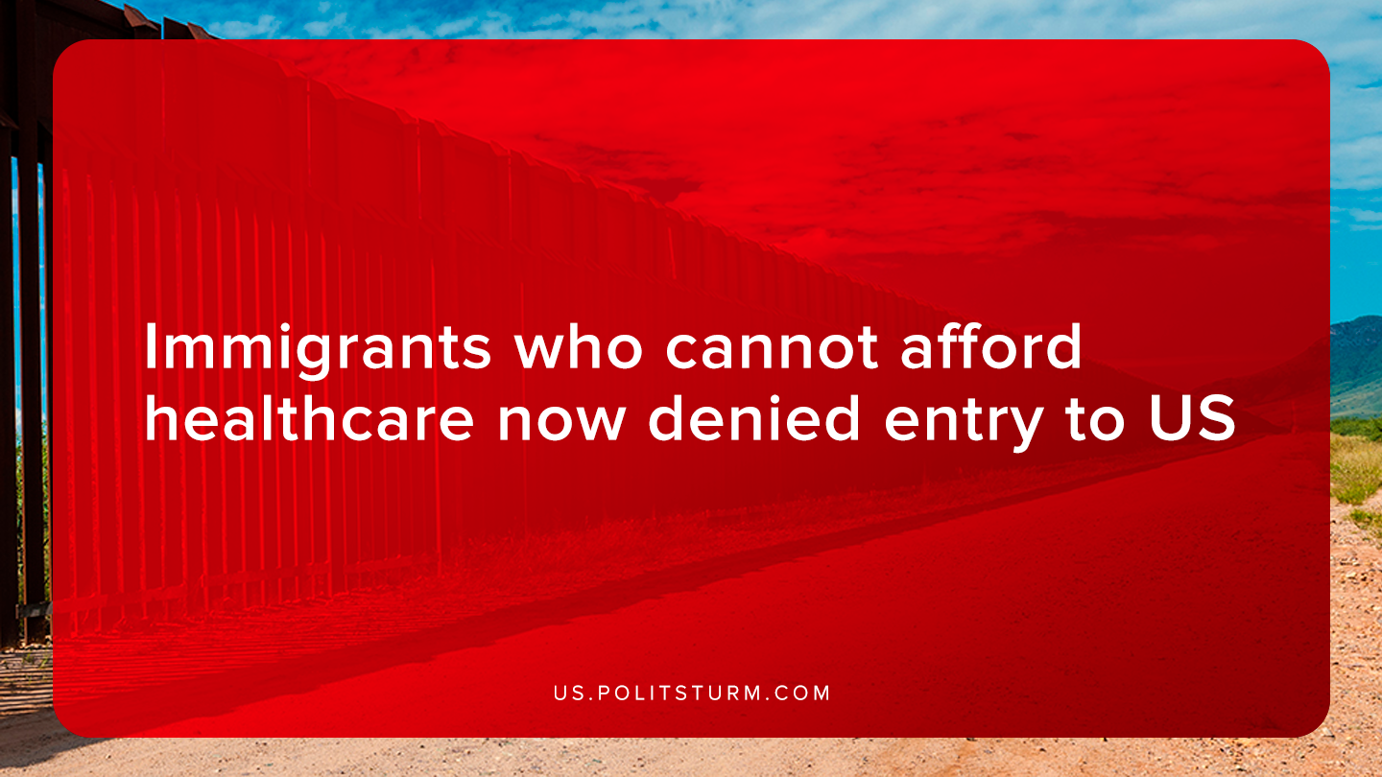

Original article
2019-10-17
1 min read

Donald Trump signed a new proclamation into law that will prevent immigrants from entering the United States if they cannot obtain medical insurance. The proclamation is intended to prevent immigrants from entering the United States who would “financially burden the United States healthcare system”.
The justification for the proclamation was that uninsured immigrants who need to utilize health care services create costs for taxpayers and the health care system. Since the United States has a largely privatized system without universal healthcare insurance, millions of Americans are uninsured.
Citing a statistic that “lawful immigrants are about three times more likely than United States citizens to lack health insurance,” the Trump administration is restricting legal immigration to those who cannot afford to insure themselves within 30 days of entry to the United States.
While the Trump administration claims to be protecting the American “taxpayer”, they are rather restricting legal immigration to pander to and foster nationalist sentiment. The bourgeois class, of whom Trump is a representative, uses nationalism as a tool to position the American working class against immigrants from other countries. In this way the bourgeois class can obscure class contradictions behind nationalist rhetoric.
Through Marxism-Leninism it is possible to see through the deception of the bourgeois class. It is the capitalist class that prevents the workers from achieving full employment and providing healthcare to its citizens. The capitalists are the exploiters stealing unpaid labor from the global and domestic working class, not immigrants.
Sources: 1 ,2

Original article

