ICE Raids Mississippi Processing Plants
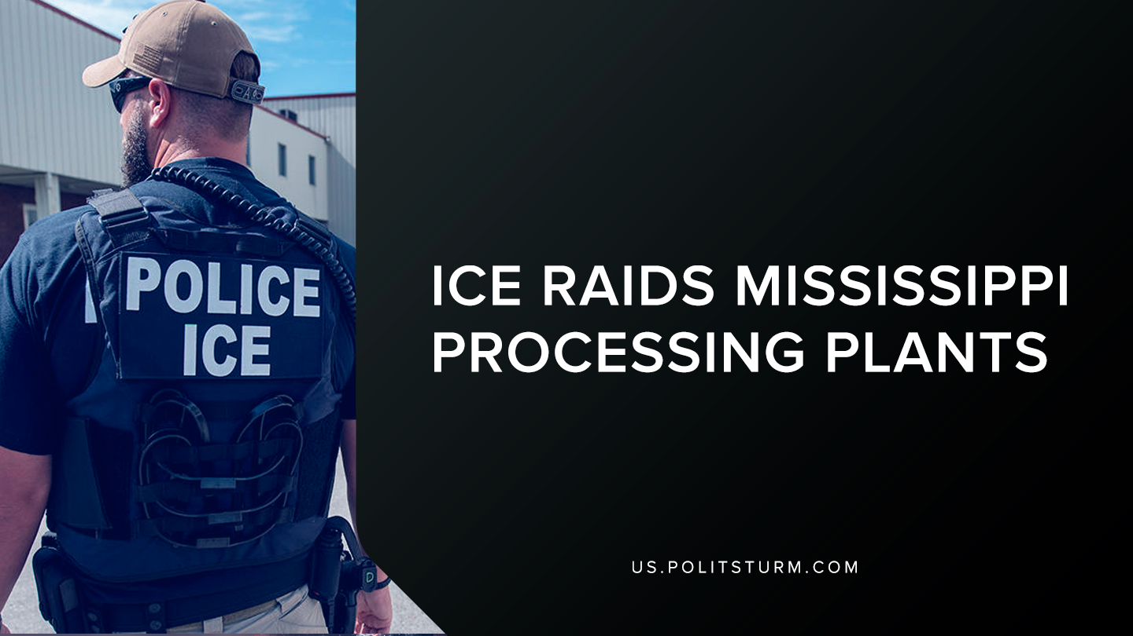

Original article
2019-08-10
1 min read

U.S Immigration and Customs Enforcement (ICE) Homeland Security Investigations executed criminal search warrants at seven agricultural processing plants in Mississippi. Subsequently, 680 workers in the plants were removed.
These workers are going to either undergo removal proceedings before federal immigration courts or they are going to be removed from the United States.
According to the U.S Immigration and Customs Enforcement press release the department is combatting “worker exploitation, illegal wages, child labor and other illegal practices”.
While the department claims to be fighting against “worker exploitation”, the capitalist class profits tremendously from the employment of undocumented workers. The Trump administration has used immigrants as scapegoats by utilizing nationalist rhetoric and policies.
The Trump administration claims to be helping domestic workers by detaining these workers, but it is just strengthening the partitions between working people. Workers in the United States, regardless of whether they have legal citizenship and residence or not, have a common enemy: the capitalist class.
Source

Original article

