Hunger Crisis Deepens in Kazakhstan
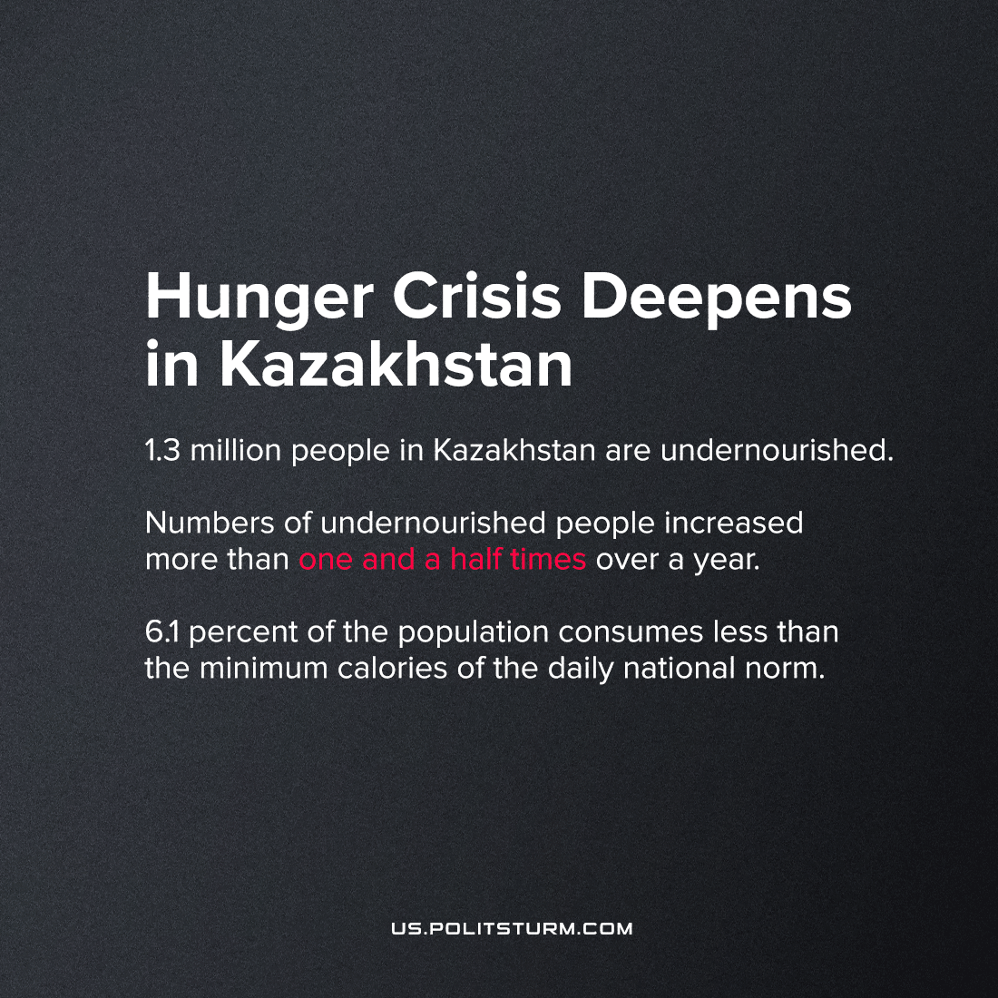

Original article
2022-07-14
1 min read

Over the past year, the quality of nutrition among the population of Kazakhstan decreased by 9.2 percent and amounted to 3,111 calories per day for each person. This is the lowest indicator since statistics were taken into account.
In four regions, the caloric content of food was below the national average.
Pavlodar (4120 calories) and Akmola (3780 calories) regions were the leaders in terms of calorie intake. At the same time, in urban areas, the value of food is lower than in rural areas. With a difference of 163 kilocalories in 2021.
The minimum daily norm of nutrition in the Republic of Kazakhstan is 1861 kcal. In 2021, 6.1 percent of the population ate below that minimum. At the same time, the number of undernourished people in the country has increased more than one and a half times over the year: from 832.5 thousand people in 2020 to 1.3 million people in 2021.
At the moment, we see a negative trend associated with those people who have started consuming fewer calories per day. This means that the country is dependent on global trends and the complexity of the current situation in the world.
All costs fell on the common populace and access to food is limited, so, as a population, either there is no money, or there is no access to quality goods. All these are the costs of the modern economic system and the lack of a fair distribution of resources. Humanity will only forget hunger once we are in the transition to socialism, when the whole economy will work to meet the needs of all society.
Source: 1

Original article

