Huawei Sues U.S. Department of Commerce
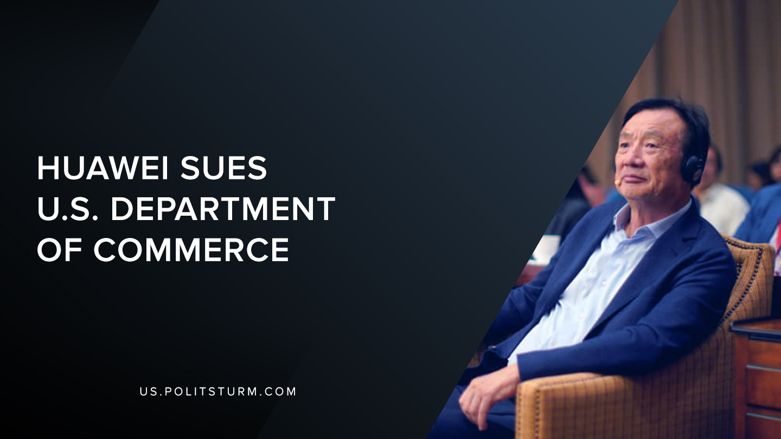

Original article
2019-07-11
2 min read

Huawei Technologies Co., Ltd. (Huawei) was recently been added to the U.S. Export Administration Regulations (EAR) entity list, a move that would place additional restrictions on Huawei exports. 68 non-US affiliates of Huawei were also added to the entity list. The stated reasoning behind the Bureau of Industry and Security ruling was that Huawei “has been involved in activities contrary to the national security or foreign policy interests of the United States”.
Huawei executive Ren Zhengfei expects that overseas cellphone sales will drop by 40% and has reduced revenue forecasts because of the move. The company also expects to face technical challenges in finding alternative component vendors for its products but has taken steps to develop its own software and hardware solutions.
The latest development in the trade war between U.S Department of Commerce and Huawei surrounds a civil suit about the seizure of Huawei equipment. Telecommunication equipment was shipped from China to an independent laboratory in California for certification testing. At the time, no license was required to ship equipment from the U.S to China for Chinese-origin equipment of this type. Nevertheless, the equipment was seized and detained in Anchorage, Alaska.
Huawei is suing the U.S State Department of Commerce because at the time of the equipment seizure, a license was not required yet the U.S has not responded to Huawei’s request for a response and a subsequent release of the equipment. Typically, the Bureau of Industry and Security says this process takes around 45 days for such a response, but this request has been outstanding for over 20 months.
The intensification of the trade war and competition between the Untied States and China is evident in the recent actions taken against Huawei. As Huawei develops into a leader in telecommunications and technology, the U.S. has taken strong protectionist measures to slow down or impede Huawei’s development with any tools at its disposal. However, as international competition between countries and firms intensifies the workers in both the U.S., China, and all over the world have a common adversary which stands independent of national boundaries, the global capitalist class, who exploits the global working class.
https://www.federalregister.gov/documents/2019/05/21/2019-10616/addition-of-entities-to-the-entity-list
https://www.courtlistener.com/recap/gov.uscourts.dcd.208536/gov.uscourts.dcd.208536.1.0.pdf
https://www.japantimes.co.jp/news/2019/06/18/business/corporate-business/huawei-chief-says-u-s-sanctions-will-cost-30-billion-revenue/#.XR-S9etKjcs

Original article

