How Much Could the US Spend On People Instead Of Bombing Iran?
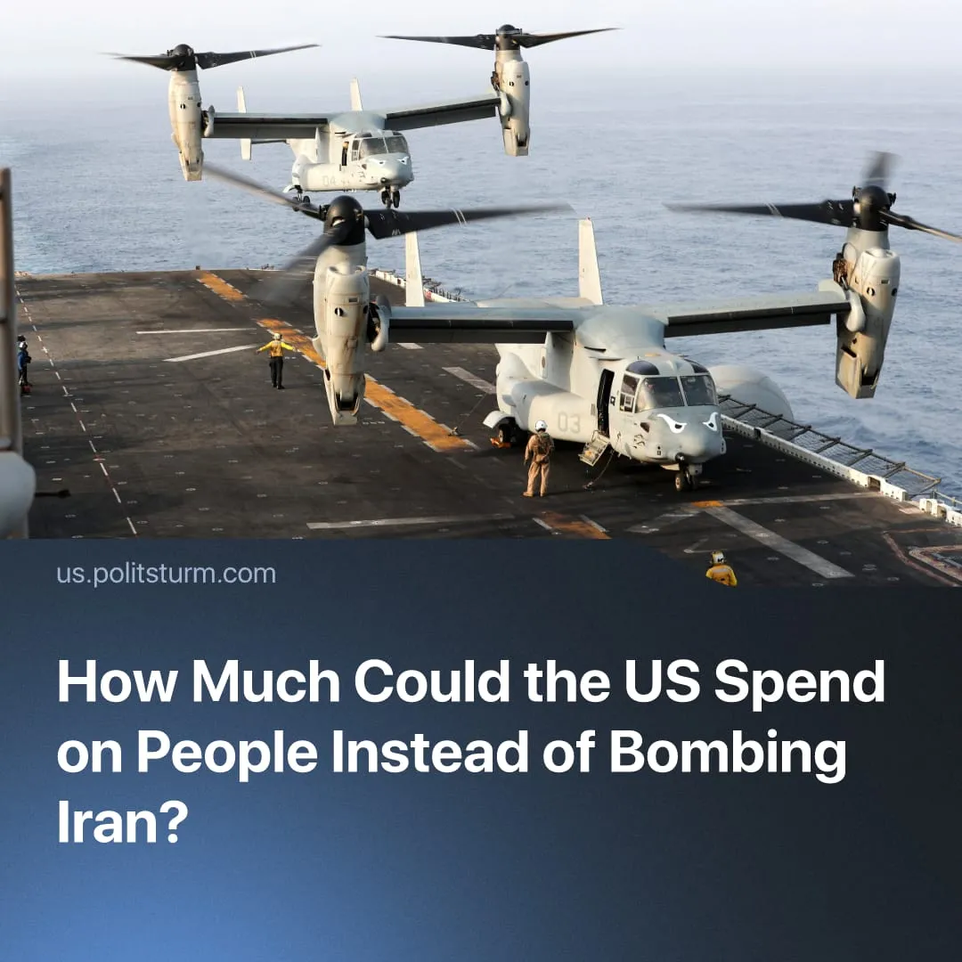

Original article
2026-03-14
1 min read

$6 billion spent bombing Iran in the first week enriches monopolies, while Americans struggle to afford their basic needs.
Details. In just the first week of US strikes on Iran, the Pentagon spent roughly $6 billion on some of America’s most advanced weapons.
► These costs massively boost the profits of monopolies. The same sum could provide annual lunches for ~10 million food-insecure children or fund a year of preschool education, healthcare and nutrition for ~400,000 children. Additionally, ~375,000 low-income households could receive rental assistance for a year.
Context. Americans are currently facing a cost-of-living crisis, with 52% reporting they struggle to afford necessities and bills. Oil and food prices are likely to continue rising amid the closure of the Strait of Hormuz, a key oil transit route affected by the US–Iran conflict. Yet as prices climb, Trump said the US would “make a lot of money.”
► In 2025, the Trump administration passed a budget that cuts the social sphere and increases military spending to $1.01 trillion. American capitalists have made rapid use of this spending in 2026; the invasion of Iran is the second foreign invasion in less than three months, despite Trump’s promises of “world peace”.

Original article

