How Europe Is Turning Right: 2024 European Parliament Election
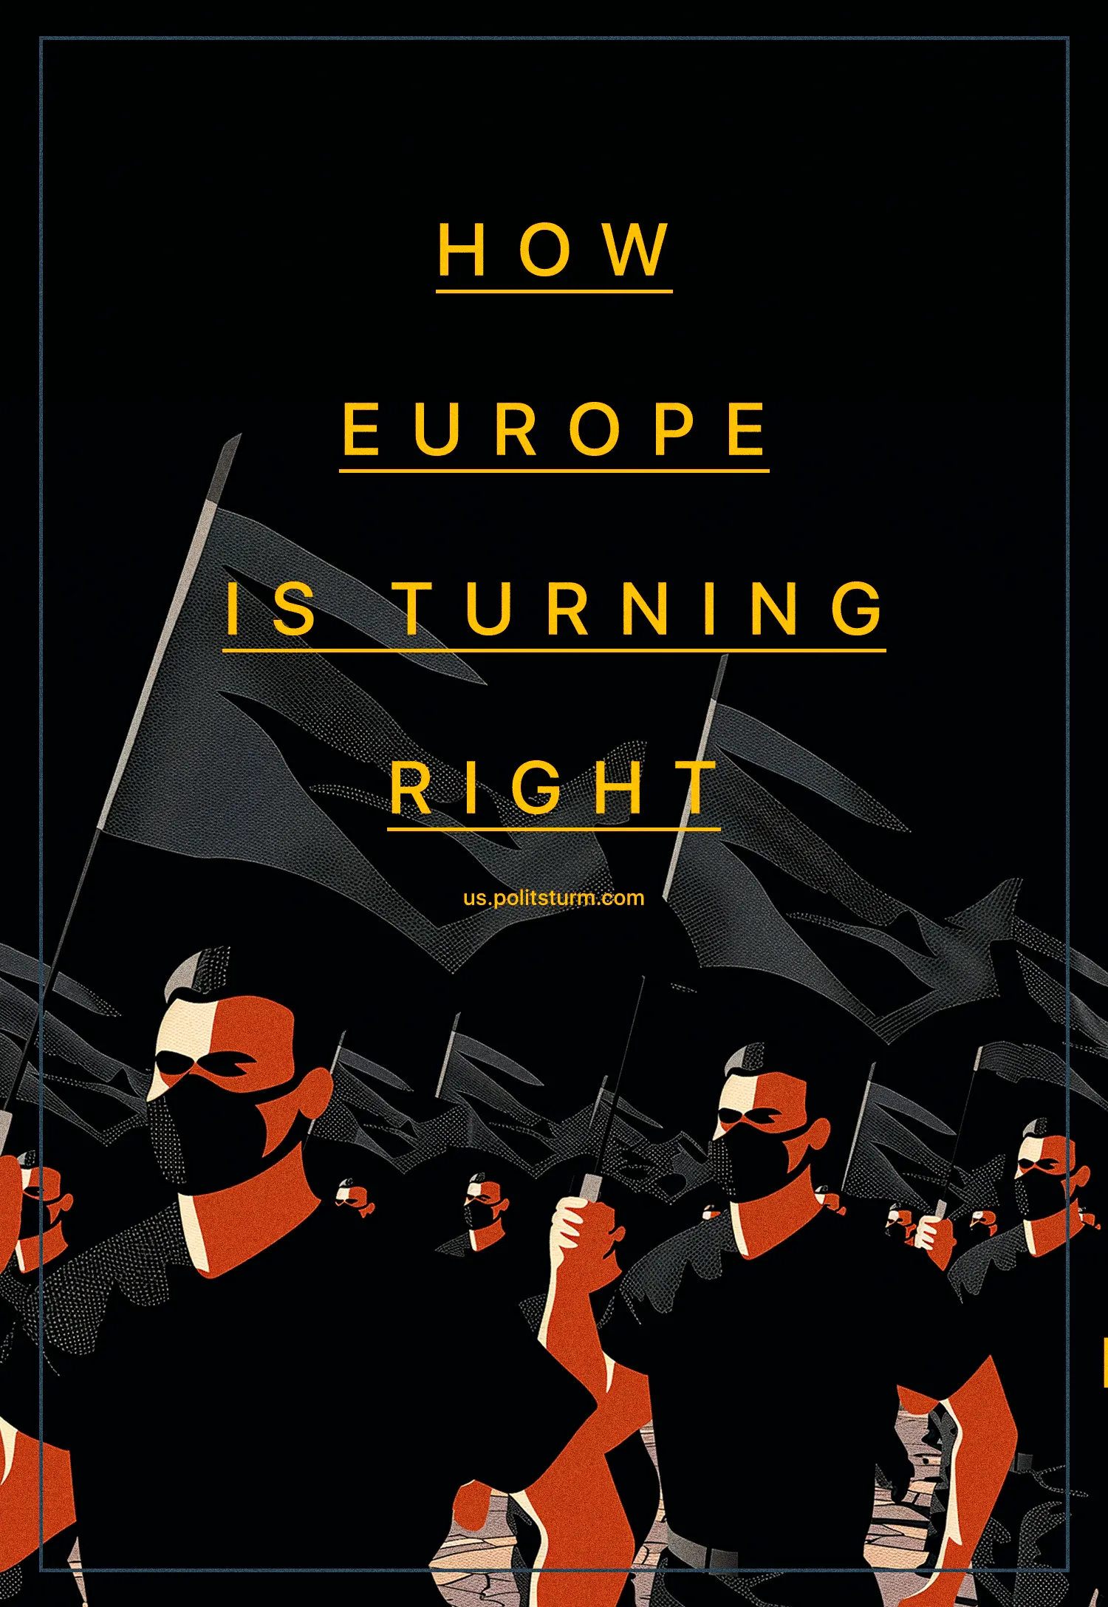

Original article
2024-07-08
31 min read

From the 6th to the 9th of June, an estimated 375 million people were eligible to vote in the 2024 EU parliamentary elections. The elections were marked by the far-right, populists and demagogues of all sorts making gains. What is the real significance of these elections and do ordinary people have an actual say in how things are run across Europe?
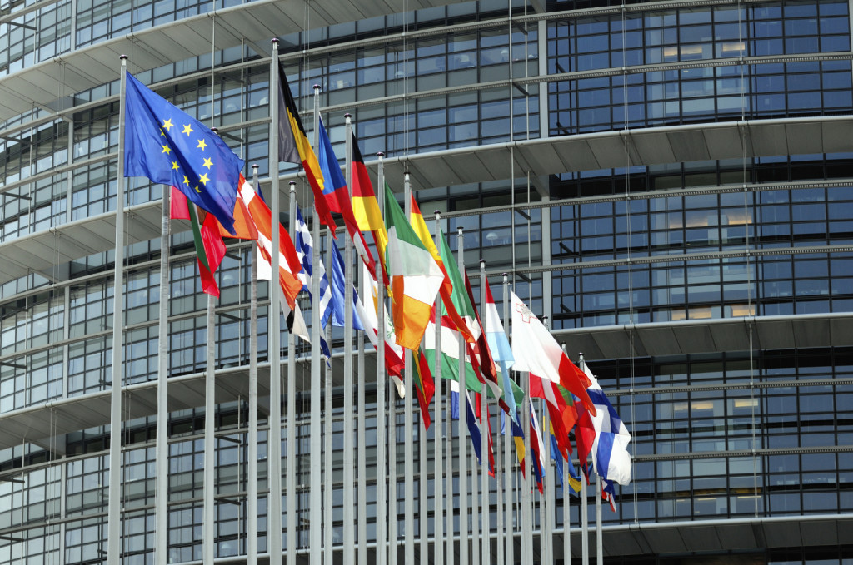

1. What is their significance?
The EU Parliament elections occur every 5 years. To address their importance and understand, why the parties of EU countries struggle to win seats here, it is necessary to outline the role and function of the EU Parliament.
Like most parliaments worldwide, it is a legislative assembly that votes upon and passes laws. The European Commission proposes laws, which the EU Parliament and Council of the EU then debate, amend and then approve. Both the EU Parliament and Council have authority over the EU budget, while the Parliament is meant to supervise and scrutinise other EU institutions, particularly the Commission.
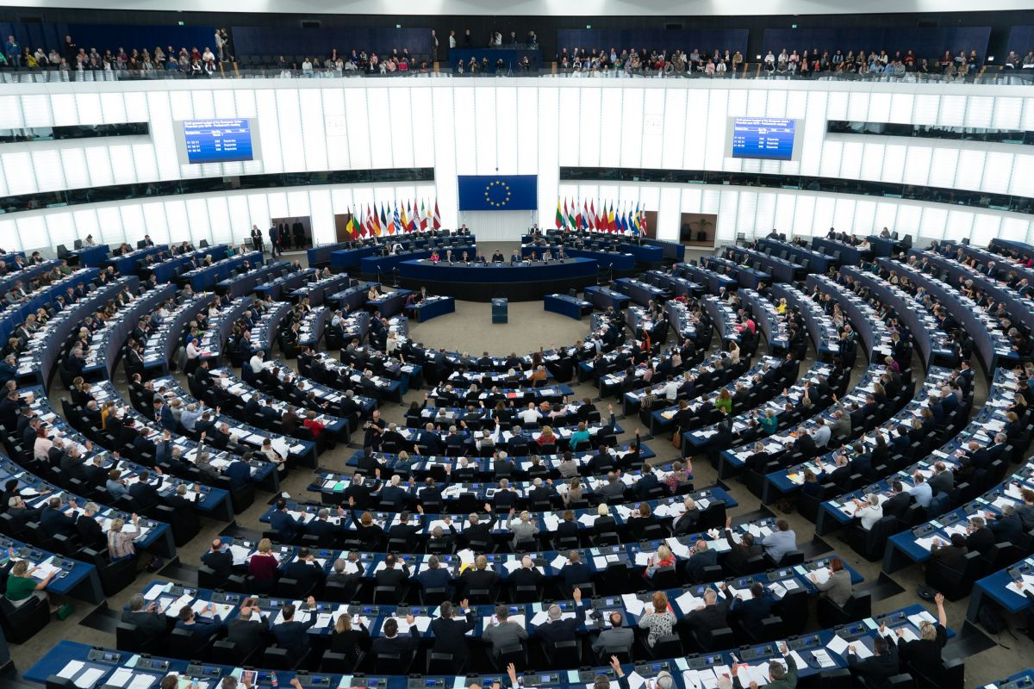
Once a law is passed by the EU Parliament and Council, then they are enforced by the Commission, ensuring each EU member state implements the law properly. Crucially, EU law generally takes precedence over an EU member state’s national law. In fact, this was a big point of contention during Brexit, where the EU was seen as subverting the national sovereignty of the United Kingdom. If the EU member state fails to comply with EU law, then the Commission can take legal action against it with the Count of Justice of the European Union (CJEU).
Its elected representatives come from every EU member state according to the principle of degressive proportionality. This means that the number of seats each EU state has is roughly proportionate to its relative population size. Each of the 720 seats roughly corresponds to 500,000 people each [1].
As it is a multi-national pluralistic assembly, it needs a framework to unite the disparate parties of each country into blocs espousing a common manifesto and vision. These blocs are called European political parties, or Euro-Parties. As of 2024, there are 10 such Euro-Parties, representing different political currents, from far-right to social-democrats. There are many other elected Members of the European Parliament (MEPs) who are independent or part of national parties that haven’t joined any of these associations.
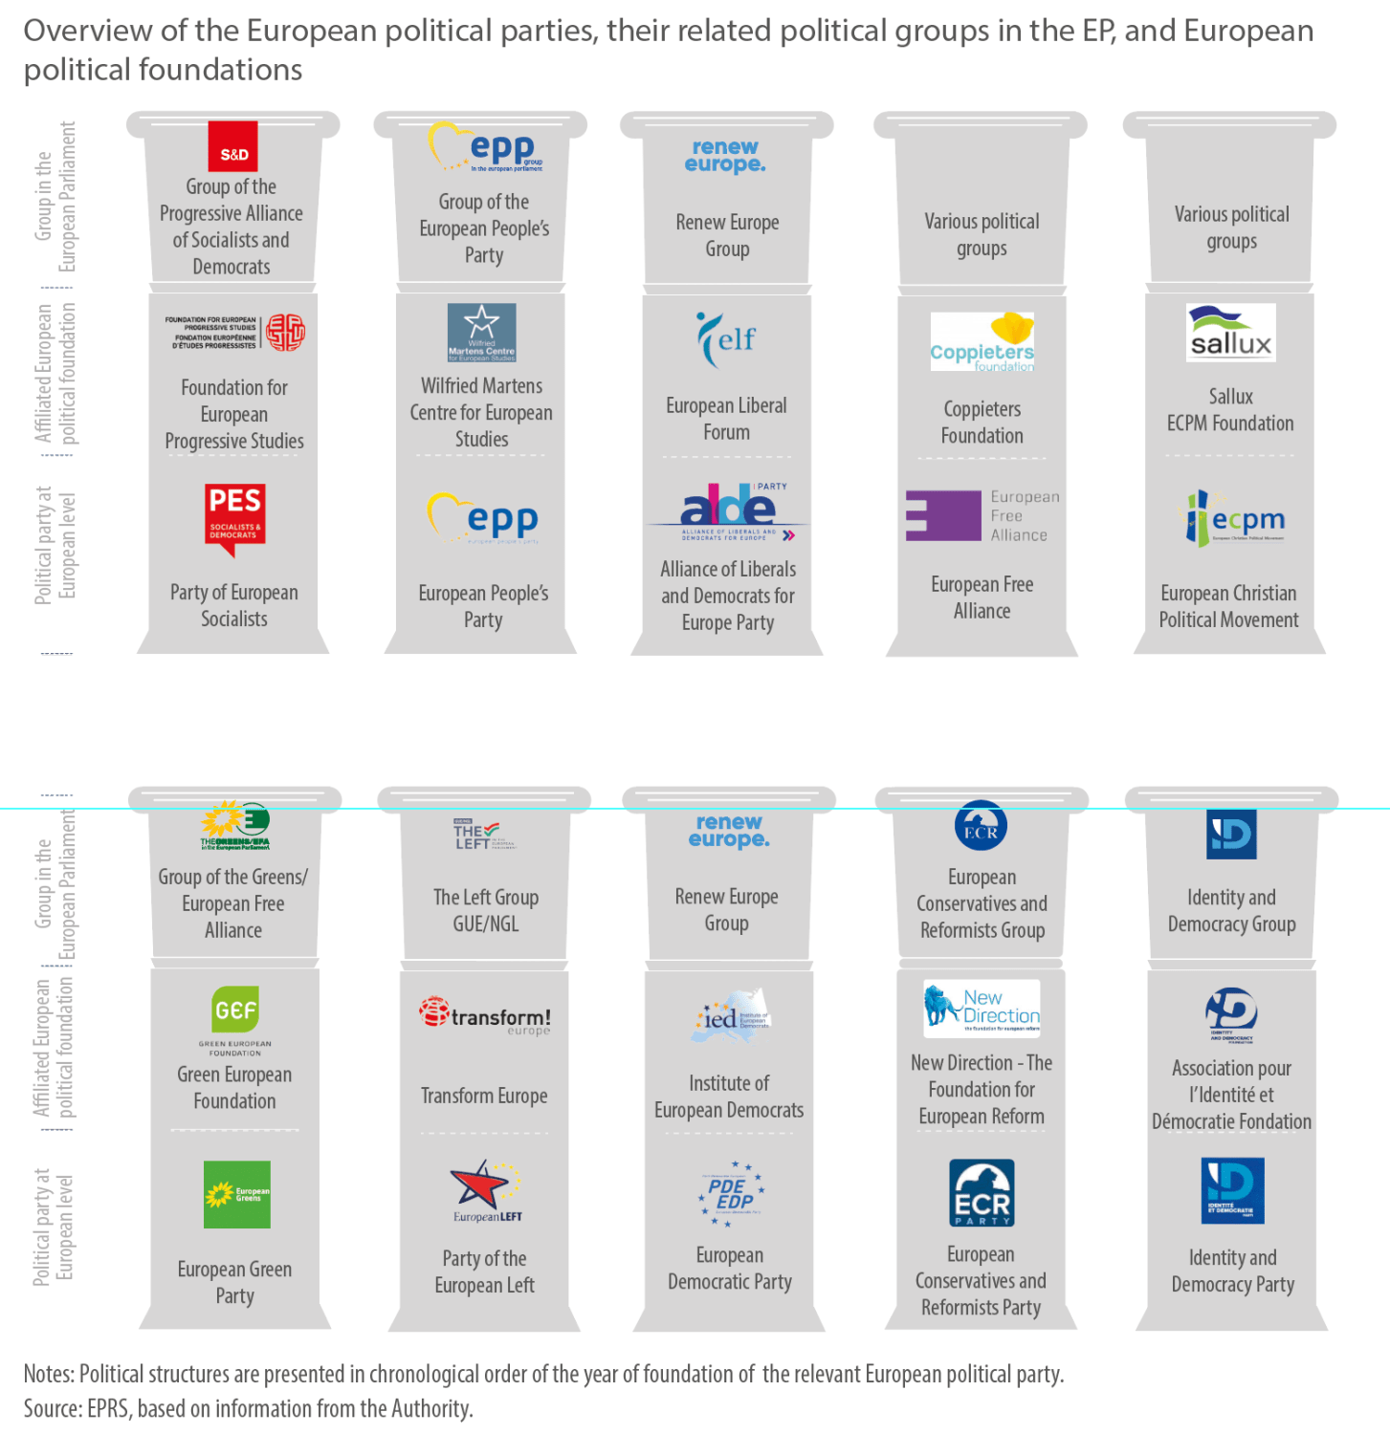
Besides political influence, funding is of particular interest for organisations seeking to be elected to the EU Parliament. MEPs earn €8,020.53 per month from the EU budget, as well as a daily subsistence (for rent, transport, food) allowance of up to €304, and a monthly general expenditure (for purchase of equipment) allowance of up to €4,299 as well as a travel allowance (for flights) of up to €2,400 per month [2]. In total that is around a maximum of €19,586 per month that an MEP gets from EU funding. Checks from the EU Parliament’s administration are virtually non-existent, so it is very possible that an MEP can pocket these funds or contribute them as funding to their party.
In addition, each Euro-Party receives funding from the EU budget. The total annual budget is €54 million. Out of the total, 10% is distributed equally between the parties, and 90% is distributed proportionally to the number of MEPs each party has [3].
As a result, there is a great incentive for parties to get elected into the Euro-parliament. The chance to influence the policies of the European Union, but also big money attracts politicians from EU countries.

2. What is the situation in Europe in the background of the elections?
Before moving to the results, we need to look at the current situation in the European Union and understand what impact it made on the recent elections.
The economy is one of the main problematic places. The capitalist-owned media calls the current situation in the European economy a recession or a state threateningly close to recession. This word was taken out of the dictionary for one purpose only, namely not to use the word crisis. Because recognising the crisis will only exacerbate an already dire situation by encouraging speculators to pull funds away from investments.
On one hand, inflation in Europe continues to decline steadily from 10.6% in 2022 to the current 2.6%. At the same time, the main blow of inflation fell on the energy sector, where it rose as high as 41.5% [4] which eventually led to the limitation of all goods and services. This recession is not because the economy has miraculously “recovered”, but largely due to, among other factors, the increase in the prime lending rate. This rate, which was lowered for the first time since 2019 only on June 6 to 4.25% [5], means banks now receive money at higher costs. As a result, they raise interest rates on loans, making borrowing more expensive for citizens and businesses. This, in turn, negatively impacts the living standards of workers from both sides.
Under such conditions, capitalists find it unprofitable to meet the needs of the masses they exploit. Europe’s workers are also quite well educated and with it an awareness of their rights and economic interests, such as wage increases in response to rising costs of living.
At the same time, Europe’s population is ageing and it is becoming increasingly difficult to maintain the same standard of living for the majority of the population within the framework of capitalism. As there are fewer and fewer people of working age, there are less and less people really creating the social wealth from which, some of it can be used to support a disproportionately growing number of pensioners. And capitalism is not about charity, capitalists can never just give away their money, especially for the existence of pensioners who are no longer working, as then they will be outcompeted and ruined by their more unscrupulous and ruthless competitors. We have previously written about the decline of the EU population.
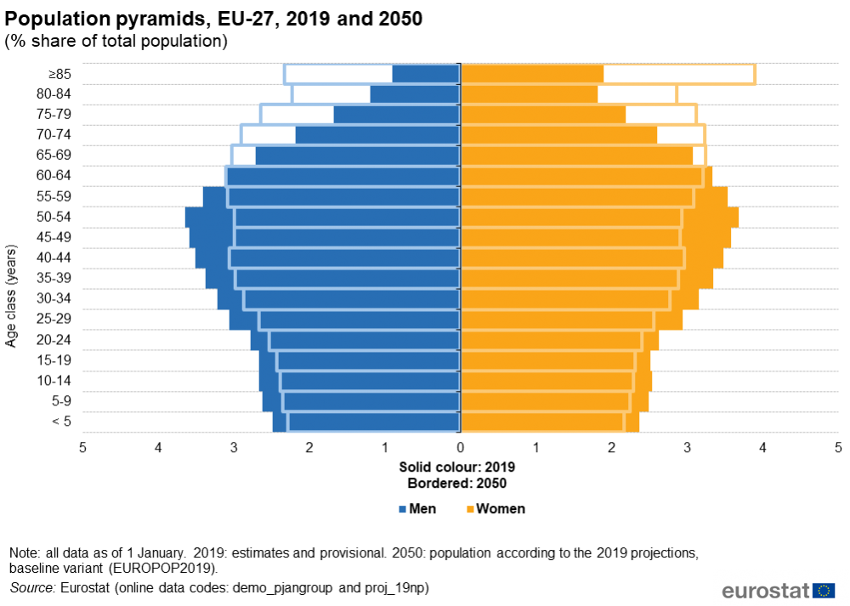
The ruling class tries to cope with this issue, to no avail. Pension reform has been carried out in France (in connection with which there were mass protests that ended without success), Greece (against the background of the deepest economic crisis) and Belgium. The bourgeoisie wants to and certainly will follow these examples in the rest of Europe.
In order to deal with this situation, European capitalists use migrants. The already large influx of migrants (cheap and often disenfranchised labour) has intensified in Europe [6]. The importation of young and able-bodied people, according to the Committee on Migration, Refugees and Displaced Persons of the EU Parliament [7], can solve the situation.
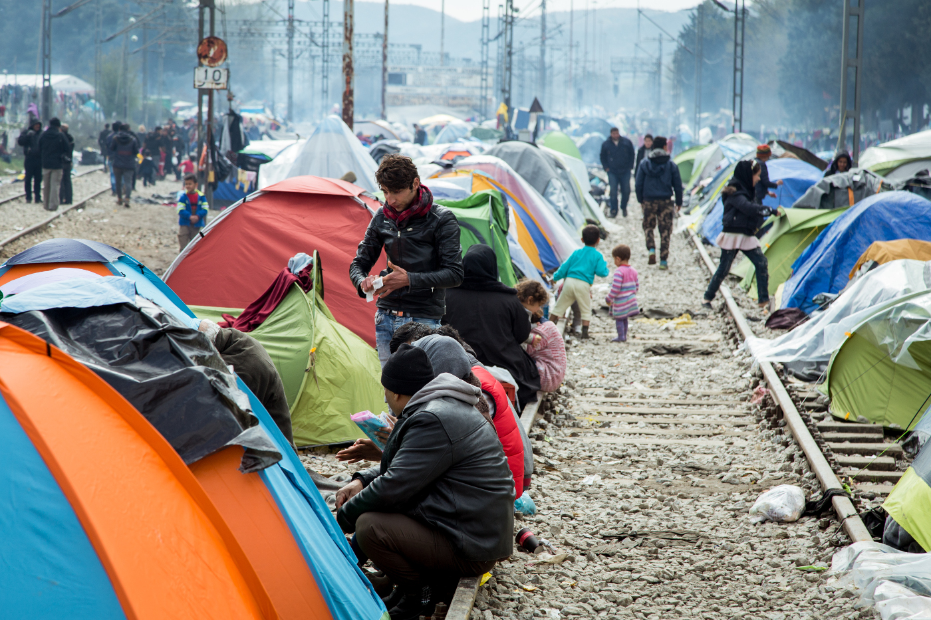
Such migrants and refugees (often fleeing war, poverty and often imperialist dependency that can be traced back to an EU member state), are normally especially poor and unfamiliar with whatever the local language and culture are, making them vulnerable to the most predatory capitalists as well as lumpen elements within illegal industry to exploit as modern slave labour.
The European bourgeoisie benefits from a lack of integration between the native European workers and the migrants. They promote chauvinism amongst Europeans towards immigrants, at the same time as trying to push immigrants towards religious extremism (many of them are Muslims) and chauvinism of their own to cope with their worse conditions.
Lofty words about “human rights” and a “humanitarian crisis” in capitalist mass media are used to hide this simple truth: the EU needs a cheap migrant workforce. In this context, we can see why the European Union endorsed and promoted “multiculturalism” policies. It used any means at its disposal in order not to integrate migrants into European society but to keep them alienated, and hostile to the social environment. It makes it easier for capitalists to split the workers’ movement, alienate migrant workers from Europeans and, at the same time, allow them to cut benefits for the latter by large use of cheap labour.
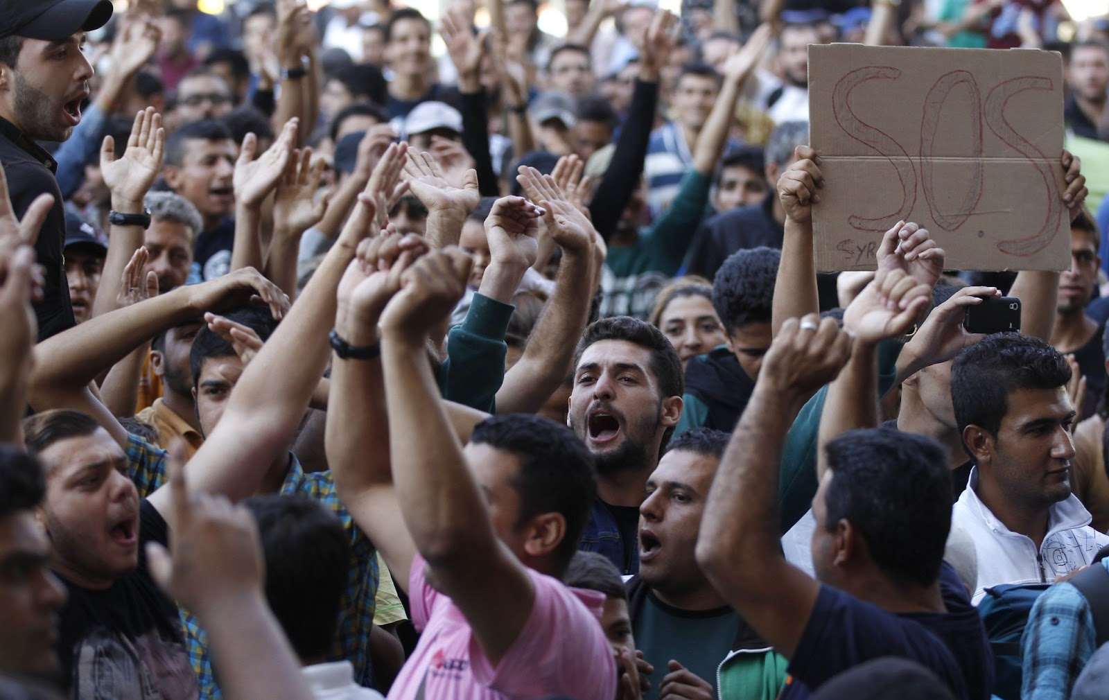
But it’s not only migrants. Social inequality grows in general. Despite different statements about the “welfare state”, the rich are getting richer and the poor are getting poorer even faster in Europe. In 1995, the richest top 1% of people in the EU had 22% of the wealth and now have 26% [8]. Now, the wealthiest 10% of Europe own 67% of the total social wealth, while the poorest 50% own only 1.2% of it [9].
And at the same time, the export of capital intensified, some enterprises were transferred to the U.S. for tax benefits, and some were exported to less developed countries to exploit labour at a cheaper price. Thus about $300 billion is flowing out of Europe every year [10].
The EU government, while paying lip service to being popular and “democratically” (in the liberal sense) elected, is doing little to nothing to help the mass of working people. Since 2021, the EU has spent about $800 billion to help companies deal with the energy crisis [11]. At the same time, people must content themselves with a sharp increase in prices for electricity and heating, social advertising about the need to turn off lights everywhere and live at freezing indoor temperatures during the winter.
Due to the EU Parliament’s unprecedented generosity, and no small amount of price gouging, companies achieved records profit and were able to give good reports to investors in order to attract even more money.
The current situation in Europe is also characterised by the increased fascisation. The scapegoating of migrants is part of this, but in attention, the liberal-democratic authorities are continuously eroding the bourgeois-democratic rights that they supposedly champion. Increased police brutality and intolerance of protests (made very visible in France last year) [12] and restrictions on the right to organise collectively and the right to strike [13].
In addition, one function of the government that, unlike the gutted welfare programmes, is continuously growing is the military. European military spending has been increasing for the past 8 years [14], as the world gears up for another imperialist war.
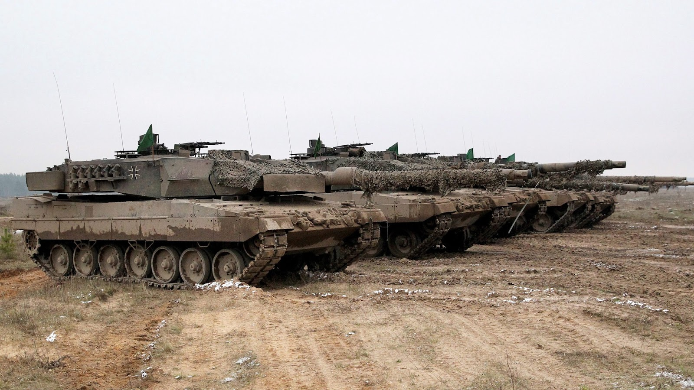
And in conjunction with this, comes the rise of chauvinist hysteria. Not only in the aforementioned nationalist and anti-Islam sentiment directed against migrants but also against competing imperialist blocs. Russophobia is on the rise in Europe, with incidents ranging from cancelling courses on Dostoevsky due to his nationality [15], attacks on Russian immigrants in Europe [16], Russian athletes banned from sports competitions [17], to clamping down on Russian residents and expelling thousands in the Baltic states [18].
These causes, combined with the growing impoverishment of workers and the decline of the “welfare state” across Europe have led to the end of a relatively long period of stability in Europe. Now most working people look to the future with dread, knowing that the welfare programmes that remain are not enough for one to afford the necessities for life. They are left puzzled and confused at how things have gotten so bad, so quickly (and are continuing to decline). In the absence of a united perspective, they are susceptible to the simplistic explanations and reactionary solutions offered by the far-right.
All this together, leads to a natural sentiment of the masses to resist their growing impoverishment. We are witnessing a rather strong trend across Europe of growing labour consciousness. Unions are increasingly organising strikes as employers refuse to provide the working conditions they want and want to preserve their profits. We have seen the phenomenon of European-wide farmer protests (as we have written about earlier), which were caused by a number of reasons, crucially including falling profits and lower subsidies for farmers from the EU budget.
So, the background of these elections can be described by one word – crisis. Economic crisis, migration crisis, worsening living standards, loss of stability and faith in tomorrow; chauvinism and militarisation characterise modern Europe.

3. Analysis of the results of the elections to the European Parliament
Having understood the causes, let us now look at their consequences. Elections in Europe have shown a significant increase in the popularity of right-wing parties. This has already led to the dissolution of parliament in France – basically the second-strongest EU country – and the removal of the Belgian Prime Minister. In addition, turnout has increased to 51.08% [19].
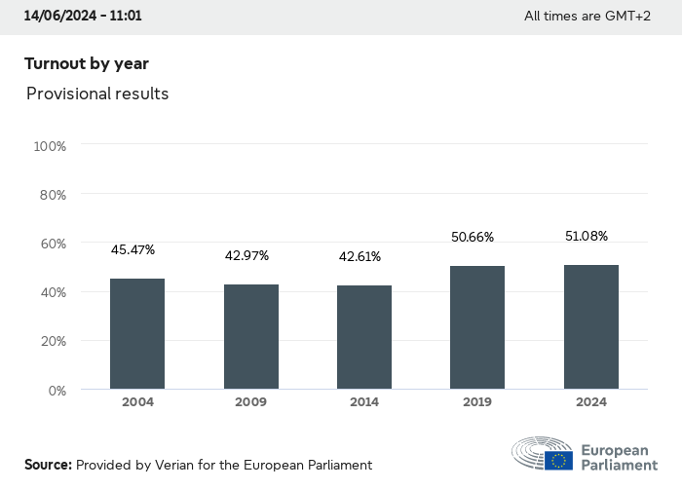
In France, Austria and Italy, right-wing parties came first, and in Germany, they overtook parties from the ruling coalition. As a result, the two most right-wing Euro-parties – “European Conservatives and Reformists” (ECR) and “Identity and Democracy” (ID) - will have a combined total of 131 seats. If they had formed a coalition, they would have become the third force in the European Parliament: centre-left coalition called “The Progressive Alliance of Socialists and Democrats” (S&D) remained the second largest with 137 seats. According to preliminary results, they lost two seats from the “Social Democratic Party of Germany” (SPD), to which German Chancellor Olaf Scholz belongs. This year’s EU election was the worst result in SPD history (about 14% of the vote) [20].
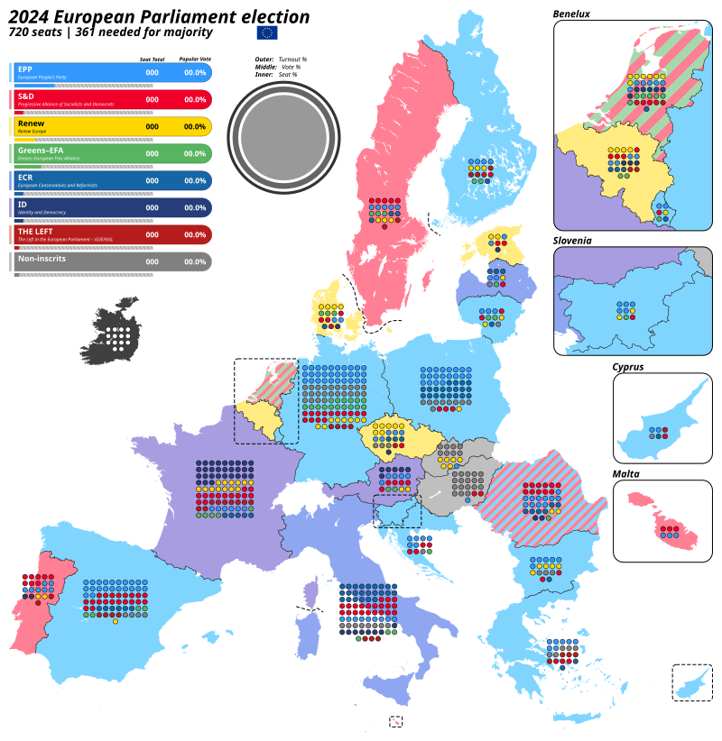

France
In the last French elections, the far-right “Rassemblement Nationale” (RN) (formerly known as the “National Front”) party won with 31.5% of the vote. This result is almost double that of the “Besoin d’Europe” coalition (14.5%), which is backed by President Macron’s “Renaissance” party. The RN’s support grew by 8% compared to 2019, allowing it to increase the number of seats in the European Parliament it has from 22 to 30. The RN has been led by Marine Le Pen for a long time. She contested the presidential elections several times and was the runner-up in the 2018 and 2022 presidential elections in France.
The coalition “La France fière” (“Proud France”), which unites the far-right party “Revenge” (formed by “National Front” renegades, dissatisfied with the moderating course of the RN) and the “National Center for Independents and Peasants” (CNIP) party, also significantly strengthened its position. It won 5.5% of the vote and will take five seats in the European Parliament as part of the “European Conservatives and Reformists” (ECR) Euro-party. France’s section of the “European People’s Party” (EPP) was joined by the “Republicans” (LR) with 7.2% [20].
Due to the dissolution of parliament and the success of the right in the elections, a so-called ‘popular front’ was formed in France. This is an attempt by the “left” to somehow counter the right by using the name of the pre-WW2 popular front.
This coalition includes the Socialists (i.e. social-democrats), Greens (another kind of social-democrats), opportunist Eurocommunists from PCF and the broad-left coalition “La France Insoumise”, based around the personality of Jean-Luc Mélenchon.
“We call for the creation of a new popular front, bringing together in a new form all humanist, trade union, associative and civic forces of the left spectrum. We seek to promote a program of social and environmental transformation to create an alternative to Emmanuel Macron and fight the racist project of the extreme right” - said Manuel Bompard from LFI [21].
As was said above, this ‘popular front’ has nothing in common with an actual popular front and is only used as a populist slogan to get votes for social democrats.
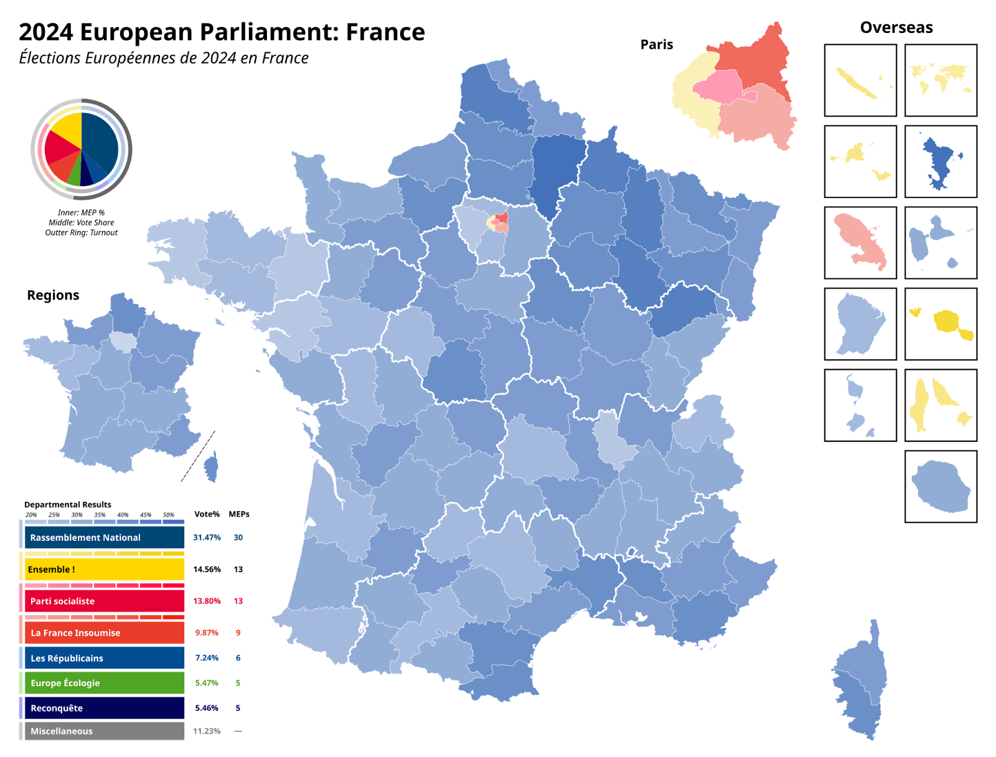

Germany
In Germany, the right-wing “Alternative for Germany” (AfD) party significantly strengthened its position with 15.6% of the vote, 5.5 percentage points higher than in the previous election. Despite a series of scandals related to its representatives (some of which relate to their attempts to exonerate the Nazi Waffen-SS) [22], AfD was ahead of all parties from the ruling coalition: the “Social Democratic Party of Germany” (SPD) with 14.1%, the “Union 90/Green Party” with 12% and the “Free Democratic Party” (FDP) with 5.3%. However, it lost significantly to the conservative alliance of the “Christian Democratic Union” and “Christian Social Union” (CDU/CSU), which won 30% of the vote [20].
Of the 96 seats reserved for German representatives in the European Parliament, the CDU/CSU will win 29 seats, the AfD will get 15, 12 for the SPD, 16 for the Greens and the FDP will get 5.
In May 2024, “Alternative for Germany” was excluded from the “Identity and Democracy” (ID) Euro-party (over some of its candidates' apologia for the Nazi SS) [23], despite a potential opportunity (combined with France’s “Rassemblement Nationale”) to increase its representation by nearly 20 seats. Following its success in the June 9 election, the AfD advocated early elections in Germany itself, similar to France. However, the federal government said on June 10 that no such initiative was being considered.
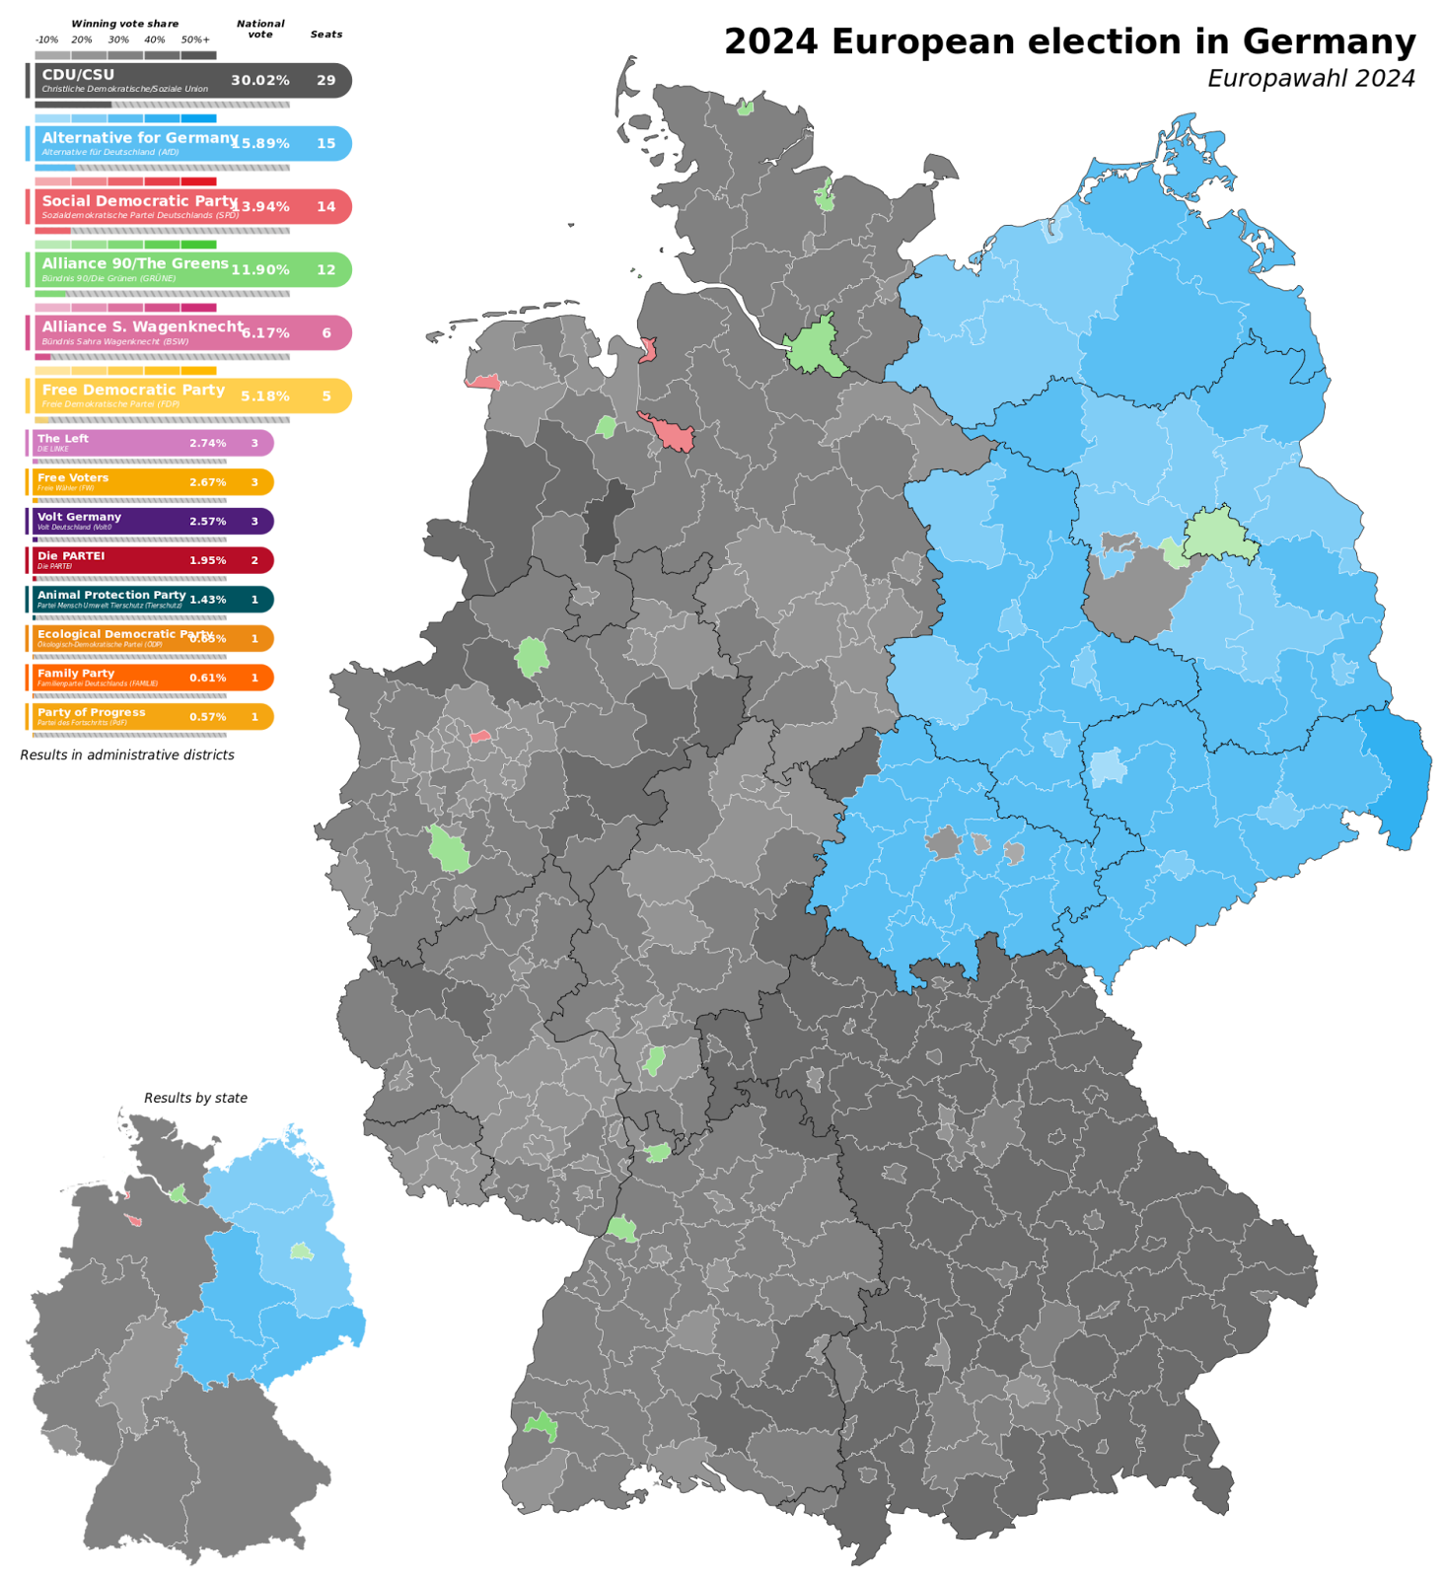

Spain
The recent European elections in Spain, similar to Germany, were won by the conservatives who went into opposition, representing the EPP Euro-party. The “Popular Party” (PP) received around 34.18% of the vote (compared to 20.35% in 2019), surpassing Prime Minister Pedro Sanchez’s ruling party, the “Spanish Socialist Workers’ Party” (PSOE), which garnered around 30.19% (down from 33.18% in 2019). The right-wing “VOX party”, the so-called “moderate Eurosceptics”, which is part of the ECR Euro-party, won 9.62% of the vote, increasing its representation in the European Parliament from three to six seats. In 2024, Spain also saw the emergence of a new far-right populist and conspiracy theorist party, the “Holiday is Over” (SALF), which won 4.58% of the vote and will win three seats in the European Parliament.
Thus, of the total number of seats (61) for Spanish deputies, supporters of right-wing and far-right parties will occupy nine [20].
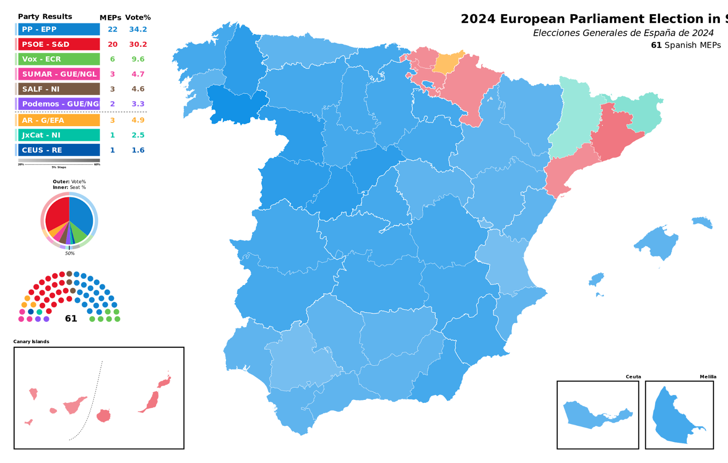

Italy
In Italy, the right-wing “Brothers of Italy” party, led by Prime Minister Giorgi Meloni, won with about 28.59% of the vote (up from 6.44% in 2019). Brothers of Italy has direct connections to neo-fascists: the party leadership and its symbol, the flame in the colours of the Italian flag, were transferred from the “National Alliance” party (1995-2009), and this party was a direct successor of the “Italian Social Movement”, created after WW2 by remnants of Italian fascists. They have already become infamous for sympathising with Mussolini and performing the Roman salute (the raising of hands to the sun - a fascist symbol). The results significantly increased the party’s representation in the ECR caucus by 19 seats.
Other right-wing parties showed declining results compared to previous elections. For example, the “League for Salvini Prime Minister” (LN), belonging to the Identity and Democracy Euro-party, worsened its result by about 25%. The populist “Five Star Movement” (M5S) received 9.66% of the vote, down from 17.06% five years ago. The right-wing “Forward Italy” (FI) party, founded by Silvio Berlusconi, got 8.8% of the vote, but it is part of the conservative EPP Euro-party in the European Parliament [20].

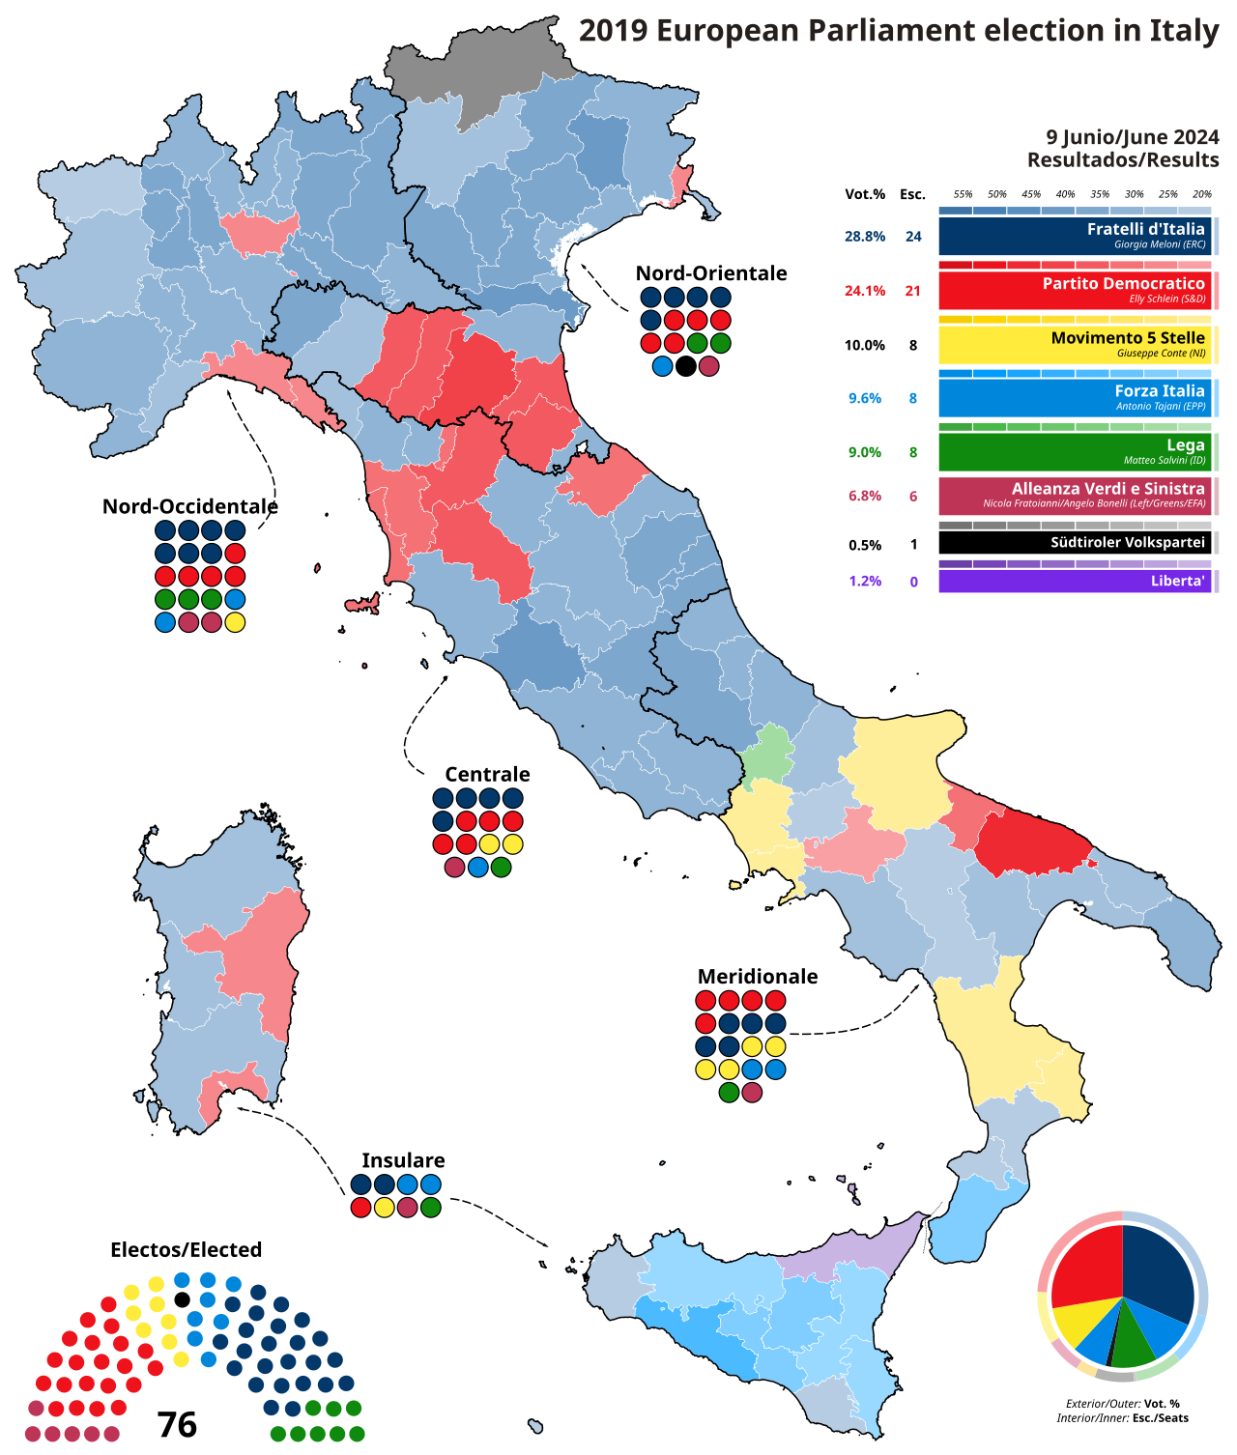

Poland
In Poland, the latest European elections were won by the “Civic Coalition” (KO), the party of Prime Minister Donald Tusk, who promised to put the country back on the European path after a decade of rule by the right-wing “Law and Justice” (PiS) party. KO, belonging to the European People’s Party, received about 37.4% of the vote, which corresponds to about 18 seats in the European Parliament. Another 7.3% of the vote (about two seats) went to the “Third Way Alliance”, which is also part of the ruling coalition in the republic [20].
PiS, a party belonging to the ECR Euro-party, received almost equal results with KO and won about 20 seats in the European Parliament. The far-right Polish Confederation also managed to enter the EP, winning six seats out of 53 reserved for Polish lawmakers.
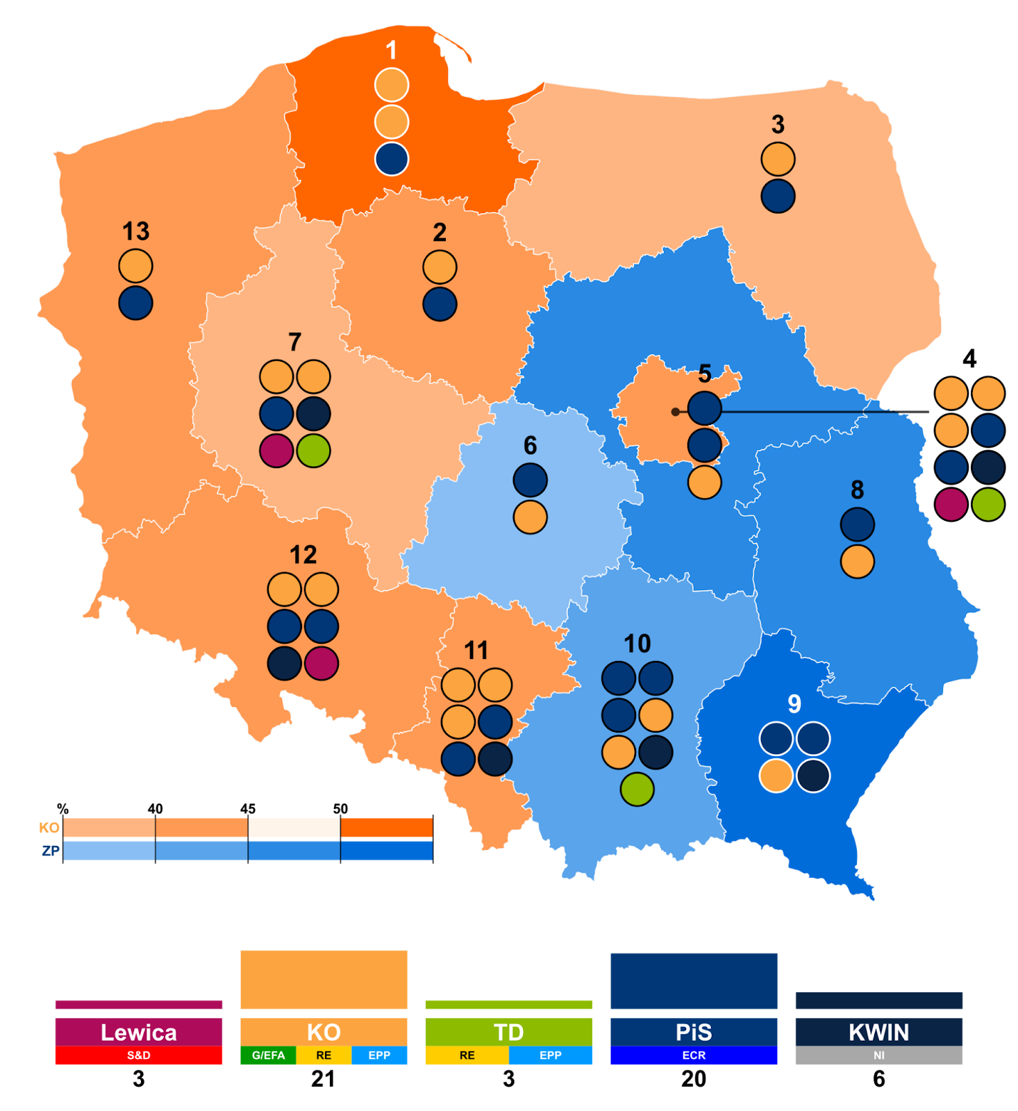

Greece
In the European elections of June 2024, Greece saw a significant rise in support for various political parties on the far right.
Support for the main Greek parties is declining, with the ruling right-wing “New Democracy” party winning 28.31% of the vote and 7 seats (down from 33.12% and 8 seats in 2019). Social-democratic “SYRIZA” party won 14.92% of the vote and 4 seats, down from 23.75% and 6 seats. The other social democratic party, “PASOK” increased its vote to 12.79% (3 seats), up from 7.72% (2 seats) in 2019.
The far-right religious party “Niki” gathered a percentage of 4.42% and elected an MEP to the European Parliament. Similarly, the far-right party “The Voice of Reason” party received 3.04% of the vote, electing its President. This party supports the “European Conservatives and Reformists” Euro-Party, aligning with other conservative Euro-party across Europe. The “Greek Solution” party, another far-right party, saw an increase in support, winning 2 seats (up from one in 2019) with 9.3% of the vote.
On the left, the Communist Party of Greece (KKE), the only ‘Marxist-Leninist pole’ party of IMCWP to get in the EU Parliament, recorded a rise, receiving 9.25% of the vote and 368,000 votes. This is an increase compared to the 2019 European elections (5.35%). However, in real terms, the increase from 2019 is only a little more than 60,000 votes and did not result in any new KKE MEPs [24].
And yet, despite its modest electoral success, the far-right “Greek Solution” still managed to surpass KKE in the vote. In general, we can see that way more votes went to the far-right parties compared to the previous elections, and this poses a big question regarding the tactics of the communists.

Summarising the election results
The Liberals and the Greens lost the most seats in the election results. This happened to the Liberals because in general they have never taken into account the demands of the masses and are direct appointees of big business. They only pursue goals favourable to the capitalists, masking them with fairy tales and false promises about how their policies are beneficial to all.
The Greens naturally lost all the attention in their favour during the 2019 elections, when the green agenda was fashionable together with increased activity by eco-activists. Against the background of the current crisis, worsening living standards, the so-called “Special Military Operation” in Ukraine, and the farmer protests, the working people of Europe have become less interested in the measures proposed for taking care of the planet as proposed by the Greens and the EU as a whole.
In fact, these measures normally amounted to market-based incentives to draw investment to “sustainable” spheres or promote individualist lifestylist changes, and their purpose was really to protect the profit of the capitalists, using ineffective half-measures to protect nature at the expense of workers. And often not even that, as the Greens in the German coalition government preside over the closure of nuclear power plants [25] in favour of the reopening of coal plants [26].
The masses became disillusioned with the current liberal centrist government and are no longer willing to go along with the eloquent orators and meaningless and insincere promises of a better life from the politicians in the ruling parties. This disillusionment across Europe has been best exploited by the right wing. They’re pulling out their two favourite “solutions” to absolutely every problem:
- Reduce taxes
- “Solve” the migrant problem
However, like every other time they’ve been tried, these “solutions” will not help the working masses.
The tax cuts are solely in the interests of the capitalists who want to gut all welfare functions of the government, as they see them as money that could be going into their pockets instead.
Regarding decreasing taxes (and similarly the collapse of the “welfare state”), we have already demonstrated above that this trend is worldwide and has only intensified with the collapse of the USSR. The populace is generally in favour of more taxes on the rich, but even such lukewarm social-democratic policies are almost nowhere to be seen implemented anymore.
Billionaires and multi-millionaires can simply emigrate from the countries together with their capital, in case of such measures. While even if they did stay, the causes that drive the increasing destitution of workers, crises, wars, homelessness and inflation remain – the “welfare state” was never intended to solve these issues and indeed it never did entirely. It was intended to temporarily content the workers’ movement with reforms to improve living conditions while maintaining the fundamental – private ownership of the means of production. So even in theory, raising taxes on the rich cannot cure the problems of capitalism.
But the proposed tax reduction is always beneficial to capitalists, because the reduction of taxes for the entire population is beneficial to the rich, seeing as they pay hundreds of thousands from millions, while ordinary workers pay thousands from tens of thousands.
Not only does the capitalist save more, but he does not depend on the level of publicly available medicine, transportation, education, etc., which is used by ordinary citizens. And if taxes are reduced, all of the above are the first things that the government will defund, and so they will inevitably lose quality or availability. We are now witnessing a similar crisis in Argentina, where they forgave the debts of the rich and cut the budget for the entire population.
On the other hand, given Europe’s ageing population, the phenomenon of migrants and their growing numbers will be basically “solved” according to the right wing by their even greater exploitation and their ever-increasing disenfranchisement.
The right-wing populists always point to migrants as the culprits for the deterioration of living standards. They say that “they agree to work for less pay and thus worsen the situation of the workers”. But in reality, as we can see, it was the capitalist who destroyed all the conditions of normal life in less developed countries or enforced relations of dependency on these countries (which forced the migrant to come to a more developed country), who also chose to hire the migrant, who also chose to fire the local workers.
These facts aren’t mentioned, obviously. This unscrupulous example of finding fault and blaming the migrants and refugees themselves for the problems that the EU is facing directly benefits the bourgeoisie. Workers are deluded into literally seeing other workers as a problem and a threat, and as a result, start fighting amongst themselves based upon nationality or race. And the same capitalist often adds fuel to the fire, through their talking heads in the government, or the media monopolies they own and through their sponsored right-wing and far-right parties.
Turnout is low at just over 50% as it generally is for liberal democracy (as we have written about previously), however for these elections, it has risen two years in a row. It is reasonable to assume that the reason for half the electorate not voting is the same sentiment that no matter the result of these elections, nothing fundamental will change.
No matter who is elected and no matter what they promise, the most important things to the working people remain the same (i.e., the rising cost of living, crumbling infrastructure and social services, militarism and imperialist war).

The Communist Parties of Europe
But what about the communists? The communists are too weak and fragmented to offer a real alternative. The results show us that opportunism and the flourishing of broad leftism, of all types of revision lead not to increase in the votes, but to defeat.
Many ‘communist’ parties have embraced agendas and slogans imposed by the bourgeoisie, such as social-chauvinist support for Russia’s so-called “Special Military Operation”, or the “Axis of Resistance” and Hamas. They chose to align with particular sides in the inter-imperialist conflict and imperialist political agendas (or bury their heads in the sand) rather than maintaining a truly proletarian internationalist stance.
These opportunists essentially advocate for nothing substantially different from regular European social democracy – where perhaps especially corrupt billionaire capitalists are executed every now and then (while their right to exist as a class goes unquestioned). Their focus on trying to win seats in the EU Parliament, to the point of uniting in broad-left Euro-parties with social democrats and other eclectic leftists demonstrates an overreliance on electoral and legalistic struggle.
The aim to win parliamentary success (along with the EU funding that this grants) has resulted in the flourishing of demagoguery, bureaucracy and formalism – ensuring these parties stay aloof from the working masses they seek to represent. As a result, ironically, this strategy has also led to their parliamentary failure.
These elections only prove that the absolute majority of the current ‘communist parties’ of Europe are hindered by ideological confusion (and dilution with broad-left adventurism) and are unable to lead the working people.
Communist parties must adhere to the principles of Marxism-Leninism, rigorously educate their members, and forge deep links within the modern labour movement in order to assist it. The fact that these organisations fail to do this means that they cannot be called parties of the Leninist type.
“Unity is a great thing and a great slogan. But what the workers’ cause needs is the unity of Marxists, not unity between Marxists, and opponents and distorters of Marxism.” – V.I. Lenin, Unity
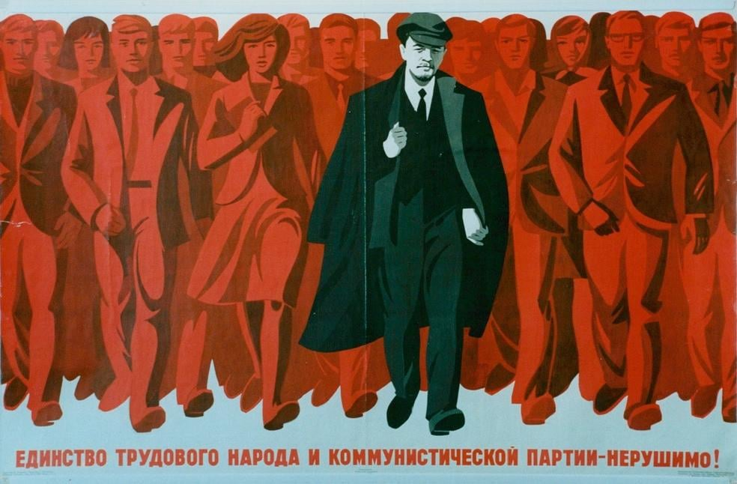
The Unity of the Working People and the Communist Party is Unbreakable!
If Communists do not fulfil their duty, and demonstrate to the workers their true interests and win them over by fighting for it, then the workers will be won over and misled by their enemies. This is demonstrated by an analysis of the vote in Germany, where a third of the voters polled (who stated their occupation as a blue-collar worker) voted for the AfD, while 24 per cent voted for the CDU/CSU [27].
Here it is, the result of the countless centrist declarations of ‘unity’ with renegades, opportunists and revisionists of all kinds. These are the results of adventurous attempts to win votes from an unclear audience by loud pro-Palestine phrases without denouncing Hamas, distancing themselves from terrorism, adventurism and intentional deaths of the civilian population. Capitalists immediately turned this half-hearted position in their favour and declared that the “Communists defend terrorists” [28], successfully getting this message across not only to the European petty-bourgeois public but to the workers as well.
Despite spontaneous resistance against the capitalists’ assault on their rights and livelihood, the workers’ movement also remains weak and fragmented. In the absence of a united class perspective, and struggle, the popularity of the right and far-right’s rhetoric about the tax burden and scapegoating of migrants and refugees is growing. And with this, comes a corresponding rise in their parliamentary representation.

4. Conclusion
In conclusion, the election results across Europe highlight a trend towards the ascendance of far-right ideologies and parties. This is especially so in the case of Macron's defeat and his announcement of parliamentary elections as well as the worse performance of all three German government parties compared to the AfD. As far-right movements gain traction, the ongoing trends that the liberals have readily fostered will grow more openly and faster: heightened European militarisation (which we have written about previously), increased fascisation and reaction, and a renewed assault of workers’ liberties and living standards by the capitalists.
Addressing these pressing challenges necessitates recognising that the European Union, conceived as a capitalist union from above, continues to reveal its true nature as an imperialist bloc. Despite its veneer of “all-European democracy”, “human rights”, and the “welfare state”, the reality of the EU echoes Lenin's assertion (in On the Slogan for a United States of Europe) that “a United States of Europe, under capitalism, is either impossible or reactionary”.
In these elections, the capitalist class retained its dominance without losing a single seat, while not a single Communist party with influence in the working class and labour unions saw an increase in its representation. Consequently, the left, often well-meaning, but thoroughly reformist in its attempts to mitigate the inherent flaws of capitalism, finds itself at an impasse. This predictable stagnation has only worsened conditions for workers, opening the door for right-wing factions that capitalise on populist rhetoric, particularly concerning migrant issues.
In the absence of genuinely communist and proletarian parties in the EU countries, the working class lacks a cohesive force to effectively counter the rise of the right-wing.
It is not enough to oppose reactionary forces with good intentions alone. The task of forming Communist parties across Europe remains, and we are involved in this work. Join us.
Sources:
[1] https://www.europarl.europa.eu/infographic/meps-seats/index_en.html
[2] https://transparency.eu/how-much-does-an-mep-make/
[3] https://eur-lex.europa.eu/EN/legal-content/summary/transparent-funding-of-european-political-parties.html
[4] https://amp.rbc.ru/rbcnews/economics/02/03/2024/65e342c29a79475cd3d6725e
[5] https://quote.rbc.ru/amp/news/666064669a7947bfbbf9bc7f
[6] https://www.interfax.ru/world/923305
[7] https://assembly.coe.int/nw/xml/XRef/Xref-XML2HTML-en.asp?fileid=23745&lang=en
[8] https://wir2022.wid.world/www-site/uploads/2023/03/D_FINAL_WIL_RIM_RAPPORT_2303.pdf
[9] https://www.euronews.com/business/2024/04/01/wealth-inequality-where-in-europe-is-wealth-most-unfairly-distributed
[10] https://amp.rbc.ru/rbcnews/economics/18/04/2024/662161659a79474d915490d4
[11] https://tass.ru/ekonomika/17034915/amp
[12] https://www.france24.com/en/europe/20230629-why-deadly-police-shootings-are-on-the-rise-on-france-s-roads
[13] https://www.socialeurope.eu/europe-world-leader-in-eroding-workers-rights
[14] https://eda.europa.eu/news-and-events/news/2022/12/08/european-defence-spending-surpasses-200-billion-for-first-time-driven-by-record-defence-investments-in-2021

[15] https://www.newsweek.com/college-backtracks-banning-teaching-dostoevsky-russian-1684080
[16] https://www.washingtonpost.com/world/2022/03/07/antirussian-hate-putin-europe/
[17] https://www.bbc.co.uk/sport/60568139
[18] https://www.aa.com.tr/en/europe/thousands-of-russians-face-expulsion-from-latvia-due-to-immigration-law-amendments/3105049#
[19] https://results.elections.europa.eu/en/turnout
[20] https://amp.rbc.ru/rbcnews/politics/10/06/2024/6666dbdf9a7947ed2def9222
[21] https://www.humanite.fr/politique/france-insoumise/legislatives-2024-nous-appelons-a-la-constitution-dun-nouveau-front-populaire-annoncent-les-partis-de-gauche
[22] https://www.politico.eu/article/far-right-afd-group-alternative-for-germany-expel-maximilian-krah-scandal/
[23] https://www.reuters.com/world/europe/far-right-european-parliament-group-expels-germanys-afd-after-ss-remark-2024-05-23/
[24] https://inter.kke.gr/en/articles/A-hopeful-and-significant-rise-for-the-KKE/
[25] https://edition.cnn.com/2023/04/15/europe/germany-nuclear-phase-out-climate-intl/index.html
[26] https://www.reuters.com/business/energy/germany-approves-bringing-coal-fired-power-plants-back-online-this-winter-2023-10-04/
[27] https://library.fes.de/pdf-files/a-p-b/21287.pdf
[28] https://exxpress.at/oesterreichs-kommunisten-verteidigen-die-terrormoerder-israel-nicht-das-opfer/

Original article

