How Did The Cuban Government Prepare The Restoration of Capitalism?
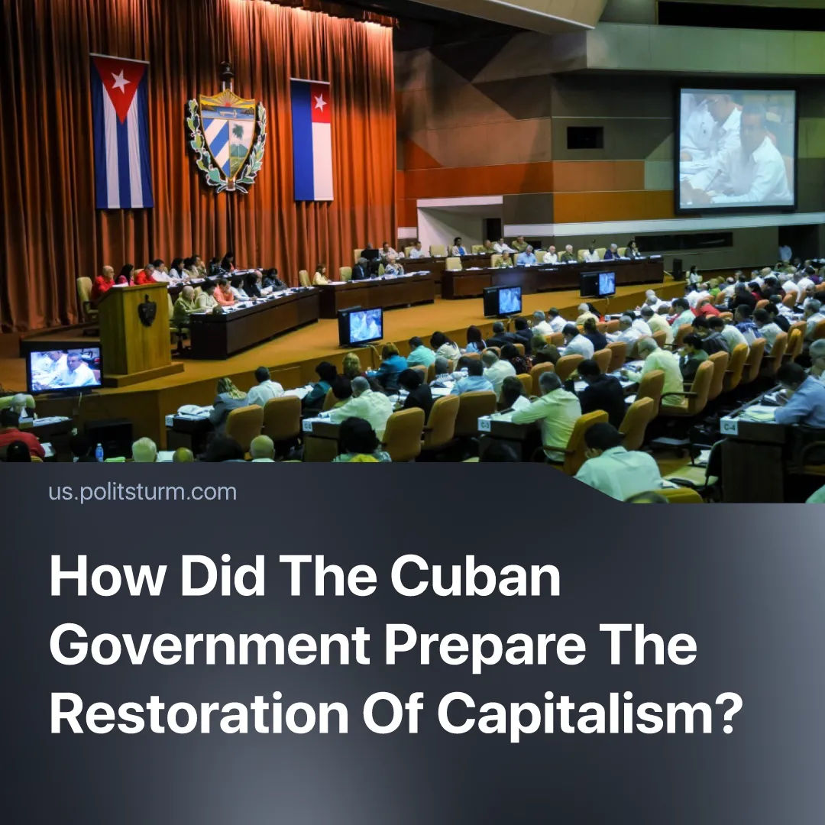

Original article
2026-06-27
3 min read

The opening of Cuba to American capital occurred in the spirit of the classic imperialist expansion of XIX-XX centuries. Cuba's leadership revealed the regime's essence as a dictatorship of capital.
Details. During the discussion of “economic reforms”, Cuba’s leadership stated that these measures would “protect socialism” and “maintain state control”. This was intended to create the impression of a gradual retreat. In reality, the "reforms" largely consolidated the existing order of things.
► This is confirmed by Cuban President Diaz-Canel, who reported that many “reforms” were discussed back in the early 2010s, but were postponed.
How did Cuba's leadership encourage the growth of capitalism? After the collapse of the Soviet Union, Cuba entered the "Special Period" and opened to foreign investment to compensate for the loss of Soviet subsidies. Around the end of Fidel Castro's life, at the turn of the 1990s and 2000s, the restoration of capital and the establishment of a bourgeois dictatorship were underway. By 2011, private businesses were permitted to purchase wage-labour.
► In 2016, the Cuban government had already passed a bill legalising small- and medium-sized private businesses. This was a similar formalisation of what already existed in practice: the government was already tolerating a large black market, which then simply became “legal” capitalists. The 2019 constitution enshrined private property over the means of production and legally guaranteed the rights of capitalists. The private sector has expanded in parallel. In 2024, the non-state sector accounted for 55% of retail sales, the first time private capital has surpassed state commerce. Private importers brought in over $1 billion in foreign goods, a 34% increase year-on-year.
► Modern Cuba's economy operates on the economic laws of capitalism. Workers sell their labour-power for wages to GAESA and private employers, who appropriate the surplus as profit. The bulk of goods are produced not for use but for sale. The law of value governs distribution through prices and increasingly impoverishes the workers. Capital flows into the profitable light industry.
Consistently developing, defending, and strengthening capitalism, the Cuban government transformed itself into a bourgeois dictatorship. The widespread introduction of capitalism, the general growth of private capital, and the transformation of public enterprises into the property of a closed corporation run by military and government functionaries changed the nature of the regime and the balance of class forces. The 2026 reforms and all previous measures cannot be said to be “concessions” extracted under pressure while “protecting workers' interests”. They form part of a consistent policy of cultivating and protecting capitalist interests, whilst subordinating Cuban workers to it.
► Behind the continuing facade of the Cuban Revolution, hiding behind the previous rhetoric and portraits of former leaders, primarily Fidel Castro, a military-bureaucratic elite has emerged, intertwined with a new bourgeoisie that uses state property as private property and continues to govern under socialist rhetoric. This is not a question of "defending the revolution", since the government no longer represents the revolution and the Cuban workers.
► Under a bourgeois dictatorship, state property is, in fact, private property. The state acts as a collective capitalist owner. In this sense, the Cuban regime is very similar to the regimes in China, Vietnam, and North Korea.
How do Cuban opportunists negotiate terms for surrender to the US? The US-Cuba secret negotiations that began in March 2026 represent a classic imperialist situation. Under pressure from a stronger capitalist power – intensified sanctions, fuel shortages, blackouts, and a collapsing economy – Cuba is being forced to submit to a more dominant capitalist power. The goal is to secure the military and economic interests of the American bourgeoisie, which cannot tolerate a Chinese dependency 90 miles from its coast amid a deepening global crisis.
► The legal framework for "foreign investment", unlimited foreign private trade and other related things all serve one goal: to open the gates to foreign capital, allow it into the domestic market, and share in the surplus value the bourgeoisie extracts from the Cuban proletariat.
► These laws and all previous measures have revealed the essence of the regime as a bourgeois dictatorship. Not concessions while protecting the interests of workers, but a consistent policy of cultivating capitalism, protecting the interests of capitalists, and subordinating to them.

Original article

