How Did Capitalist Media Frame Europe’s Protests?
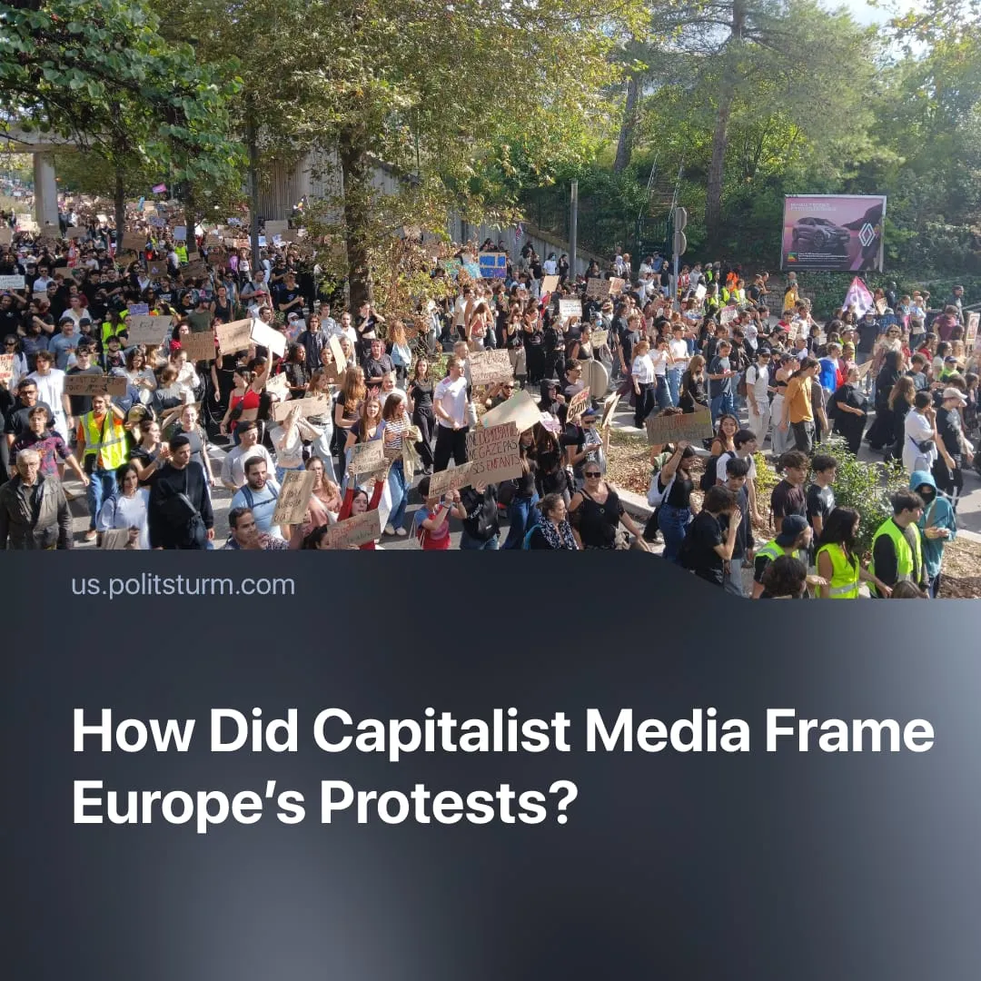

Original article
2026-11-02
2 min read

Capitalist media and state officials have focused on property damage and violence while portraying Europe’s mass protests as the work of “far-leftists” and migrants.
Details. The capitalist media focused heavily on property damage and looting. France 2 devoted 75% of its broadcast coverage to property damage, 12% to conspiracy theories about left-wing organisers, 8% to protesters' demands and just 3% to police violence. Images and videos of looted small businesses were also promoted, with appeals by shop owners attracting millions of views.
► Government officials condemned property damage while defending the police response. Prime Minister Lecornu justified police actions that resulted in a protester's arm being severed by a flash-bang grenade. Macron and Lecornu later called for full compensation for material damage. Macron declared that “we all feel anger and shame”, while Italian Prime Minister Giorgia Meloni stated that “There is nothing revolutionary about destroying and stealing” and that “Destruction and theft are not protest; they are criminality.”
► Political figures also portrayed the unrest as the work of “far-leftists” and migrants. The French government described protesters as “agitators” and “thugs”, while other officials blamed “far-leftists”. France's far-right leader warned of an “army of crime” supposedly invading the country, while Donald Trump claimed that France had been “conquered, looted, and burned to the ground by migrants, jihadists, and communists”.
Context. The protests began in France in early October over underfunded schools, before spontaneously spreading across Europe amid deepening capitalist crisis. Rising inflation, soaring fuel and housing costs, deteriorating public services and worsening working conditions fuelled discontent among workers, students, lumpen and other strata. These spontaneous protests were subsequently pushed towards looting and arson by provocateurs and adventurist “ultra-revolutionary” groups.
► Over the past 15 years, rent and housing costs have increased by roughly 30-60%. In 2025, almost 93 million people in the EU are living close to the poverty line. Meanwhile, European governments have rapidly expanded military spending amid preparations for further imperialist conflict.
► European governments have also expanded repressive measures amid rising inter-imperialist tensions and militarisation. This has accompanied the fascisation of political life, including bans on communist organisations and the growth of far-right parties.
► The portrayal of mass protests as the work of “far-leftists” has become common and is used to justify further repressive measures. During the 2020 protests following George Floyd's killing, Donald Trump blamed Antifa and other radical left-wing groups for the violence. During the 2023 pension protests in France, the government and media similarly focused on the actions of the “Black Bloc”, associating the unrest with “far-left” elements.

Original article

