How Are Republicans Preparing for the Midterms?
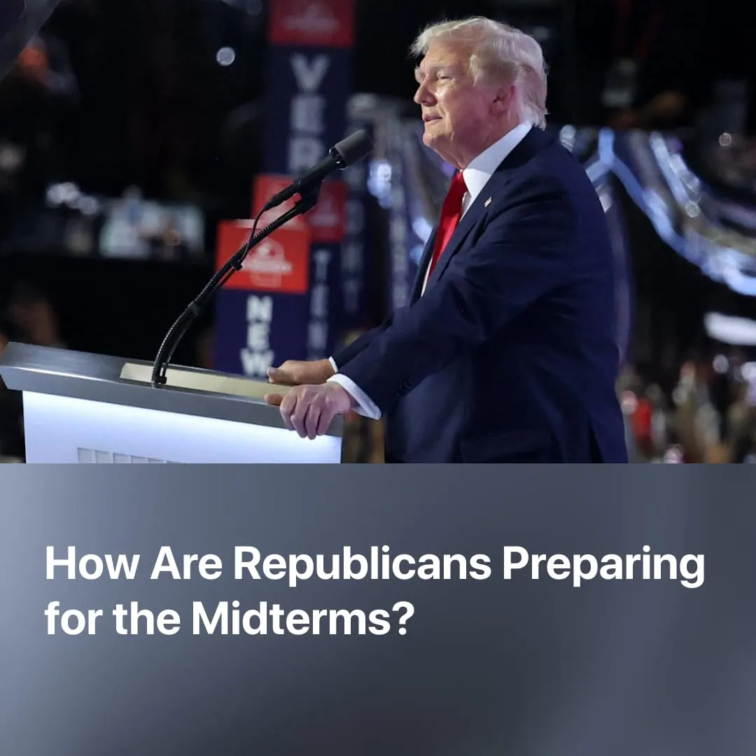

Original article
2026-09-28
2 min read

With the US midterms weeks away, Trump is bribing voters with $5,000, branding Democrats as communists, and banning critical media from the White House.
Details. The 2026 Republican National Convention in Dallas set out the Republican electoral strategy ahead of the midterms, with Trump himself asking the RNC crowd to pledge their allegiance to him.
► Trump attempted to bribe the electorate with the "Trump dividend", promising to pay $5,000 from tariff revenue to every American adult, on condition that Republicans hold a majority in both houses of Congress. However, the exorbitant cost and the failure to deliver on his past promise of a "tariff dividend" make this unlikely to materialise.
► Republicans are ramping up anti-communist fearmongering around certain Democratic candidates, claiming there is a "Bolshevik Revolution in the Democratic Party" and promising to be crusaders who ensure "America will never be a communist country". Republicans have also seized on figures like Hasan Piker, who falsely present themselves as communist, to portray growing left-wing sentiment among Democratic voters as "communist" influence.
► The White House suddenly banned major news outlets from its press briefings, claiming they had failed to publicise his "achievements". In response, several outlets announced they would stop broadcasting the presidential press pool. Trump already relies heavily on his Truth Social platform for announcements, and has now launched his own “Trump TV”.
► Trump is dismissing the declining state of the economy, claiming it has never been better. He has used press releases to make claims such as "the poverty rate has reached its lowest level in American history". At the same time, the administration refuses to admit evident failures in resolving the war with Iran. Hoping to deflect the conflict's impact on the midterms, Trump claimed "the war is going to end immediately after the election”.
► Trump has also attempted to reform electoral law in his favour, particularly by limiting voter participation. His latest attack on mail-in voting was blocked by the Supreme Court, while his party's gerrymandering strategy succeeded in several states.
Context. The Republican Party is forecast to suffer a severe loss that would cost them their Congressional majority. Driven by the economic crisis, increasingly unpopular immigration policy, and worsening living conditions, Trump's approval has reached the lowest ever rating for a sitting president at 30%, dragging his party down with him. A negative outcome in this election would give strong impetus to the growing movement within the party to move away from MAGA.
► The oil price shock from the Iran war has deepened the economic crisis American workers were already facing: heightened food prices and steadily rising rent have kept poverty measures above pre-Covid levels. While Trump has increased wealth for capitalists through deregulation and expanded domestic production, workers have seen no relief.
► Unable to address these fundamental problems, Democratic and Republican leadership compete to outdo each other in populism and fearmongering. Anti-communist hysteria is a prominent feature for both, Bernie Sanders and others have repeatedly called Trump's right-wing administration "Stalinist".

Original article

