Yemeni Houthi rebels attack multiple Israeli ships.
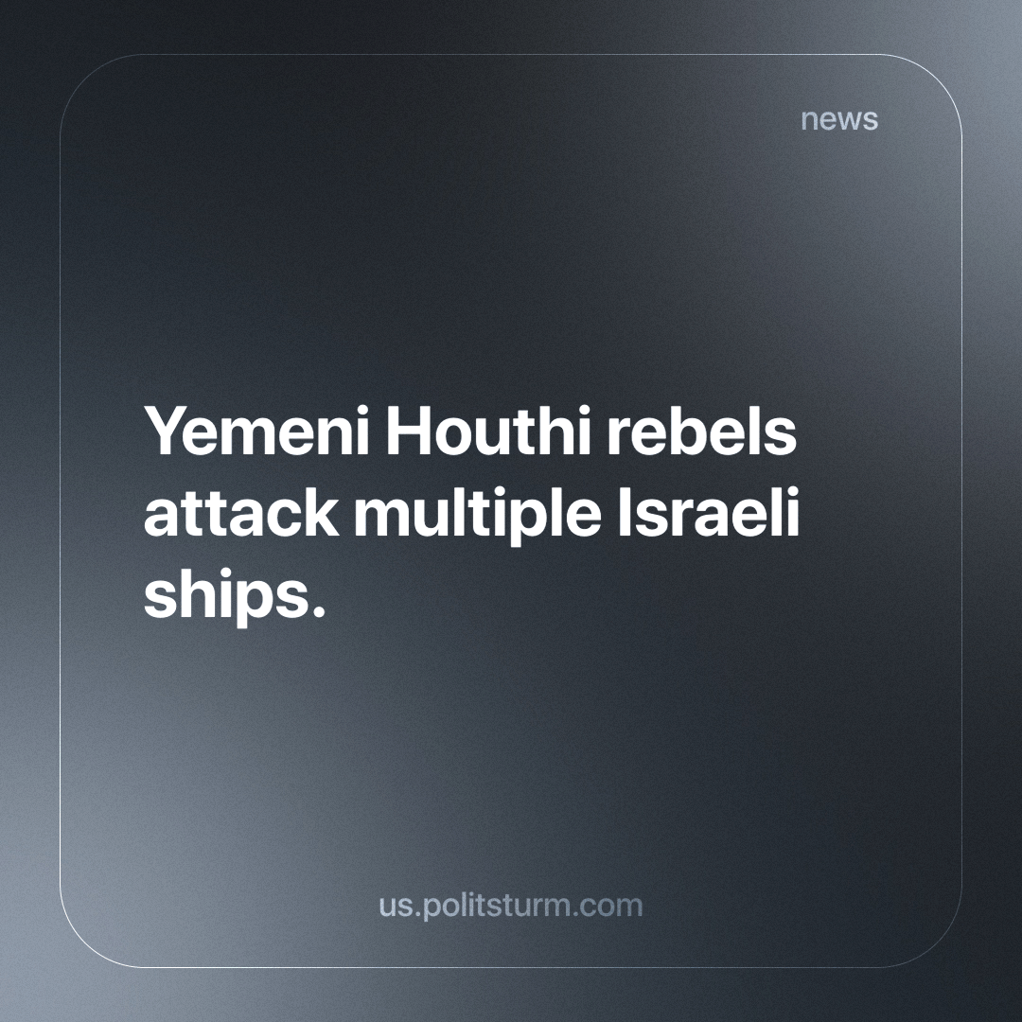

Original article
2023-12-21
3 min read

In the past few weeks, several Israeli ships off the coast of Yemen were attacked by the local Houthi rebels. These ship attacks were part of a larger group of incidents between Israel and the Houthi rebels. The recent escalation of incidents was due to the heightened struggle of local imperialist powers in the locality of Israel. The struggle between Israel and the Houthis is part of a global capitalist system of imperialist rivalries.
The current conflict is rooted in the history of imperialism, the current epoch of capitalism. Iran has helped fund and raise the Islamist Houthi rebels in Yemen for their own interests. The support from the Iranian imperialists for the Houthi rebels increased in 2014 when the civil war broke out between the Houthi rebels and the local leadership, supported by Saudi Arabia.
This conflict had spread the presence of Iranian capital throughout the Middle East to the dismay of Saudi Arabian and, more importantly, US capital. The entanglement between multiple local capitalists and larger capitalists has only brought the suffering of the working class through wars and more recent petty conflicts that are at hand, especially in Yemen. For example, according to the charity Save the Children, between April 2015 and October 2018, it is estimated that 85,000 children died of hunger.
The first Israeli ship in the recent conflict, “Galaxy Leader,” was captured by Houthi rebels a few weeks ago. On November 19th, off the coast of Yemen in the Red Sea; unbeknownst to all this became the first of many such incidents.
A statement was made afterwards by Houthi military spokesman Jahja Sari, who announced that all ships with connections to the “Israeli enemy” would now be “legitimate targets” setting the stage for further conflict.
The Houthi rebels, after issuing this warning, “have targeted two Israeli ships with an armed drone and a naval missile” according to an Israeli spokesperson. The recent threat posed by the Houthi military spokesman has become a reality.
The ships “Unity Explorer” and “Number Nine” were quoted as having damage by reporters on the scene: “One ship was significantly damaged, and it is in distress and apparently in danger of sinking, and another ship was lightly damaged.”
Only a few days ago, a tanker ship named Strinda was struck by a cruise missile as it passed through the Bab-el-Mandeb Strait on the way to the Suez Canal. Houthi forces in Yemen have again claimed this attack, saying it was “headed to the ports of the Israeli occupation.” No casualties were reported.
This continued barrage of attacks has cost Israel an estimated billion dollars. The US in turn, is manoeuvring to defend their own and Israel's shipping with military force. Recently, it was announced that the US would launch Operation “Prosperity Guardian” to defend this shipping in the region.
This proposed Operation is certainly intended to protect their interests and to maintain and keep open capitalist markets. Billions of dollars of shipping and goods from across the world pass through the region every day, allowing for the global markets to operate and profit. The costs of the operation, and increased costs due to circumnavigating the Red Sea, will be paid off by price increases and taxation - ultimately paid for by the workers.
The tension and infighting between capitalist states in the region of the Red Sea is a complex web of interests of the ruling capitalist class. The same class that exploits the working people, and batters them into submission, forcing them to live paycheck to paycheck. The wars and destruction in the name of profits are in no way in favor of the working class. Supporting conflicts between competing capitalist blocs is not the task of the working class. Rather, it is to overthrow the people that create the wars and exploitation, the capitalist class. It is only the working class led by the vanguard party that can end these senseless conflicts of destruction for good.
Sources:
1 2 3 4 5 6 7 8

Original article

