Housing Development: Loans, Crisis, and Problems


Original article
2025-06-14
59 min read

Why are millions of new homes built worldwide, yet housing remains unaffordable? How do construction corporations make huge profits by aligning with governments and monopolizing markets? Why do overproduction crises lead to declining living standards, and is there an alternative to the chaos of the construction sector under capitalism? We explore how a planned economy could resolve the housing crisis once and for all.

I. Who Earns What?
One of humanity’s fundamental needs — housing — is relentlessly exploited across the capitalist world as a source of profit for construction monopolies.
The construction industry is a cornerstone of the global economy, encompassing a wide range of activities: from building residential and commercial properties to developing infrastructure like roads, bridges, and power plants. This sector is dominated by large corporations, some of which can be considered monopolies in their respective markets.
The construction industry is a major global economic force, generating immense profits for its owners. However, society often bears the burden of problems and debts stemming from this sector. A particularly pressing issue, despite the abundance of housing options, is the inability to meet the demand for affordable and convenient housing for hundreds of millions of people in need.
The construction sector’s share of GDP varies significantly by country. According to 2021 data, it accounted for 4% of GDP in the United States, 5.7% in France, 5.9% in Germany, 6.9% in China, and 8.2% in Russia.
Capitalist economic principles actively drive the expansion of construction monopolies worldwide. These giants expand by absorbing smaller rivals in a fiercely competitive market. Below are some of the most prominent global construction monopolies:

• China State Construction Engineering Corporation (CSCEC): With a market capitalization exceeding $200 billion, this company, founded in 1982, operates in over 100 countries. It undertakes projects ranging from residential and commercial buildings to infrastructure and state-sponsored initiatives. As China’s largest construction firm and one of the world’s leading contractors, CSCEC benefits significantly from government backing, enabling it to secure major tenders and execute large-scale projects. The company contributes approximately 2% to China’s GDP.
• VINCI (France): With a market capitalization of over $60 billion, VINCI was founded in 1899 and operates in more than 100 countries. Specializing in the design, construction, and management of infrastructure projects—such as roads, airports, bridges, and tunnels—VINCI maintains a leading position in various construction market segments through its extensive global network and numerous subsidiaries. Its revenue accounts for about 1% of France’s GDP.
• Bouygues (France): Another French corporation, with a market capitalization of around $30 billion and revenue equivalent to roughly 0.7% of France’s GDP. Bouygues specializes in construction, real estate, transportation, and telecommunications. It holds leading positions in Europe and Africa and is active in Asia and North America. Since 1989, Bouygues has operated in Russia, and its former president, Martin Bouygues, joined the board of the Skolkovo Foundation (a Russian innovation hub) in 2010 at the invitation of Viktor Vekselberg. His specific role at Skolkovo remains unclear. Martin Bouygues passed away in 2015, and since early 2021, Olivier Roussat has served as the company’s CEO.
• ACS Group (Spain): With a market capitalization of approximately $25 billion, this construction and engineering conglomerate is a global leader. Founded in 1997, ACS Group focuses on civil engineering, infrastructure, energy, and industrial facilities, operating in over 40 countries. Its revenue represents about 1% of Spain’s GDP.
• Bechtel Corporation (United States): Headquartered in San Francisco, California, Bechtel is currently the largest U.S. construction company. Founded in 1898, it has completed over 25,000 projects across 160 countries. Notable projects include the Channel Tunnel (connecting the UK and France) and major global infrastructure developments. Bechtel holds a leading position both in the U.S. and internationally, making it one of the world’s most influential construction firms. In 2023, its annual revenue exceeded $20 billion. While its precise contribution to U.S. GDP is unclear, Bechtel’s work in energy infrastructure and transportation significantly impacts economic activity in the U.S. and beyond.
In Russia, the construction sector is one of the most significant and influential components of the economy, substantially contributing to the country’s GDP.
Among the Russian construction companies currently dominating the market and playing a pivotal role in infrastructure development and the broader economy, the following stand out:

• PIK Group: One of Russia’s largest construction and real estate development companies, with a market capitalization exceeding 600 billion rubles (approximately $6 billion). It contributes about 1.5% to Russia’s GDP. Founded in 1994, PIK acquired Moscow’s third-largest prefabricated house-building plant No. 2 in 2001, followed by another major Moscow plant, No. 3, in 2005. In 2006, PIK purchased Stroyinvestregion, expanding its development activities into Russia’s regions.
In mid-2016, PIK announced the acquisition of Morton, one of Russia’s largest developers. Since 2018, the company has been developing its own business ecosystem and pursuing an expansion strategy. In 2021, PIK launched its first international project, One Sierra, in Manila, Philippines. In February 2022, Brand Finance recognized PIK as Europe’s most valuable real estate development brand, with its value rising 87% to $1.25 billion. Also in 2021, PIK began producing furniture under its own brand.
Between 2018 and 2021, PIK was embroiled in a high-profile conflict in Moscow’s Kuntsevo district. Homeowners opposed PIK’s redevelopment project, which involved demolishing several residential blocks. Residents organized petitions and set up protest camps to prevent demolition and commercial redevelopment. However, their efforts were suppressed by police and private security firms (known as ChOPs in Russia, short for private security organizations). There were reports of masked individuals intimidating remaining homeowners, damaging homes and utilities, assaulting residents, and even firing at their apartments. The final residents of the targeted buildings were forcibly evicted with the assistance of bailiffs.

• LSR Group: This company specializes in residential and commercial construction, as well as the production of building materials. Founded in 1993 by entrepreneur Andrey Molchanov, who later served as an aide to the Minister of Health in 2007 and represented the Leningrad Region in the Federation Council (Russia’s upper parliamentary chamber) from 2008 to 2013.
In early 2024, Molchanov stepped down as CEO after being included on sanctions lists by “unfriendly countries”. Reports indicated that he reduced his shareholding in LSR from 55% to 45%, with the former CFO taking over management. Between 2007 and 2012, LSR actively developed land owned by the Ministry of Defense in St. Petersburg.
The company has repeatedly benefited from lobbying by St. Petersburg Governor Alexander Beglov. For instance, in 2019, Beglov publicly thanked LSR during a legislative report, and in 2022, he met with LSR’s CEO to discuss joint social infrastructure projects, praising the company as a “reliable partner” for the city. LSR also has ties to Moscow Mayor Sergey Sobyanin, who has publicly criticized one of LSR’s competitors, PIK Group. With a market capitalization exceeding 200 billion rubles, LSR contributes approximately 0.7% to Russia’s GDP.
• Samolet Group: With a market capitalization of around 100 billion rubles, Samolet contributes about 0.3% to Russia’s GDP. The company is known for large-scale residential projects, particularly in the Moscow region. Some of Samolet’s projects in Moscow and the Leningrad Region are partly owned by Maksim Vorobyev, brother of the Moscow Region’s governor. The company’s board chairman and shareholder, Dmitry Golubkov, is a deputy in the Moscow Regional Duma (regional legislature) and serves as deputy chairman of the committee on construction, architecture, housing, utilities, and energy. In early 2024, Samolet acquired Sistema, a commercial bank.

Samolet’s operations have frequently sparked conflicts with local communities. Residents have protested against deforestation and the destruction of natural landscapes. The company’s large-scale projects often lack adequate supporting infrastructure, leading to shortages of kindergartens, schools, clinics, and public transport in new neighborhoods. This has caused dissatisfaction among both new residents and long-term locals, who report a decline in quality of life. Homebuyers have also faced delays in project completion, poor-quality construction, substandard finishing, and issues with utilities in delivered properties. Residents and activists have filed lawsuits against Samolet, accusing the developer of violating urban planning regulations, environmental standards, and contractual obligations with shareholders (known as doleviks in Russia, referring to participants in shared-equity construction agreements).
Like other major corporations, construction companies exert considerable influence over both economics and politics. Their impact is evident through lobbying efforts, support for specific politicians, and active participation in decision-making processes that affect the construction industry, the allocation of government contracts, and the development of infrastructure and urban planning policies.
Large corporations allocate substantial funds to back candidates who pledge to advance industry-friendly policies. This may include reducing regulatory barriers, increasing government spending on infrastructure, or providing subsidies.
Financial support for politicians is particularly noticeable during election campaigns. For instance, in the United States, construction companies often provide funding through so-called Political Action Committees (PACs), organizations that collect and distribute funds to support politicians advocating for initiatives beneficial to specific industries. The more a construction company invests in a campaign, the greater the likelihood that its interests will be prioritized in future political decisions.
Major construction firms actively lobby for legislation that reduces taxation, regulates land use, and simplifies access to government tenders. One example is a construction amnesty (a policy allowing the legalization of unauthorized buildings, known as samostroy in Russia, or simplifying regulations for new construction without lengthy bureaucratic processes).
Additionally, construction companies frequently push for programs to stimulate housing development or secure government subsidies for infrastructure projects. These efforts enable developers to win lucrative contracts and subsidies, significantly boosting their revenues.
Through robust lobbying and political connections, some companies gain consistent access to government projects, limiting competition and creating privileged conditions for their growth. As a result, smaller or less connected construction firms are often squeezed out of the market, and the allocation of government contracts becomes less transparent. This dynamic fuels market monopolization driven by the political influence of large construction companies.
Funding political campaigns, backroom deals, and illicit contract awards can foster systemic corruption. Corruption scandals in the construction sector are often tied to the distribution of government contracts. Construction firms may collude with officials to secure favorable contracts without transparent bidding processes.

For example, according to a 2005 report by Transparency International (a global non-governmental organization dedicated to combating corruption), $13 million in bribes was paid during the construction of a waste incineration plant in Cologne, Germany, which had a total cost of $500 million. A British subsidiary of the Norwegian developer Veidekke admitted to bribing a senior government official during the construction of a dam in Uganda. Similarly, several international construction companies involved in dam projects for a water supply initiative in Lesotho’s highlands (South Africa) were found to have paid bribes totaling $2 million.
In the United Kingdom, a 2008 investigation exposed widespread collusion among companies bidding for government contracts. The Office of Fair Trading identified 112 companies that conspired to inflate the cost of construction contracts, including tenders for schools and hospitals. These firms secretly agreed on bid prices, with companies uninterested in winning the contract submitting artificially high bids. This created a false impression of competitive pricing and market dynamics for decision-makers awarding the contracts.
In Canada, a 2018 scandal erupted involving construction firm SNC-Lavalin and the construction of the McGill University Health Centre (MUHC) in Montreal. It was revealed that SNC-Lavalin executives paid bribes totaling $22.5 million to secure a $1.3 billion contract for the project.
Also in Canada, in 2022, the city of Winnipeg won a civil lawsuit against its former chief administrative officer, who was accused of colluding with a construction organization to manipulate procurement processes, inflate costs, and eliminate unwanted subcontractors during the construction of the city’s downtown police headquarters.
In Brazil, the industrial conglomerate Odebrecht, which includes construction projects among its operations, was implicated in a 2017 corruption scheme involving political figures. The investigation uncovered bribes exceeding $3 billion paid to secure contracts for public infrastructure projects.
In Spain, in 2013, 50 officials in the city of Marbella were convicted of corruption and real estate fraud. The head of the city’s planning department, Juan Antonio Roca, was found guilty of orchestrating a “systemic corruption network” and accepting bribes worth hundreds of millions of euros from construction companies in exchange for illegally allocating land for development.
In Ireland, in 2012, a former city council member was convicted for accepting three illegal payments of €60,000, €10,000, and €10,000 from a development company in 2006. According to the prosecution, he influenced council members and other officials to rezone land in favor of the developer, who sought to change the land’s designated use in County Waterford.
Capitalist Russia is no exception when it comes to the fusion of the construction industry with political power. For example, following the 2020 municipal elections, the Kazan City Duma (local legislature) elected deputies including Marat Ganiev, director of Promyshlenno-Stroitelnoye Obedinenie “Fors” (an industrial-construction association), Bulat Akhmetgaraev, head of Stroitelno-Montazhnoye Predpriyatie “Portal” (a construction and installation company), and Radik Salimgaraev, CEO of the major local development company “Unistroy.”
Among Voronezh's newly elected deputies were Andrey Boyko, deputy CEO of Joint Stock Company (JSC) “DSK” (a house-building company), and Artem Chekmarev, commercial director of JSC “Zavod ZhBI No. 2” (a precast concrete plant).
In Sochi, the City Assembly elected developer Denis Tantsura and Oleg Fateev, a senior executive at “Sochi-Park Pyat Plus,” a company managing apartment complexes.
In Krasnodar, the City Duma seat was taken by Ekaterina Afonina, director of the region’s leading development company “SZ Stroyelektrosevkavmontazh.” In the State Council of the Republic of Komi, prominent local developer Sergey Kulakov, head of “KS Alfa Ltd,” secured a position.
In Novosibirsk, developer and founder of the “Diskus” Group, Alexey Dzhulay, and Kirill Pokrovsky, development director of the “KPD-Gazstroy” Group, were reelected to the City Council.
In Belgorod, Nikolai Ryapukhin, CEO of “Mostdorstroy Ltd” (a bridge and road construction company), and Maxim Egorov, head of JSC “Domostroitelnaya Kompaniya” (a house-building company), were reelected to the Council of Deputies, marking their repeated terms.
In Rostov-on-Don, Dmitry Bondar, director of “Stroyindustriya” (a construction company), and Valery Levchenko, founder and head of the construction firm “Kristina,” were reelected to the City Duma. Both were among the three wealthiest deputies in the previous session.
These cases represent just a fraction of the construction executives holding political office across Russian regions.
Occasionally, startling cases come to light: according to the press service of the regional branch of the Investigative Committee (Russia’s federal agency for investigating serious crimes) of the Republic of Dagestan, in November 2023, a former deputy minister of education and science of the republic was detained on suspicion of accepting a bribe of an especially large amount. According to the investigation, from 2013 to 2023, the suspect received bribes totaling 60 million rubles (approximately $600,000) from the head of a commercial organization in exchange for facilitating the award of government contracts for repair and construction work on facilities under the ministry’s jurisdiction. A total of 15 government contracts were secured, with a combined value exceeding 160 million rubles (approximately $1.6 million).
Previously, in 2017, Alexander Khurudzhi, the Russian Presidential Commissioner for the Protection of Entrepreneurs’ Rights, reported that the construction industry led the Russian economy in the number of criminal cases initiated against entrepreneurs.
On a broader note, analysis of the global construction industry shows that in 2023, the total revenue of the world’s largest construction companies reached $1.997 trillion , a 3.4% increase from 2022. The majority of this revenue (53.5%) was generated by Chinese companies. Following them are companies from Europe (particularly France and Spain), Japan, the United States, and South Korea, which collectively account for approximately 21%, 9%, 8%, and 5% of the total revenue, respectively.

II. When Did Construction Become So Profitable?
The rapid growth of the construction business in Europe, which brought infrastructure and housing development to the prominent position it holds today, began after the Second World War. This was due to several key factors, especially in countries like England and France, including the so-called "baby boom" and the urgent need to rebuild destroyed infrastructure.
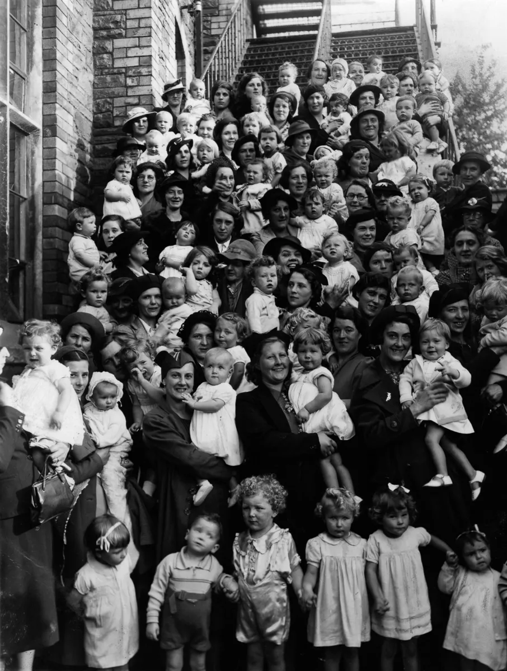
The “Baby Boom”. After the end of World War II, Europe and the United States experienced a significant rise in birth rates, known as the “baby boom.” This phenomenon led to an increased demand for housing, which became a primary driver of growth in the construction sector.
The baby boom occurred primarily in relatively developed Western countries where relatively favorable economic conditions remained after the war. This phenomenon represented a form of so-called “demographic compensation” related to the end of the war. The idea is that demographic events in a generation’s life were postponed (or, conversely, accelerated) due to certain factors that disrupt their natural sequence, that tend to occur with increased (or decreased) intensity once those factors disappear. This surge in intensity is what produces the compensatory effect.
The birth rate in the United States and Europe rose sharply after the war, not only due to the formation of many new families, but also because existing families, who had postponed having children due to the unfavorable conditions of wartime, began to do so.
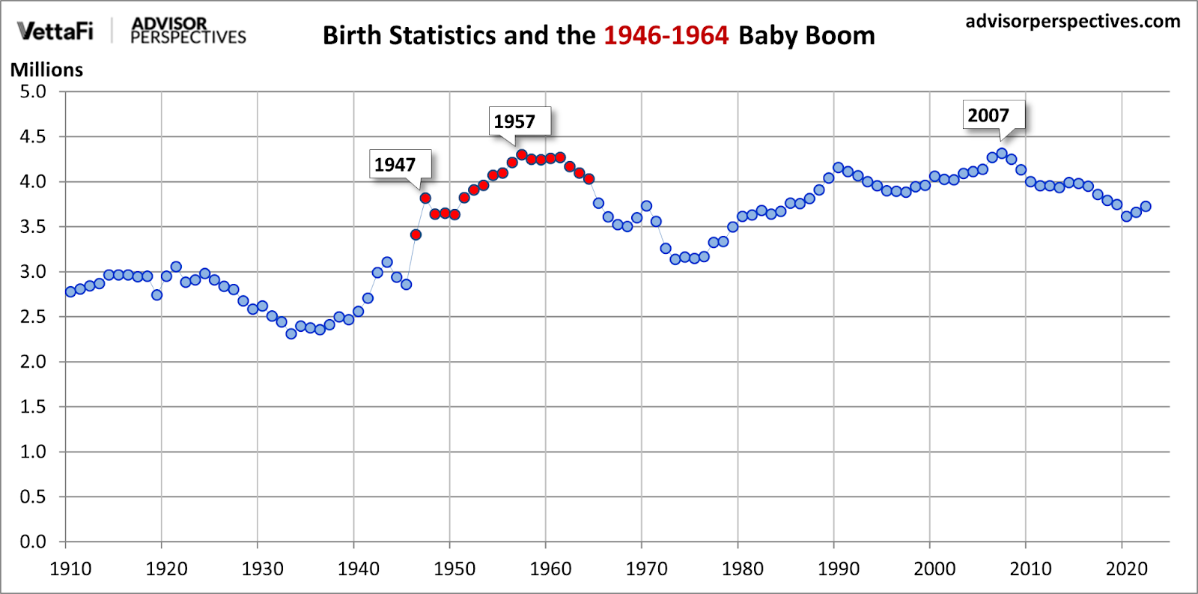
Chart: 19-Year Birth Surge in the U.S. After World War II
In the United Kingdom, the postwar period was marked by active construction, which began with a program to rebuild cities that had been damaged during the war. In 1945, the government launched initiatives to construct large-scale housing developments, known as "planned towns". It was necessary to provide housing not only for the baby boomers but also for soldiers returning from the war.
In postwar France, the initial funding for the restoration of destroyed infrastructure came largely from American money through the Marshall Plan. This contributed to a surge in housing construction, which also occurred against the backdrop of rising birth rates and increasing migration to urban areas.
Similar processes took place in other European countries as well, such as Germany and Italy.
The construction boom in Europe, driven by the recovery of the economy and infrastructure, continued until the late 1960s.
In the United States, during the mid-20th century, a key socio-cultural phenomenon emerged: Suburbia (meaning a residential area on the outskirts of a city). Suburbia, in turn, became one of the central elements of what is commonly referred to as the “American Dream”.
The "American Dream" is the idea that every American citizen, through hard work, can achieve success, independence, and prosperity. For many Americans, an important part of the American Dream was, and still is, owning a home, which symbolises not only financial stability but also "success" in life.
The idea of Suburbia as a distinct phenomenon emerged after the Second World War, when economic growth, the development of transport infrastructure, and the availability of housing loans enabled many American families to move from densely populated cities to suburban areas. During those years, the dream of owning a home in a quiet, safe neighbourhood became more attainable than ever before. This shift was supported by programmes such as the Veterans Housing Act, which granted veterans the right to obtain mortgages on favourable terms. The Act was passed in 1944 as part of the G.I. Bill of Rights.
Suburbia offered residents not only housing but also the opportunity to embrace a particular way of life. People could live away from the hustle and bustle of the cities while remaining relatively close to their places of work. Against the backdrop of urban tension and growing industrialisation, the suburbs were seen as a kind of paradise where one could build a new life from scratch.
Life in the suburbs was also closely linked to dependence on cars. Homes were built at considerable distances from one another, and residents had to rely on automobiles to get to work, shops, or schools. This transport autonomy became another defining feature of Suburbia and the American way of life.
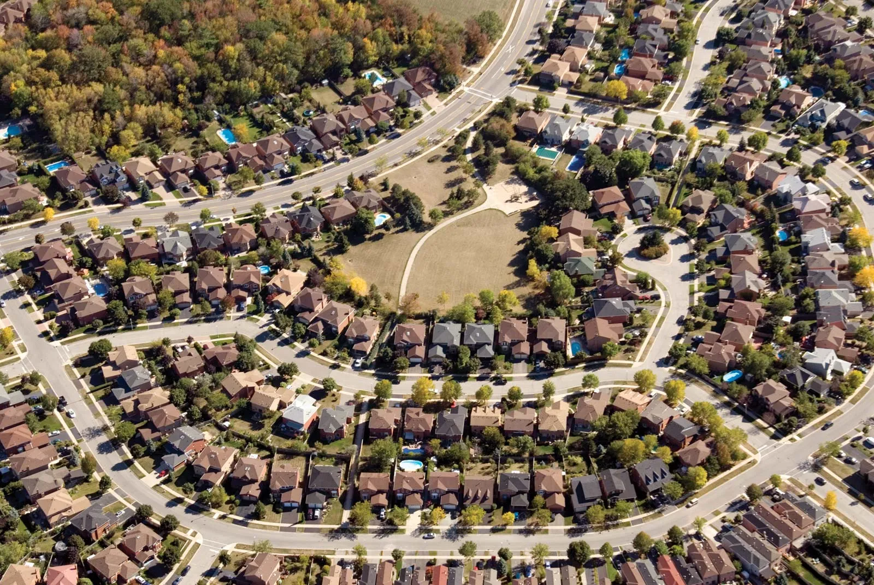
However, over time, it became clear that the isolation of the suburbs from city centres contributed to growing social stratification, racial segregation, and economic inequality within society.
Despite this, the idea of Suburbia remains an important part of life for millions of Americans today, who continue to view suburban living as a key element of the ideal of "privacy, comfort, and prosperity," where owning a home symbolises "success and independence".
Naturally, in a capitalist society, no mention is made of class advantages in the pursuit of life's benefits.
Such ideas in any capitalist society serve to distract from the core issue — the political and economic foundations on which that society is built. And under capitalism, these foundations not only fail to support the realisation of that dream, but in fact — actively obstruct it.
Capitalist ideology seeks to focus people’s attention on their personal qualities and their ability to “adapt” to the capitalist world, making the accumulation of wealth the meaning of life, a goal that, in reality, remains unattainable for the vast majority.
The growth of the construction industry in the United States naturally led to the emergence of construction monopolies and the rise of construction tycoons — major capitalists capable of exerting significant influence over infrastructure development, real estate, and economic relations in the country.
Among the most well-known of these figures, the following can be mentioned:
- Stephen Ross — founder and chairman of Related Companies, one of the largest development firms. The company is known for building and managing major residential and commercial properties not only in the United States but also around the world. Ross's net worth is estimated at nearly $13 billion.
- Leonard Stern — the owner and chairman of the board of Hartz Mountain Industries, which is one of the largest owners and developers of commercial real estate in New York and New Jersey. Stern’s fortune is estimated to exceed $7.5 billion.
- Richard LeFrak — the chairman and CEO of LeFrak, a private family company founded by his father in the early 20th century. Today, the LeFrak Organization owns more than 400 buildings, including residential, office, and retail properties. The company also has an energy division that owns around 800 oil and gas wells. LeFrak’s fortune exceeds $6 billion.
- And, of course, the real estate magnate Donald Trump, who became widely known for his active political career. Since 1971, he has been the president of The Trump Organization, founded by his father, Fred Trump, who was also a well-known developer and the successor to the family’s real estate business, which began in the 1920s. Trump was the beneficiary of several trust funds created by his father and paternal grandmother, starting in 1949, when he was three years old and, as stated in an investigation by The New York Times, he was already "a millionaire by the age of 8". According to Forbes, Trump’s net worth is approximately $3.7 billion as of September 2024.
From 1990 to 2020, China experienced one of the largest construction booms in world history, closely linked to the so-called "open-door reforms" and the policy of attracting foreign investment.
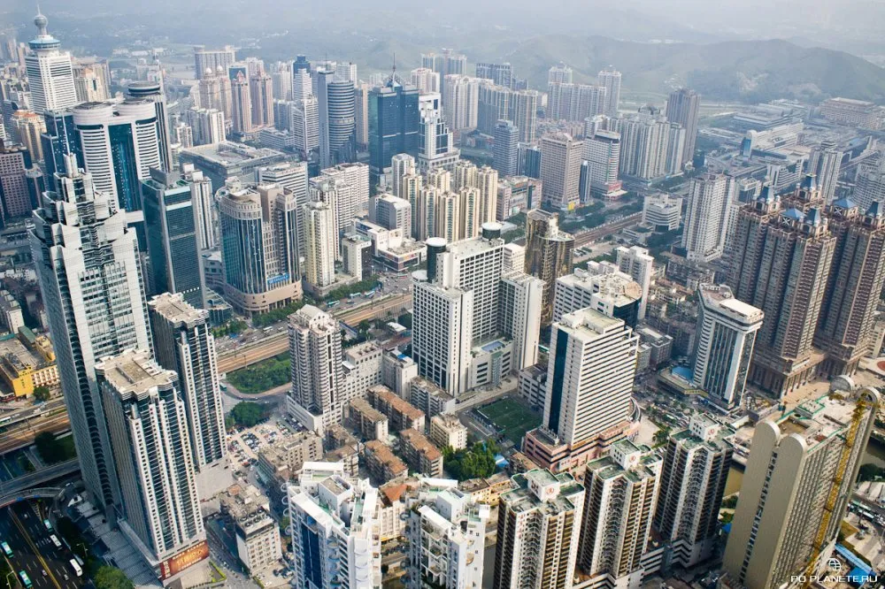
Shenzhen city
In the late 1970s, economic reforms were initiated in China, opening the doors to both domestic and foreign private capital. As a result of these reforms, foreign companies, attracted by the low cost of labor and the rapidly growing consumer market, began to actively invest in China.
By 1994, there were 29,300 enterprises with foreign capital involvement in the country, with the total amount of foreign investment in them amounting to 14.9 billion yuan. At the same time, local developers and construction companies, with the support of foreign investments that gained access to the country's economy, actively invested in various projects, including those related to residential construction. As a result, a residential and commercial real estate market was created in China.
On the one hand, this led to a sharp acceleration of urbanization, the development of modern residential neighborhoods with well-developed infrastructure in China, and the creation of new jobs.
On the other hand, market-driven construction has generated inevitable problems, leading to a large-scale crisis that continues to this day and threatens not only to undermine China’s financial system, which is estimated at 60 trillion US dollars, but also to shake the entire global economy.
Currently, several major Chinese construction companies can be highlighted, operating both in the Chinese market and internationally.
The China State Construction Engineering Corporation (CSCEC) is the largest construction company in China and one of the largest construction contractors in the world. It is among the top twenty companies in the country.
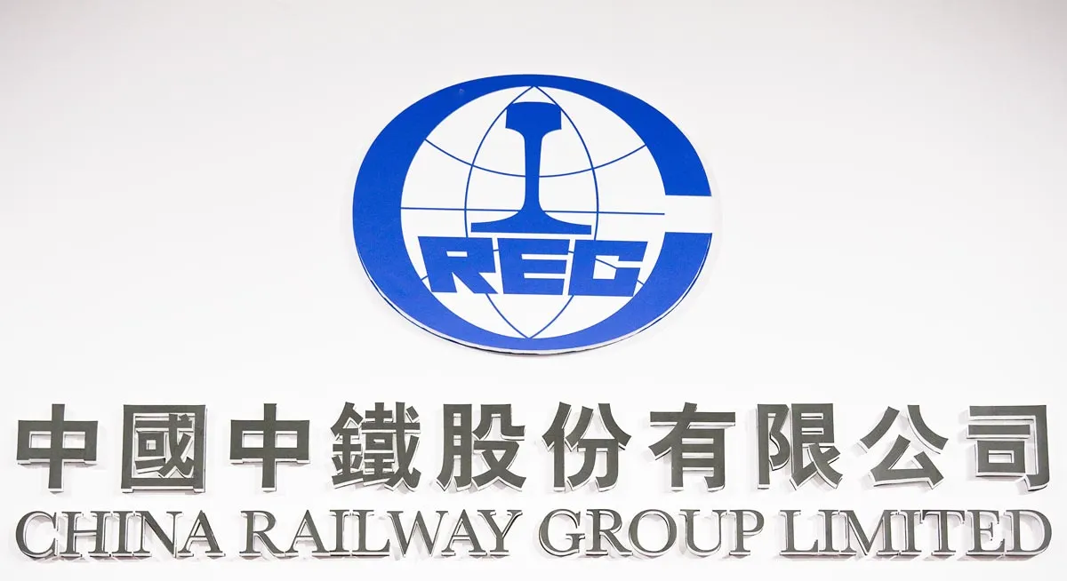
The China Railway Group Limited (CREC) is one of the leading companies in the field of railway construction, specializing in high-speed railway and metro projects. The company has a capitalization of over $20 billion.
The China Gezhouba Group Company Limited (CGGC) is one of the largest contractors in the world and one of the largest publicly traded companies in China.
The China National Building Material Group (CNBM) is an industrial conglomerate specializing in the production of construction materials. It ranks among the top 100 companies in China and is also listed among the top 200 companies globally.
China Evergrande Group was a diversified Chinese investment holding company, once one of the largest property developers in China. The controlling stake was held by Chinese billionaire Hui Ka Yan. Since the beginning of 2020, the holding company faced financial difficulties due to high debt obligations, which by the end of 2021 exceeded $300 billion. On January 29, 2024, the Hong Kong court decided to liquidate China Evergrande Group due to the company's inability to propose a plan for debt restructuring. Following this, its stock plummeted by more than 20%, causing the Hong Kong Stock Exchange to suspend trading of securities from the group's three listed companies. This bankruptcy became one of the largest in the world and the biggest in China's real estate sector.
The construction business in Russia began to develop rapidly in the early 1990s, as the country transitioned to market relations.
During this time, construction cooperatives and small companies began to form. Many professionals who left Soviet organizations started their own crews and worked on private orders, which came from new entrepreneurs and newly wealthy individuals who, overnight, were actively reconstructing the real estate that had come into their hands.
The criminal business was also not left out of the large sums of money circulating in the construction sector. Structures emerged that not only helped to "source" the necessary materials for construction but also sought to control the profits of construction organizations, as well as influence decision-making through their people in the management of companies.
By the mid-2000s, there was a growth in the number of large construction projects, and new market segments such as commercial real estate and residential construction began to develop.
Among the many small and medium-sized companies, the larger ones began to stand out. In 2020, the leader in housing construction volumes in Russia was the PIK Group of Companies, which completed 2.17 million square meters. The top three also included Setl Group and LSR, which built 597,000 and 460,000 square meters, respectively, and Ingrad Group of Companies, which built 418,000 square meters. The volume of construction work in 29 regions of Russia exceeded 100 billion rubles. In total, according to preliminary estimates, 7.2 trillion rubles were spent across all regions.
In general, the concept of a capitalist "welfare state" implies active government involvement in providing citizens with basic services and welfare, including through the development of infrastructure and housing construction. These projects require large financial investments, stimulate demand for construction services, and investments in them, leading to initial growth in the industry against the backdrop of an overall improvement in the economic well-being of some segments of the population.
However, within a capitalist economy, which is governed by market laws, the construction industry for development companies is ultimately just a business, viewed by them as a profitable investment that can bring substantial returns.
Capitalists actively invest in construction projects, viewing them as long-term assets. Real estate remains one of the most stable and profitable forms of investment, especially in times of economic instability. This leads to an increase in the number of commercial and residential projects, where investors see the opportunity to extract maximum profit from the future rise in property prices.
Due to the contradictions inherent in the capitalist economy, active housing construction not only fails to improve the living conditions of the majority of people, but also inevitably leads to recurring and intensifying global crises.

III. Unaffordability of housing
Despite decades of robust growth in the global construction industry, which has produced billionaire tycoons closely aligned with governments and politicians, the housing crisis remains a pressing issue in both economic and social policy worldwide. In many ways, the challenge of unaffordable housing — and the resulting burden of mortgage debt on populations — parallels the “land question” of the early 20th century in its scale and impact.
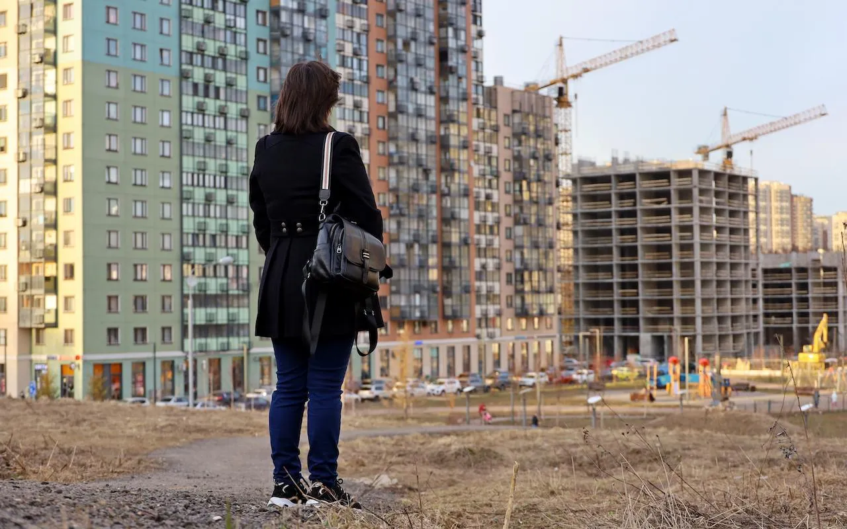
On one hand, the supply of completed and under-construction housing is theoretically sufficient to meet societal needs. On the other hand, this housing is largely owned by wealthy magnates, and skyrocketing prices combined with unaffordable mortgage payments effectively bar working people from purchasing homes. Housing often requires entering decades-long debt servitude to property owners and banks. Economic and political instability, coupled with uncertainty about the future, further undermines housing affordability.
Access to housing directly affects quality of life, prosperity, and social stability. Here’s how housing ownership varies globally:
• In Western European countries like Germany and Austria, roughly 50% of the population lives in rented housing, driven by high property costs and a well-developed long-term rental market.
• In Eastern European countries such as Romania and Bulgaria, over 90% of residents own their homes, a legacy of socialist-era policies that allowed widespread privatization of state-owned housing. However, homeownership rates in these countries are gradually declining due to rising property prices, ongoing privatization, and growing economic inequality, which has created “low-income groups” amid persistent inflation inherent to market economies.
• In Japan, about 61% of the population owns their homes, with high property costs in major cities like Tokyo pushing many toward renting.
• In South Korea, approximately 57% of residents are homeowners.
• In the United States, around 65% of the population owns their homes.
• In China, over 90% of people own their homes, fueled by a state-supported construction boom described earlier.
• In Russia, according to Rosstat (the Russian Federal State Statistics Service), about 85% of the population owned their homes in 2023. This high rate stems from the mass privatization of housing in the 1990s, when millions of citizens were able to claim ownership of their state-provided apartments at no cost. However, the rental market is growing rapidly, particularly in major cities like Moscow and St. Petersburg, where property prices are prohibitively high.
Globally, the number of people without housing or employment is rising. Homelessness and household debt have become some of the most debated issues, both at the national and international levels.
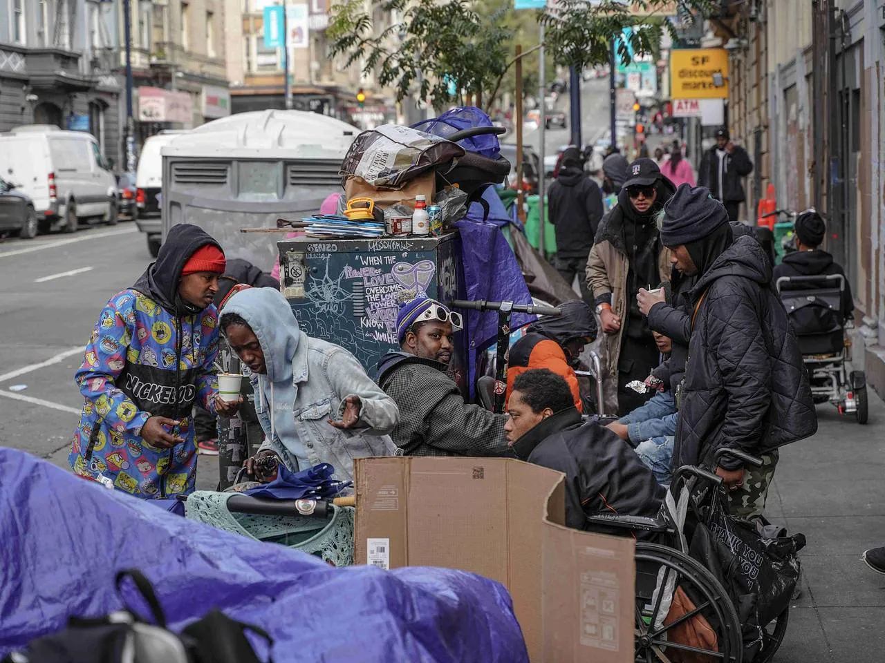
According to the U.S. Department of Housing and Urban Development, there were 650,000 homeless people in the United States in 2022. In Europe, the European Federation of National Organizations Working with the Homeless reports that homelessness in countries like the United Kingdom and Germany has surged by 30–40% over the past decade. In India, approximately 1.8 million people are considered homeless.
In Russia, official homelessness figures vary widely, but experts argue they are significantly understated. Estimates range from 200,000 to 3 million homeless individuals, depending on the criteria used.
Rising property costs are forcing people to take out mortgages with increasingly longer repayment terms. In the Eurozone, studies show the average mortgage repayment period grew from 19.8 years to 22.1 years between 2016 and 2018, with some terms extending up to 40 years. In the U.S., mortgage terms typically range from 15 to 30 years, with reports in January 2024 noting rising interest rates on 30-year loans. In Russia, the average mortgage term increased from 17.2 years to 25.2 years between February 2019 and October 2024. People are also increasingly relying on loans to cover daily expenses, especially as the cost of goods and services rises. According to global consumer finance market analysis, outstanding consumer loan balances hit a record $17 trillion in 2023.
Growing debt levels often lead to higher rates of homelessness. Households unable to keep up with loan repayments face the risk of losing their homes. In some countries, like the U.S., evictions due to missed mortgage or rent payments have reached record highs, with landlords filing approximately 3.7 million eviction cases annually.
In Russia, household debt is also rising rapidly. People are increasingly turning to microloans to cover everyday expenses, purchase homes, or even pay off existing debts. According to data from the Domklik platform (a Russian real estate and mortgage service), property prices in Russia have risen by an average of 73% over the past five years (since 2019), with regional increases ranging from 39% to a staggering 282%.
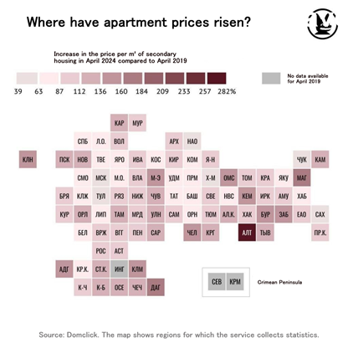
Meanwhile, citizens’ incomes have grown by only a few per cent. Declining real incomes (the ratio of income to prices) and inflation are pushing people to rely on loans for basic needs.
There is a trend toward declining homeownership and a growing rental market, driven primarily by housing costs that are unaffordable for most people. In so-called “social welfare states”, workers are forced to survive on low wages that lag behind inflation, compounded by mounting debt to banks.
Access to housing directly shapes living standards, prosperity, and social stability. The declining share of homeowners fuels rising homelessness. Failing to meet the basic need for housing inevitably leads to broader social consequences, including dissatisfaction with quality of life, uncertainty about the future, and, in many cases, declining birth rates.
Moreover, the economic inability of people to become homeowners has given rise to a growing social class of rentiers (property owners who profit from renting out housing). Precise data on the number of rentiers worldwide is scarce. One source, citing Goskomstat (the Soviet-era State Statistics Committee, now Rosstat), estimated there were about 200,000 rentiers in Russia in 2011. This number has likely grown significantly since then.

IV. Crisis
The construction industry is one of the most dynamic and capital-intensive sectors of the economy, but it is also highly vulnerable to crises of overproduction, which are inherent to capitalist systems.
These crises in the construction sector typically unfold in a predictable pattern:
1. During periods of relative economic prosperity, demand for construction projects rises. Consumers and businesses are eager to buy homes and invest in commercial properties, fueled by relatively affordable credit and mortgages, as well as expectations of rising property values. Developers, aiming to capitalize on this boom, ramp up construction of residential and commercial projects, often financing these ventures with loans.
2. The construction boom leads banks and financial institutions, driven by profit motives, to issue an excessive number of loans to both consumers and developers, often at higher interest rates. This creates an «economic bubble» (an unsustainable surge in asset prices driven by speculative borrowing).
3. Eventually, real incomes, lagging behind inflation and corporate profits, begin to decline. Consumers become less able to repay existing loans or take on new ones, leading to a slowdown in property purchases. The market becomes harder for sellers, and developers, unable to generate sufficient revenue, struggle to repay their loans. The overall debt burden on both households and construction companies grows. At some point, the supply of properties exceeds the population’s ability to afford them.
4. This oversupply triggers a drop in property prices and leaves unsold housing idle. Many projects become unprofitable, preventing developers from repaying loans. Defaults rise, and banks, facing widespread non-payments and losses, are forced to curtail lending.
5. The bubble bursts, leading to:
- Consumers unable to afford properties.
- Developers unable to complete projects, with finished projects turning unprofitable.
- Financial institutions facing bankruptcy due to unpaid loans.
- Bank failures impacting industries, domestic and international trade, and other sectors.
- Reduced access to essential goods and services lowering living standards.
- A collapse in the construction sector, triggering a banking crisis and, ultimately, a broader economic downturn.

4.1 The 2008 Global Financial Crisis
The 2008 global financial crisis, which profoundly impacted the world economy, followed this exact pattern. It originated in a U.S. real estate bubble and spread globally.
The primary cause was excessive lending in the housing sector. In the early 2000s, subprime mortgages (loans issued to borrowers with low creditworthiness) made homeownership accessible to more people, boosting demand and spurring construction. Banks, chasing profits, issued loans to high-risk borrowers, while mortgage-backed securities (financial instruments tied to mortgage payments) were sold to investors worldwide. Property prices soared, creating the illusion of endless growth.
By 2007, however, demand for housing began to wane as consumer purchasing power declined. Hundreds of thousands of homes were put up for sale due to unpaid mortgages, and many borrowers defaulted on their loans, sparking a wave of foreclosures. These defaults triggered a chain reaction of bankruptcies among banks and financial institutions tied to mortgage securities.
To mitigate losses, banks drastically reduced lending, including to developers. This led to frozen construction projects worldwide, fewer new developments, and delays in completing existing ones. The resulting decline in production caused mass layoffs and rising unemployment.
Reduced bank lending also curbed demand for goods and services beyond construction. In 2009, global trade volume fell by nearly 12%, and global GDP contracted by 2.3% — the first decline since World War II.
Worsening economic conditions fueled mass protests in North Africa and the Middle East, including Tunisia, Libya, Egypt, and Syria, leading to uprisings, armed rebellions, and, in some cases, government overthrows.
To mitigate the crisis, many countries introduced measures to support the construction industry, such as mortgage subsidies, property tax reductions, and incentives for new projects. From December 2007 to June 2010, the U.S. Federal Reserve provided trillions of dollars in low-interest loans to banks, corporations, and governments.
In Russia, the crisis was felt through disruptions in foreign trade, capital outflows, and tightened conditions for external borrowing. This led to falling prices for export commodities (raw materials and metals), a sharp decline in industrial production, and job losses. In December 2008, Russian industrial production fell by 10.3% compared to December 2007, marking the steepest decline in a decade.
That year, Russian budget expenditures — primarily injections into the banking system — exceeded 3% of GDP. According to the World Bank:
“This stabilized the banking system amid severe liquidity shortages, prevented public panic, stabilized net deposit outflows, encouraged growth in foreign currency deposits, avoided major bank failures, and supported banking sector consolidation.”
The 2008 crisis had a profound and lasting impact on the global economy, with effects still felt today. Declining GDP and trade increased unemployment and income inequality.
Following the crisis, birth rates in many countries began to decline more sharply. The rising burden of public debt and the need to bail out banks critical to the capitalist economy led to increased tax pressures on citizens. Reduced investment slowed the adoption of new technologies. Indeed, according to many experts, the repercussions of the crisis continued to be felt years later. In particular, in 2014, then-Russian Prime Minister Dmitry Medvedev noted that the global economy had not fully emerged from the crisis since 2008.

4.2 China
Another example of a construction sector crisis is unfolding in China. For decades, China has experienced rapid growth in construction, driven by urbanization, economic development, and rising consumer demand for housing and commercial properties.
The sector thrived on large-scale residential complexes, office buildings, and infrastructure projects, supported by government policies and strong demand from homebuyers and investors.

Many companies, such as the industrial giant Evergrande, expanded their assets through intensive lending, banking on sustained growth in property sales and prices to repay their debts. In 2009, developers issued $675 million in bonds (debt securities backed by cash or assets, used to raise external capital and reduce reliance on bank loans). By 2020, this figure had skyrocketed to $65 billion.
However, the real estate market began to overheat. On one hand, the initial surge of urbanization slowed as fewer people moved to cities. On the other, China’s economy faced setbacks from the COVID-19 pandemic and trade tensions with the U.S., which dampened overall growth.
Persistent inflation outpacing wage increases, coupled with rising household debt, eroded Chinese consumers’ purchasing power and willingness to invest in property. Construction of new projects far outstripped affordable demand, with housing supply growing while demand slowed.
The mounting debt burden became unsustainable, and developers struggled to meet their financial obligations, triggering a liquidity crisis (a shortage of cash to cover immediate expenses). The threat of defaults loomed over construction firms.
To prevent a broader economic collapse, the Chinese government introduced lending restrictions and tightened sector regulations. In 2020, the “three red lines” policy was enacted, limiting developers based on:
- Debt-to-asset ratio.
- Debt-to-equity ratio.
- Cash-to-short-term debt ratio.
These measures aimed to curb excessive borrowing and avert financial disaster, but they made the developers’ situation worse.
First, many firms were already heavily over-leveraged. Second, the “invisible hand of the market” (the profit-driven dynamics of capitalism) pushed companies, cut off from traditional financing, to seek funds from so-called “shadow banks” (unregulated lenders offering high-risk loans without formal oversight).
Due to liquidity shortages, developers began selling apartments before construction was complete, using the proceeds to launch new projects while halting existing ones.
The gap between surging supply and dwindling demand widened. Evergrande, burdened with over $300 billion in debt, could no longer service its obligations. The company froze numerous projects, was declared bankrupt in 2021, and effectively ceased operations. In September 2023, its owner was detained by police.
Other bank-financed developers, also mired in unpayable debts, struggle to complete projects. Defaults are rising: in 2023, 34 of China’s 50 largest developers reported missed payments.
This has led to “ghost cities” (e.g., Ordos, Chenggong, Tianducheng) — newly built districts that remain largely uninhabited despite significant investment. China now has thousands of unfinished buildings and tens of millions of vacant square meters.
He Keng, former deputy head of China’s National Bureau of Statistics, speaking at a 2023 forum in Dongguan, stated:
“How many vacant homes are there? Experts give different figures. The boldest estimate suggests enough for three billion people. That may be an exaggeration, but 1.4 billion people likely couldn’t fill them.”
To offload unsold properties, China has resorted to demolishing entire vacant neighborhoods with controlled explosions.
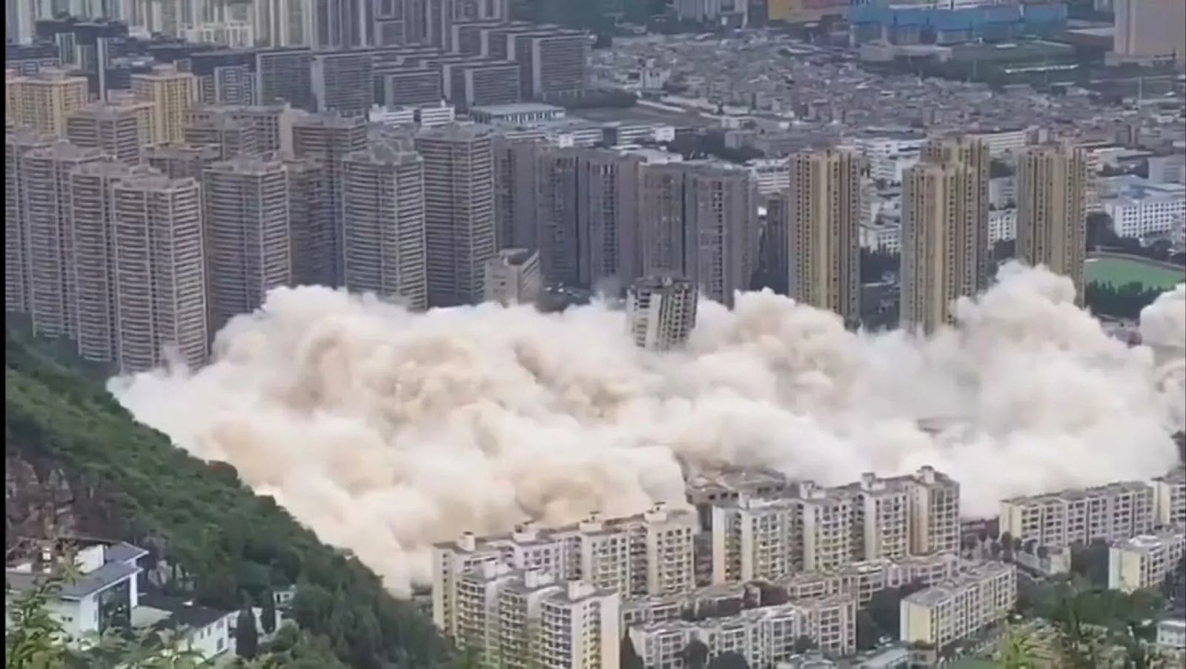
Analysts warn that a worsening situation could undermine China’s financial system, valued at $55.03 trillion in 2022, with ripple effects threatening the global economy. Given the tense international climate and escalating rivalries among major powers, such a crisis could far surpass the 2008 global financial crisis in impact.
These construction crises are specific instances of Marx’s crises of overproduction, inevitable under capitalism due to its structure.
They stem from the core contradiction of capitalist economies: the social nature of production and the private mechanisms of appropriation.
Social production achieves high productivity, but private appropriation limits access to the resulting goods. Private capital seeks endless profit, producing ever more goods (housing) while reducing public prosperity. Declining purchasing power exacerbates crises, but is not their root cause — the capitalist mode of production is.
Addressing crisis fallout in capitalism typically involves bailouts (government-funded financial injections) to prop up banks, paid for by taxpayers. In essence, ordinary citizens bear the cost of sustaining banks, which profit by lending to an increasingly impoverished population — until the next inevitable crisis, driven by the same systemic flaws. This is the nature of capitalist economics.
Moreover, the imperialist nature of modern capitalist relations, inherently transnational, spreads these issues globally.
The COVID-19 pandemic in 2020–2021 significantly disrupted the global construction industry.
Quarantine restrictions led to partial or complete halts in construction projects, increasing developers’ costs to maintain stalled projects.
Factory closures, transportation delays, and material shortages drove up prices and caused resource scarcity at construction sites. Projects reliant on imported materials faced extended timelines and higher costs.
Border closures and travel restrictions caused labor shortages, particularly in countries dependent on migrant workers.
The widespread shift to remote work reduced demand for office spaces, while restrictions on public spaces lowered investor interest in commercial properties like restaurants, hotels, and shopping centers.
Thus, the COVID-19 pandemic significantly slowed the construction industry in 2020–2021, causing abrupt work stoppages, resource shortages, and reduced demand for commercial real estate. It vividly exposed the fragility of the global market economy, tightly interconnected through transnational trade, yet vulnerable to unpredictable factors that bring profits or losses to major stakeholders.

4.3 Russia
In Russia, the construction industry began to develop relatively recently, following the country’s transition to a market economy. This development, however, took place on a foundation laid by the large stock of housing built during the Soviet era. As a result, there was a certain inertia in how citizens encountered the realities of the market economy. Nevertheless, the situation is slowly but steadily moving along the established tracks of the market system.
In 2008, as noted above, the country's economy was hit by the effects of the financial crisis that began in the United States, which required budgetary support for financial institutions in order to mitigate the onset of a recession.
In 2014–2015, the Russian Federation faced a new economic crisis caused by a combination of internal and external factors:
- There was a global decline in oil prices, which dealt a significant blow to the country's public finances, as its main source of income comes from the trade of natural resources.
- Economic sanctions were imposed by a number of countries, restricting Russian companies’ access to international capital markets.
- The decline in revenues from energy exports, along with the sanctions, led to a sharp devaluation of the Russian ruble. By the end of 2014, the ruble had lost more than 40% of its value against the US dollar. This drove up inflation, as imported goods became more expensive, and increased pressure on the real incomes of people.
As a consequence of the crisis, there was a sharp increase in inflation and a decline in real incomes, which led to a rise in poverty. According to Rosstat, by 2015, about 20 million Russians were living below the poverty line.
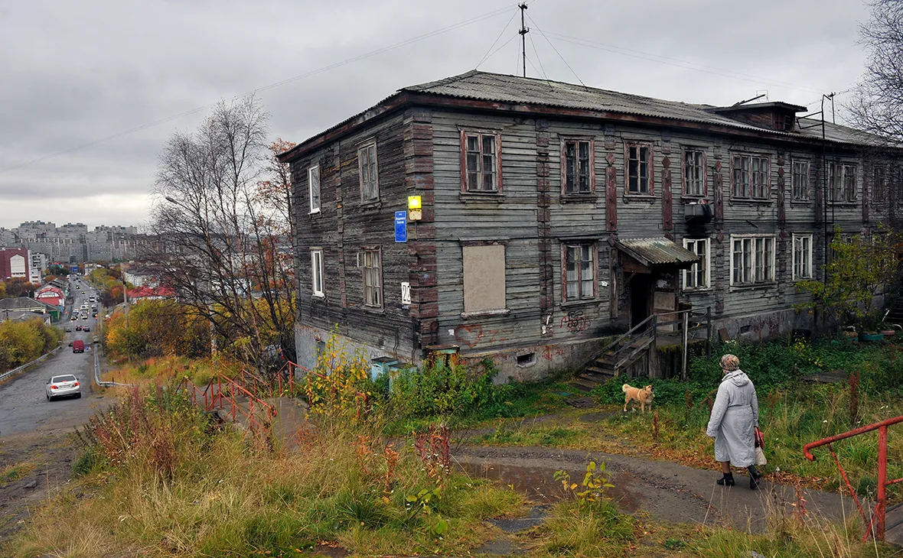
Russia’s GDP contracted by 2.8% in 2015; industrial production, retail trade, and investment also declined significantly.
The devaluation of the ruble and the rise in prices for imported construction materials led to a significant increase in the cost of construction projects. Many materials — especially in the segments of engineering systems, finishing, and high-tech equipment — were sourced from abroad. Their cost in ruble terms increased by 10% from January to December 2015, according to Rosstat. Construction companies were forced to raise prices for their projects, which further reduced demand.
Many construction projects, both in the residential and commercial sectors, were put on hold. Investors and developers faced financial difficulties and a rise in the cost of borrowed funds. The Central Bank’s key interest rate hike to 17% in December 2014 made loans very expensive for both developers and homebuyers. In this environment, developers preferred to postpone the launch of new projects or suspend the construction of those already underway. As a result, many construction sites remained unfinished.
The decline in household income and the rise in unemployment inevitably led to a drop in demand for real estate purchases. People began postponing home buying due to uncertainty and decreasing real incomes. This was particularly evident in the new housing segment, where demand fell by 15–20%. The mortgage lending market also shrank, as mortgage rates rose significantly.
As a result, the crisis led to many small and medium-sized construction companies being unable to withstand financial difficulties and being forced to cease operations. This accelerated the monopolization of the market: larger companies managed to survive and absorb the weaker players.
The economic problems affecting the Russian construction industry against the backdrop of global and domestic financial crises, as well as the COVID-19 pandemic, continue to this day. Moreover, we can say that, at present, conditions in Russia are developing that could lead to a crisis in the real estate market similar to those in the United States or China, with its own unique characteristics.
Since the early 2010s, the Russian construction industry began facing increasing difficulties, which led to significant changes in the sector.
Restricted access to foreign capital markets due to sanctions complicated the process of financing new projects. Banks became more cautious in issuing construction loans, and interest rates for borrowers increased. Inflation and the devaluation of the ruble also significantly affected the cost of construction materials and equipment, which raised construction costs and reduced the profitability of projects.
Another significant factor was the decline in the purchasing power of the population. Real incomes in Russia began to decrease in the mid-2010s, which led to a reduced demand for housing and commercial real estate. As a result, many construction companies faced difficulties in selling already completed properties, which in turn led to issues with the profitability of investments.
All of this led to a reduction in construction volumes, particularly in the housing sector, where demand for mortgage lending is one of the key growth factors. Numerous construction companies, especially small and medium-sized enterprises, faced liquidity shortages and were forced to freeze or even halt projects. In 2021, a 12.3% decline in the real construction market was recorded.
To boost the housing sector, the government introduced a preferential mortgage program in 2020 for buyers of newly built properties, along with family mortgage options—initiatives that have become especially relevant against the backdrop of the central bank’s key interest rate hikes. In January 2024, Russian banks received 2.3 trillion rubles in additional funding limits under state-backed mortgage programs.
However, the measures taken failed to produce the desired effect. On the contrary, the real estate market experienced a reverse trend.
After four years in operation—and more than 1.5 million loans issued during that time — the preferential mortgage program was phased out in July 2024. Over time, it had not made housing more affordable for people but had instead contributed to further price increases.
According to analysts, apartment sales in the primary housing market dropped by 31% in July 2024 compared to the same month the previous year. By 2025, the volume of mortgage lending is expected to shrink by nearly half compared to 2023. Since the summer of 2024, there has also been a noticeable decline in developer activity, as many are in no rush to bring new housing to market amid falling demand and declining prices.
At the 18th Moscow Forum of Real Estate Market Leaders in November 2024, Anton Glushkov, head of the National Association of Builders (NOSTROY), stated that developers today no longer have the financial resilience once provided by profits from previous years. He also emphasized:
“...profits from previous periods are not sitting in bank deposits—they’ve either been distributed, as is typical in business, or diversified, for instance, into land assets,” he said.
Despite the overwhelming loan terms, the need for housing continues to drive people into taking out mortgages, leaving them indebted to banks for many years to come.
According to TASS, in the first half of 2024, the share of mortgage loans where the borrower will be over 65 years old by the time the debt is gradually repaid reached 48%—an increase of 14 percentage points compared to the previous year. Central Bank statistics show that, on average, borrowers who took out a mortgage in the second quarter of 2024 already had one active loan. Furthermore, half of all mortgage holders carry debt ranging from 1 to 4 million rubles, while one in three owes up to 1 million rubles.
Meanwhile, Sberbank announced that, starting November 15, it would raise rates on its standard mortgage programs by 3.5 percentage points. The minimum mortgage rate for newly built housing will now be 28.4%, while rates for programs on the secondary market will rise to 28.1%.
According to recent statistical studies, 51% of Russian citizens have no savings, while 38% have enough savings to cover three months of expenses. 29% of respondents have savings that would last for 3 to 6 months, 20% have enough for 6 to 12 months, and only 14% of respondents have savings for more than a year.
According to a study by "RIA-rating," in seven regions of Russia, the mortgage payment exceeds 80% of the average salary of two working individuals, while the average figure for Russia as a whole is 54%.
Meanwhile, the government is showing concern and striving to improve the situation by finding new and innovative ways to support businesses and allocate citizens' funds.
For instance, Prime Minister Mikhail Mishustin announced the adoption of a state program under which a portion of payments to participants in the Special Military Operation (SMO) will be directed toward purchasing real estate, making a down payment, or paying off a mortgage.

Chairman of the Government of the Russian Federation M.V. Mishustin.
Honorary member of the Russian Guild of Realtors, Oleg Samoylov, commented on this as follows:
"Developers are struggling with sales due to the scaling back of the broad preferential mortgage program. The government measure adopted won't reverse this trend, but it could be one of the steps toward supporting the market. The state, in any situation, strives to assist the construction sector—it’s a significant part of the economy, and other sectors depend on it. If the construction market collapses, it will lead to increased social tension, and the authorities will not allow that to happen."
Thus, behind all of this, one scenario becomes evident, inevitably dictated by the capitalist structure of the economy:
- The construction and commissioning of new housing depend on the consistent profitability of the sector for developers.
- In order to continue construction, developers are forced to seek financing from financial institutions.
- Citizens in need of housing are also compelled to take out long-term loans to purchase property, often for the majority of their lives, without the ability to save any money.
- Due to the instability of the international situation, caused by the ongoing capitalist competition that leads to trade wars, price increases are inevitable.
- Inflation always outpaces wage increases, which, in real terms, tend to decline rather than grow.
- Citizens are increasingly facing the inability to repay their debts to banks.
- Construction companies, fearing a loss of profit, are forced to freeze construction projects amid falling prices and are themselves approaching default.
- Attempts by the government to rectify the situation through budgetary infusions and the introduction of preferential loan conditions only lead to price increases and, ultimately, a higher debt burden on citizens.
The financial bubble, driven by the dynamics of capitalist economics, will continue to grow and, sooner or later, will burst, further worsening the economic situation and living conditions. The ones who will suffer the most are those who lack the financial resources to cushion the consequences of this explosion — that is, the majority of the population.

V. Socialism
It is evident that the construction industry, under the conditions of a capitalist economic system, despite its vast scale and influence on political and social institutions, is unable to solve the problem of providing the majority of the population with affordable and comfortable housing. Moreover, being integrated into the chain of market economic relations, it serves as one of the catalysts of the inevitable global crises inherent in capitalism.
The solution to the problem of providing housing for people lies in transitioning to a socialist economic system. Even the relatively short experience of the Soviet Union, based on a planned state policy of mass construction and the free distribution of housing, demonstrated the possibility of fully solving people's housing issues.
The housing issue in the Soviet Union, although not resolved immediately, was ultimately fully addressed. The abolition of private ownership of the means of production and the transition to a planned economy made it possible to allocate resources in the interests of the working majority of society.
Initially, after the 1917 revolution, the pace of construction was slow due to the underdeveloped industrial and technical base, as well as the relatively sufficient amount of housing that had transitioned into the hands of the people from officials and large industrialists of pre-revolutionary Russia. Then came the Great Patriotic War and the post-war reconstruction of the country's economy.
However, from the 1950s to the 1970s, the pace of housing construction in the USSR increased, fully meeting the needs of the rapidly urbanizing and growing population. During this period, 93.8 million square meters of residential space were built in the USSR.
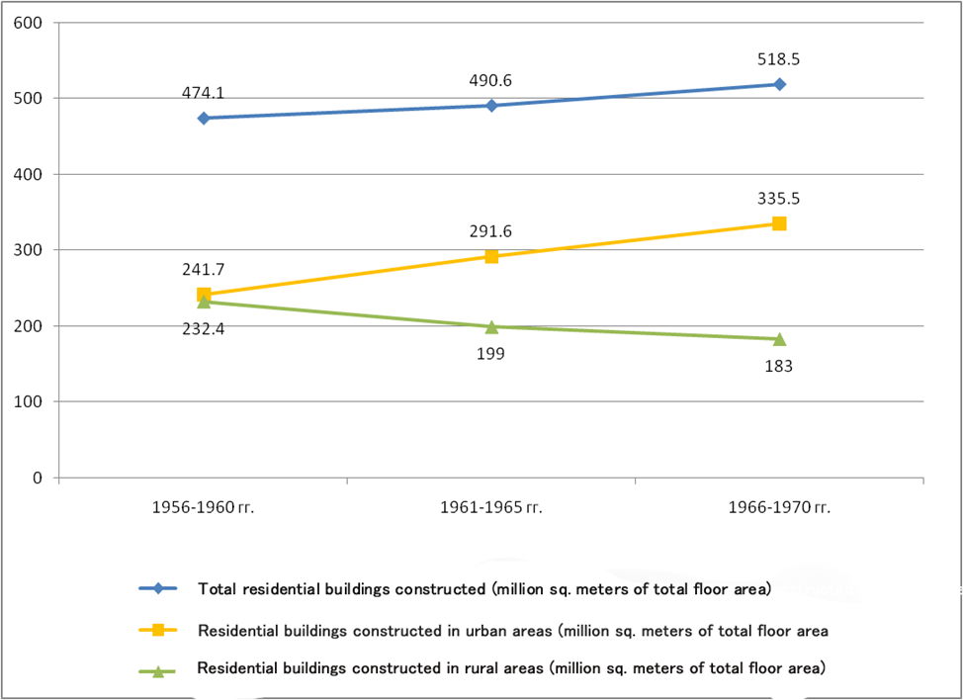
The chart is based on statistical data on residential housing construction in the USSR.
Over the period from 1918 to 1986, a total of 4,180.1 million square meters of overall (usable) housing space was commissioned.
The average size of apartments built using government capital investment and funds from housing construction cooperatives consistently increased, reaching, according to available data, from 51.6 square meters in 1976 to 72.5 square meters in 1986.
Freed from private ownership and exploitative labor, and driven by the achievements of socialist science, construction technologies were continually improved and made accessible to all. For instance, in the construction of the so-called Khrushchyovkas, technologies were used that are still employed by modern development companies today: prefabricated panel construction, welding to join panels, low-rise building methods, and more.
People in need of housing were always provided with it — either through a waiting list system based on established per capita housing standards for families, through state-supported housing construction cooperatives (which required a financial contribution as a form of participation in construction and offered installment plans to cover the cost of the apartment), or through their employer, as some organizations built housing specifically for their employees.
The problem of mass homelessness was effectively resolved; those few without shelter were, for the most part, individuals with antisocial behavior. Homelessness was in no way linked to a person’s inability to obtain housing. It was impossible to lose one’s home due to eviction for debt or as a result of fraudulent schemes.
Apartments were not private property that could be used for profit; instead, they were provided under a system of social rent. While they could not be sold, they could be exchanged within a neighborhood, a city, or even across the country. The right to use an apartment could also be passed on by inheritance.
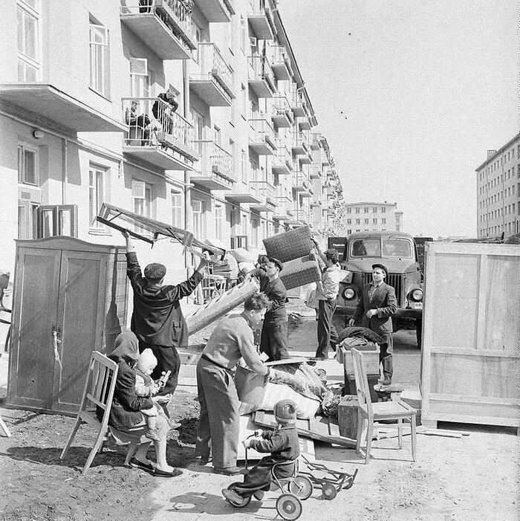
Housewarming
Naturally, there were always individuals who found ways to circumvent the law and profit from speculative apartment exchanges or illegal rentals. However, this was far from the norm—the law hindered such practices rather than encouraged them.
Thus, the elimination of the contradiction between the collective nature of production and the private appropriation of its results—that is, the transition of the economy from capitalist to socialist planned principles—made it possible to fully resolve the housing problem in the shortest possible time, providing society with housing that was both accessible and suitable for its time.

Sources
1. Article on cyberleninka.ru: “The Impact of the Construction Sector on the Development of the State's Economy: Methodology and Practice of Assessment in Russia and Abroad” — 2023.
2. RBC News Agency: “What’s Happening in Kuntsevo, Where Residents Are Protesting New Buildings” — from Nov. 21, 2018.
3. REGNUM News Agency: “Конфликт в Кунцево: если власть не одумается, дальше только баррикады” — from Nov. 20, 2018.

4. RBC News Agency: “Major Shareholder of LSR Group Reduces His Stake in the Company” — from Mar. 18, 2024.
5. “Governor Alexander Beglov’s Report to the Legislative Assembly on the Results of the Government of St. Petersburg's Activities in 2019”.
6. bpn.ru: “Former Ministry of Defense Lands Allocated for Housing Construction” — from Sep. 08, 2011.
7. tvspb.ru: “Alexander Beglov Discussed Joint Construction of Social Facilities with LSR Group CEO” — from Feb. 11, 2022.
8. forbes.ru: “Sobyanin Threatens to Remove PIK from Moscow Construction Due to Unfinished School” — from Oct. 27, 2022.
9. Vedomosti News Agency: “Governor of Moscow Region’s Brother to Develop Nekrasovka” — from May 21, 2018.
10. Versia News Agency: “‘Samolyot’ in a Tailspin” — from May 27, 2024.
11. “Consumer Rights” website: “Developer ‘Samolyot Development’ to Pay Penalty for Deadline Violations” — from June 14, 2024.
12. theguardian.com: “OFT accuses construction firms of price rigging”
13. socialistalternative.org: “Canada: SNC-Lavalin Construction Company Scandal Throws Trudeau Government into Crisis” — from Mar. 11, 2019.
14. cbc.ca: «Former Winnipeg CAO Phil Sheegl loses appeal, must pay $1.1M for accepting bribe from police HQ contractor» — from July 07, 2023.
15. lenta.ru: “50 Marbella Resort Officials Convicted in Spain” — from Oct 05, 2013.
16. irishexaminer.com: «Former FG councillor guilty of corruption» — from May 19, 2012.
17. tass.ru: “In 2022, the Number of Homeless in the US Reached a Record 650 Thousand” — from Dec. 16, 2023 г.
18. dailymoscow.ru: “Sitting on Two Chairs. Why the Construction Business Enters Politics” — from Sep. 23, 2020.
19. nytimes.com: “Trump Engaged in Suspect Tax Schemes as He Reaped Riches From His Father” — from Oct. 02, 2018.
20. Article on evolutio.info: “The Role of Foreign Direct Investment in China’s Economy”
21. Article on cyberleninka.ru: “Analysis of the Development of the Construction Business in Russia” — from 2022.
22. Article on nordsip.com: «Homelessness In Europe Grew by Over 40% in 2023» — from Oct. 03, 2024.
23. Article on tochno.st: “The Number of Homeless People in Russia May Multiply. Here's How Many There Are and How to Help Them” — from March 30, 2022.
24. ecb.europa.eu: “Trends in residential real estate lending standards and implications for financial stability” — from 2020.
25. Interfax News Agency: “US Mortgage Rates Rise to 6-Week High — Freddie Mac” — from Jan 26, 2024.
26. Article on frankrg.com: “Average Mortgage Loan Terms in Russia” — 2024.
27. rg.ru: “Millions of Americans Faced the Threat of Eviction” — from July 31, 2021.
28. Article on demoscope.ru: “Modern Russian Rentiers: Social Composition and Lifestyle Characteristics” — from 2012.
29. lenta.ru: “Global Trade Contraction Becomes Record Since WWII” — from Feb. 24, 2010.
30. ng.ru: “Manufacturing Hit by Collaps” — from Jan. 26, 2009.
31.TASS News Agency: “Medvedev: 2008 Crisis Still Not Over” — from Dec. 10, 2014.
32. lenta.ru: “The Great Chinese Bubble. China's Real Estate Market Is Plunging into a Deep Crisis. What Does It Mean for the Global Economy?” — from Nov. 06, 2023.
33. mperspektiva.ru: “How China’s Largest Developer Went Bankrup” — from Feb. 21. 2024.
34. RBC News Agency: “China Liquidates Evergrande Developer Due to Debts” — from Jan. 29, 2024.
35. markets.businessinsider.com: «Despite Country Garden's last-gasp payment, China's property sector remains in crisis: two-thirds of its developers with most offshore debt are defaulters» — from Sep. 05, 2023.
36. prian.ru: “China’s Vacant Housing Stock Is Twice the Country’s Population” — from Sep 25, 2023.
37. 1tv.ru: “Entire city blocks are being demolished in China using controlled explosions” — from Aug. 10, 2021.
38. People’s Daily: “Assets of China's banking financial institutions grew in 2022” — from Feb. 27, 2023.
39. stroygaz.ru: “How the construction market changed amid the pandemic” — from Nov. 29, 2021.
40. RIA Novosti News Agency: “The ruble ended 2014 down 41% against the dollar and 34% against the euro” — from Dec. 31, 2014.
41. 53RU News Agency: “Rosstat: 20 million Russians are living below the poverty line” — from Dec. 12, 2015.
42. Interfax News Agency: “The Central Bank raised the key interest rate to 17%” — from Dec. 16, 2014.
43. exonproject.ru: “Construction development in Russia: crises, sanctions, and inevitable growth” — from Mar. 14, 2024.
44. Forbes: “Russian banks received additional limits under mortgage state programs worth 2.3 trillion rubles” — from Jan. 29, 2024.
45. RBC News Agency: “Russia ended its preferential mortgage program with 8% interest” — from July 07, 2024.
46. Kommersant News Agency: “New housing projects are going into the red” — from Sep. 03, 2024.
47.TASS News Agency: “ЦБ: 48% ипотечников не погасят долг до пенсии” — from Oct. 01, 2024.
48. banki.ru: “Сбер повышает ставки по ипотеке” — from Nov. 18, 2024.
49. gazeta.ru: “More than half of Russians have no savings” — from Oct. 18, 2024 г.
50. Website Historical Materials: “Housing provision. The national economy of the USSR over 70 years”

Original article

