Horseback Riding Operator Underpays Employees, Houses Workers in Stables
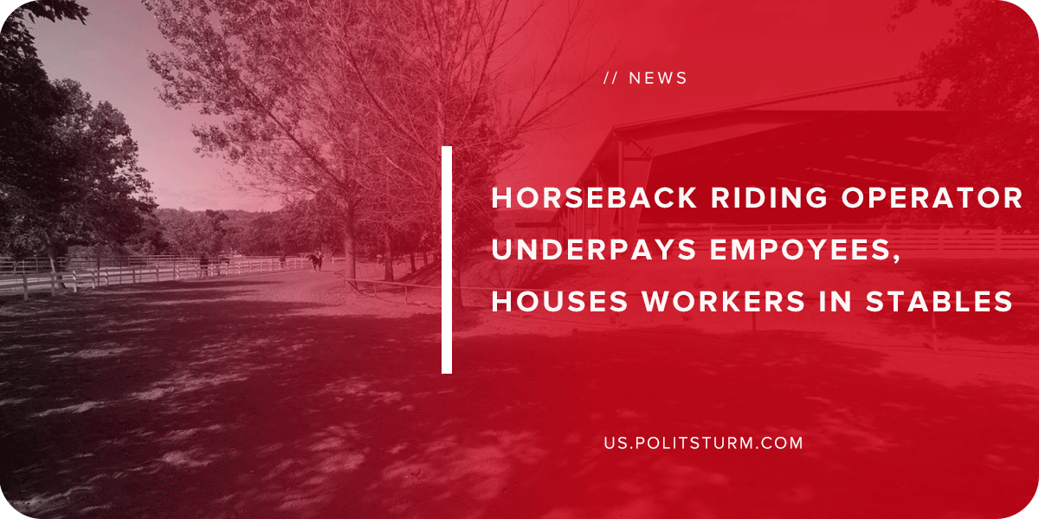

Original article
2019-04-12
1 min read

The U.S Department of Labor’s Wage Labor and Hour Division found that EWC & Associates, an operator of two horse training facilities, violated the Fair Labor Standards Act by not paying its temporary workers overtime pay.
In addition to the violations with respect to wage violations, the owner did not provide adequate housing for employees by housing the employees in converted stables without any running water. The employer also made deductions in order to cover the transportation costs to and from the home country of the workers.
The employer is forced to pay $1,270,683 in back wages and damages for the 30 workers who were affected. In addition, the employer will not be able to apply for any labor certifications such as the H-2B temporary visa program for a year.
This is just one more example of how the capitalist class will reduce the compensation and basic services to the workers to the absolute minimum. In this case, workers were housed in converted stables and underpaid as they provided the necessary labor while the capitalist profited.
Source

Original article

