Homes Are Unaffordable for Wage Workers in 71% of U.S. Counties
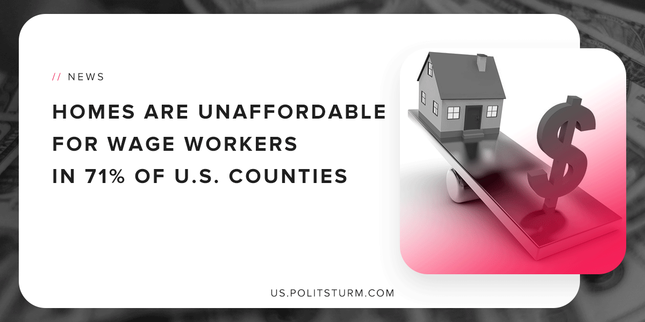

Original article
2019-04-28
1 min read

A recent release from ATTOM Data solutions, a property data provider, shows that the median home prices are unaffordable to wage workers in 71% of U.S counties. This startling conclusion was reached by comparing wage data from the Bureau of Labor Statistics to the income required to meet mortgage expenses on a median priced home.
The most expensive housing markets included Brooklyn, NY (115.9% of income) Manhattan, NY (115.0 % of income) and San Francisco (103.1% of income). These markets have effectively priced the working class out of the area. In these areas even if the average worker spent all their income on housing, they would still be unaffordable.
The working class is being priced out of certain areas due to the fact that they only derive income through wages. The capitalist class, by contrast, is able to derive unearned income through investments. Housing itself becomes an investment under capitalism, which allows investors and landlords to benefit at the expense of the working class. Only under a socialist economic system is it possible to provide quality, affordable housing to the mass of people.
Source

Original article

