The Homelessness Crisis in Canada Deepens
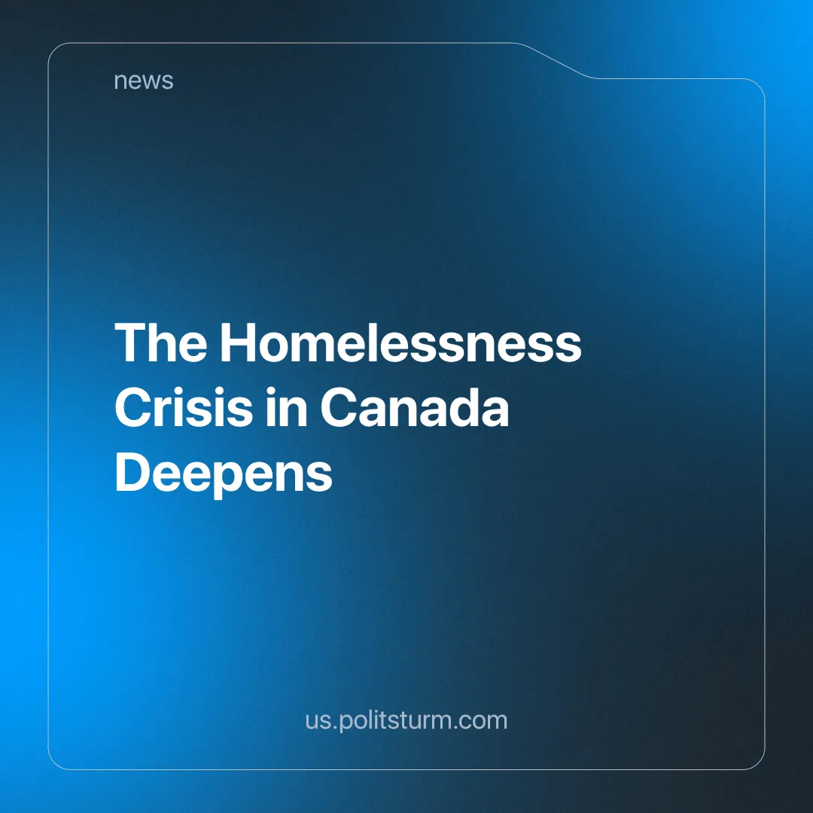

Original article
2025-01-08
2 min read

Many of the social workers in Quebec felt powerless as the homelessness crisis in Montreal deepened which has caused an increase of people forced to live outside in tents [1].
Many social workers have noticed more and more tents and homeless people on the streets of Montreal, which tend to disappear by early December. Many of the homeless people have faced rising living costs, unaffordable housing, mental and physical health problems that have led to a growing number of people resorting to living in tents, even during harsh winter conditions and subzero temperatures. That problem has been in Canada for a while in 2021 a poll was made where 11.5% of people have experienced some kind of homelessness [2].
Many of the homeless people also have faced challenges in going to the homeless shelters, as they were already full and had no more space to provide. Because of that, a lot of the homeless people have resorted to hiding in subway stations, and malls where loud music is played to get them out [3] or having to sleep standing in 24-hour restaurants.
Frontline social workers, who are stretched thin and struggling to provide adequate support, are calling for urgent government intervention to address the systemic issues driving the crisis, including poverty and housing shortages. Earlier last month the government of Quebec said that they’ve housed 1000 of the province’s homeless people, the official count of the homeless population in the province is planned for February 2025. But can the government completely eradicate homelessness in Canada?
It is a commonly known fact, that capitalism is a system with excess food production, but with starving people. Huge amount of homelessness, but empty houses. How is this possible? Under capitalism, people are divided into two classes: the exploiters and the exploited, the capitalists and the workers, those who own the means of production and take 90% of the profit for themselves and the working class who are forced to sell their labour to survive. Of course, the rich want to keep the wages as low as possible to maximize profits. And even though there is enough work to be done, enough things to do for everyone, there will always be unemployment in capitalism, to put pressure on the labour market which causes poverty. There is overproduction, but underconsumption, because of the system that we are in. The government has made every excuse for the rising housing crisis; immigrants, international students, etc. but never ever have they blamed the very system that breeds homelessness and benefits from human suffering.
Housing, itself, is a commodity. And the rich speculate on buying and selling real estate earning millions. Because of that, the housing prices skyrocket. They outbid the ordinary buyers and put astronomical prices on housing. Other than speculations on land they benefit from the estate as landowners, taking rent money from tenants or smaller businesses, which also affects the housing price overall. Having all that said Stalin’s quote comes to mind:
“If capitalism could adapt production not to obtaining maximum profit, but to the systematic improvement of the material conditions of the masses if it could direct profit not to satisfying the whims of parasitic classes, not to improving methods of exploitation, not to the export of capital, but to the systematic improvement of the material conditions of workers and peasants, then there would be no crises. But then capitalism would not be capitalism. To eliminate crises, it is necessary to eliminate capitalism” – Joseph Stalin [4].
Sources:
[1] National Post - “https://nationalpost.com/news/canada/workers-helping-the-homeless-in-montreal-feel-powerless-as-crisis-deepens” - December 22nd 2024
[2] Statistique Canada - “https://www.statcan.gc.ca/o1/en/plus/5170-homelessness-how-does-it-happen” - December 6th 2023
[3] CBC - “https://www.cbc.ca/amp/1.7396051” - November 2024
[4] Joseph Stalin - Works, Volume 12. Gospolitizdat, 1949. Pp. 235–373

Original article

