Highest Rate of Shooting Victims Recorded in Sweden
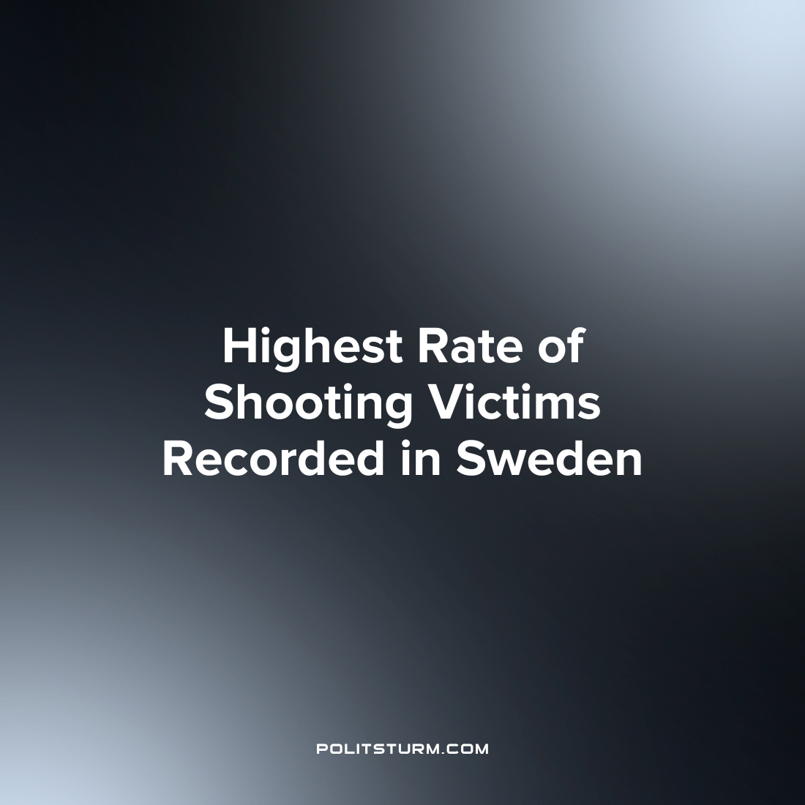

Original article
2023-01-12
1 min read

63 people in Sweden were the victims of shootings in 2022 which is the highest rate in modern Swedish history. This is a 40% increase in comparison with 2021, when 45 people died from getting a gunshot wound.
The last days of 2022 were especially bloody for Stockholm. On December 25th, a shooting took place in the Rinkeby district which resulted in the death of a 27-year-old man. On December 28th, shooters opened fire twice in the Gubbengen district. On December 27th, 28th and 31st, there were explosions in residential complexes in the southern districts of the capital, but in these cases, fatalities were avoided. Finally, on New Year's Eve, one person died, and two others were seriously injured as a result of shooting in the Veliingby district in the western part of the capital. Local police suspect all these cases of shootings and explosions were connected with the activities of organized criminal groups.
The crime rate in Sweden, as well as in other European countries is growing along with the deepening economic crisis. These countries’ residents, who are no longer able to provide a decent standard of living for themselves and their families, increasingly resort to criminal methods of expressing their discontent and despair.
To combat crime, Sweden's new government promises to carry out measures such as more police patrols on the streets and tougher penalties for lawbreakers. However, the bourgeois ruling class offers only ways to deal with the symptoms, instead of curing the disease itself - capitalism. As long as there is exploitation of man by man and the “legal” violence coming from the bourgeois state against its people, it is impossible to effectively fight against illegal manifestations of violence in society.
Sources:
Expressen – ”Blodigt rekord – 63dödsskjutningar 2022” from December 31st
SVT – ”Detta har hänt: Våldsdåden i Stockholm under jul- och mellandagarna” from December 29th
Izvestia – “In Sweden, a record 60 people fell victim to shootings in 2022” from December 5th

Original article

