Hedge Funds Speculate on the Ukrainian Conflict Market
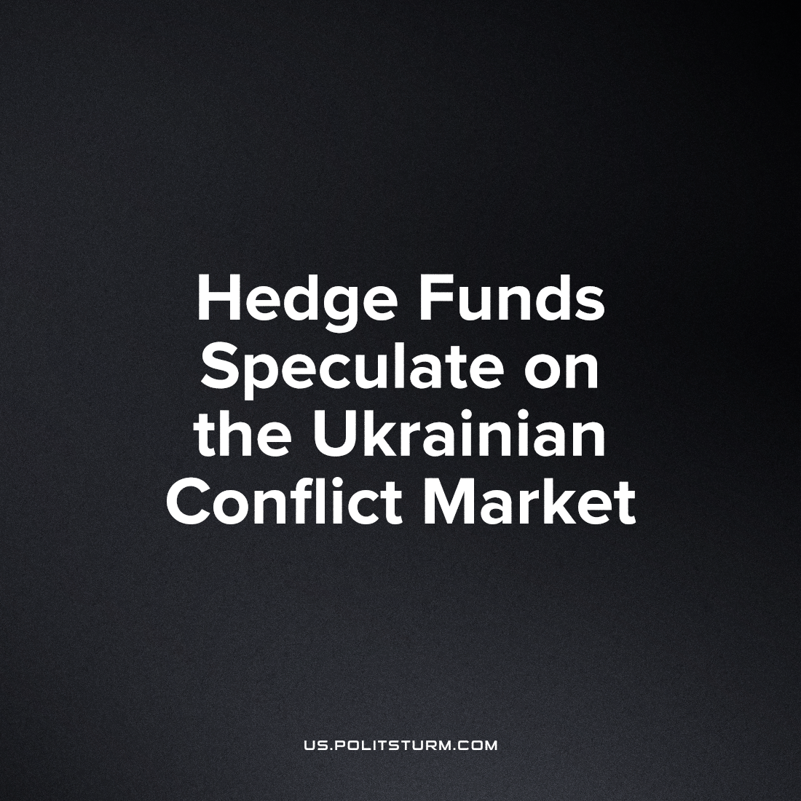

Original article
2023-05-02
3 min read

Guardian reports that the 10 largest hedge funds make huge profits speculating on food products on the Ukrainian market. Grain and soybeans are the main goods in demand in Ukraine. Hedge funds have made profits to the tune of 1.5 billion pounds sterling with speculative on the rising price of food. These profits were undoubtedly obtained by criminal means, but it is as to the same degree doubtful that the owners behind the funds will be held responsible or even scrutinized.
Olivier De Schutter, co-chair of the International Panel of Experts on Sustainable Food Systems and UN special rapporteur on extreme poverty and human rights, said: “Hedge funds and financial speculators have made obscene profits by betting on hunger and exacerbating it. That cannot be right. At the start of the Ukraine war, financial investors piled into grains and commodities in large numbers, seeking to capitalise on uncertainty and rising food prices, and they hit the jackpot.”
Statistics show that the food price index has increased by more than 50 points since 2019 and was over 150 in 2022.
Error loading image
How exactly do wars help capitalists get rich? The outbreak of war inevitably causes food shortages. General devastation, warfare, the predominance of military production over civilian production, all these consistently cause food shortages. This is precisely what the monopolists, who control the supply and markets of provisions, take advantage of. The scarcity created allows them to increase prices exorbitantly and still be sure that their products will be bought up, because food is a vital product. The nature of such speculation is cannibalistic, predatory exploitation of the needy, enrichment on the death and starvation of peoples.
Now the working class of Ukraine is faced with such devastation. It is being mercilessly robbed and condemned to extinction. The same applies to many other states in Asia, Africa, and the Middle East. By all appearances, for metropolises to live in abundance, dependent countries must die out and starve. This state of affairs can no doubt be described as a sophisticated form, a remnant of cannibalism.
The rhetoric of the capitalist class about the destructive consequences of imperialist wars and that such wars must be stopped does not accord with their actions. War brings the capitalists enormous profits unimaginable in peacetime. And war will continue as long as possible, for profits are never short, even if they are criminal. That is why the speeches of all capitalist peace activists are hypocritical.
While condemning the actions of governments that unleash wars, capitalists pay for and sponsor, promote and encourage militarism, profiting from the misery of millions. And the billions raised will undoubtedly go into a new phase of warfare and undoubtedly bring even more grief to the workers and even more wealth to the businessmen.
The hypocritical speeches of capitalists denouncing war are often coupled with the claim that war is nevertheless inevitable and thus allow the appearance of decency while actively participating in enrichment through militarism. All of this is simply a lie to the working class. Such talk is only necessary to deceive the workers, to lull their guard. Workers are also often divided among themselves, prevented from organizing, deceived by ideas of nationalism, and prevented from allowing international solidarity between workers of some countries and workers of others.
There will never be an end to war and international crimes as long as capitalism lives. It is the capitalist structure of the economy and society that produces all the social cataclysms of today: war, famine, poverty, and extinction of peoples. The only thing that matters in the capitalist system of economy is unlimited profit, and if it is necessary to make war or starve a country to death, the capitalist class will do so, as the news of the enrichment of hedge funds vividly demonstrates.
The only force that can stop the nightmare is that of a working class united by communist doctrine. Workers create all the goods in society and therefore have the decisive power they only need to realize it.
Source: 1

Original article

