Healthcare Under Socialism: The History of the Soviet Healthcare System
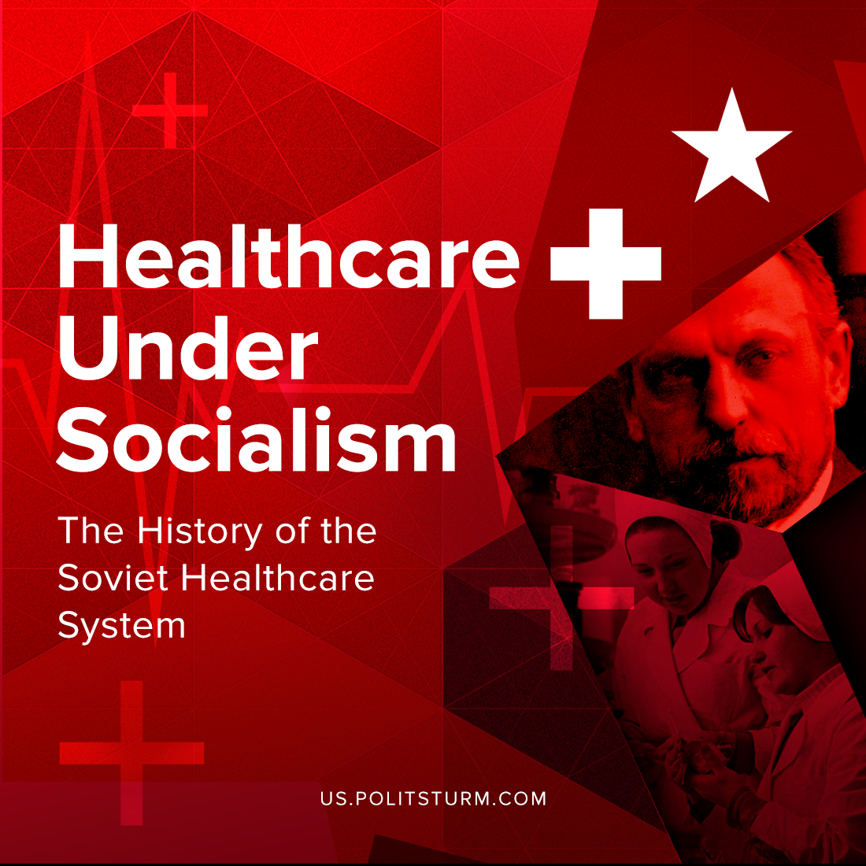

Original article
2021-09-07
18 min read

There are a lot of discussions on the healthcare systems today. Capitalist ideologists try their best to prove that the state healthcare system is too expensive and can not be implemented. But history proved them wrong. How did socialism change the approach to the management of healthcare?
As a result of the October Revolution of 1917, an entirely new state was created in place of the Russian Empire, establishing a proletarian dictatorship. For the first time in history, the country’s resources and means of production were in the hands of the majority of the population, rather than a narrow stratum of the nobility and bourgeoisie. It was a state with different principles of development and a unique communist ideology.
As far back as 1903, Vladimir Lenin outlined the objectives of the state in the sphere of health protection in the 1st Program of the RSDLP. It stressed the necessity of establishing an 8-hour working day, banning child labour, arrangement of crèches in factories, state insurance for workers, sanitary supervision in factories, etc. But like any new country, Soviet Russia was faced with many problems in all spheres which had to be solved as effectively and promptly as possible. And one of the most serious problems was the lack of a healthcare system.
Under the conditions of the hardest civil war and intervention, on July 11, 1918 after numerous and thorough discussions the Council of People’s Commissars adopted a decree “On Establishing People’s Commissariat of Healthcare” – the first highest state organ which united all branches of medical and sanitary affairs of the country. A Bolshevik and a prominent revolutionary, Nikolai Alexandrovich Semashko, became the leader of the new organization.
In the Russian Empire Semashko was a student at the medical faculty of Moscow University. Semashko’s teachers were I. Sechenov, the hygienist F. Erisman, and the surgeon N. Sklifosovsky. He was repeatedly arrested by the tsarist government, but in spite of this, he graduated from the medical faculty of Kazan University. He worked as an epidemiologist in the Oryol and Samara provinces and by 1917 had already had the well-established views and theoretical groundwork of his teachers on what medicine should be like in the new socialist state.
The main problem, however, was the lack of experience. In fact, such an experience simply did not exist. To a certain extent, the German approach, introduced by Bismarck in 1881, can be regarded as a precursor of the Soviet model. However, even his system did not cover the entire population of the country.
Error loading image
Nikolai Semashko based his proposed healthcare system on several ideas:
- Unified principles of organization and centralization of the health care system;
- Equal accessibility of healthcare for all citizens;
- Priority attention to childhood and maternity;
- Unity of preventive healthcare and treatment;
- Elimination of social bases of diseases;
- Involvement of society in the cause of healthcare.
All these ideas have been developed by many leading doctors in Russia and the world since the late 19th century. However, they were first put into the basis of public policy and implemented after the October Revolution in Soviet Russia.
Deadly epidemics of cholera, typhus, and other infectious diseases ravaged by total starvation, devastation, poor hygiene, and lack of qualified medical professionals, lack of medicines and their production. All this was by no means a complete list of the problems faced by the new People’s Commissariat of Health of the Russian Socialist Federative Soviet Republic.
There was an acute lack of hospitals, transport and fuel for it, and a lack of exchange of information between hospitals. Additional difficulties in the medical sphere arose even because most settlements had primitive or non-working water purification systems, which provoked the spread of many diseases.
Dealing with so many problems was not easy, but necessary.
Error loading image
Semashko’s main idea, around which all others began to develop, was the creation of a centralized medical system in which absolutely all such institutions were subordinated and accountable to the RSFSR People’s Commissariat for Health. As a result of these transformations, every person was assigned to a certain medical institution at their living place. In fact, such a system remained in our time in modern Russia without any major changes.
The centralization and unified health care system developed in the Soviet state was unprecedented in world practice. From October, 1917 to February, 1919, just in 2 years, important results were achieved in public health. For example, “the workers’ insurance program” was fully realized. The most progressive insurance legislation in the world was realized which made it possible to pass from insurance to social medical care for all groups of the population, introduced by the decree of October 31, 1918.
Special attention was paid to motherhood and childhood, and a network of specialized children’s clinics was created, which contributed to a serious reduction in child mortality, which had been the scourge of tsarist Russia. This contributed to a serious reduction in child mortality rates. Thus the country’s population almost doubled in the first 20 years.
New maternity wards were built throughout the country, the best medicines and conditions were provided for young mothers, and training in obstetrics and gynaecology was considered one of the most prestigious medical fields. At the same time, the government encouraged the birth of a new generation by paying subsidies for children. [1]
An important achievement was the prevention of diseases, as well as the elimination of the original causes of disease, both medical and social. The Civil War and the military intervention of 1918-1921 created an extremely difficult sanitary and epidemiological situation. According to incomplete data, from 1917 to 1922 about 20 million people got typhus, from 1919 to 1923 – about 10 million; about 65 thousand cases of cholera were registered during 1918-1919; in 1919 there was a threat of an outbreak of smallpox, the incidence of malaria and other infections increased.
Under such conditions, the struggle against infectious diseases was regarded as one of the major issues of the domestic policy of the Soviet State. Sanitary and anti-epidemic measures, improvement of living conditions, and improvement of settlements in a short period of time allowed to sharply reduce the incidence of infectious diseases, allowed to eliminate especially dangerous infections.
Error loading image
By 1922 the incidence of typhus decreased by more than 2 times compared to 1919, and in 1927 – by 89 times. After 1927 it was sporadic (some rise in 1942-1945 was noted mainly in the territories liberated from the Nazi occupation). The incidence of louse-borne typhus had decreased more than 100-fold by 1927; by 1938 it had been practically eliminated.
In pre-revolutionary Russia, from 5 to 7 million malaria cases were registered annually. In 1920 the Central Institute of Protozoal Diseases was organized, and in 1921 – the Central Malaria Commission under the People’s Commissariat of Health, under the leadership of which a scientific program for the elimination of malaria in the USSR was developed.
By 1930 the incidence of malaria had decreased by more than 3 times in comparison with the pre-revolutionary period. Since 1963, malaria in the country is not registered as a mass disease. Considerable success was achieved in the fight against other infectious diseases: in 1971 as compared to 1913, the incidence of anthrax was 45 times lower, typhoid and paratyphoid fever – 40 times lower, pertussis (1975) – 53 times lower; diphtheria, polio and tularaemia became rare.
Medical units were organized at various production enterprises of the country, which at that time were created rapidly. They were engaged in the detection, prevention and treatment of work-related diseases. They also provided first aid in case of industrial injuries of varying severity and supervised the assignment of workers to actively built health resorts.
At the same time, the development of vaccines against the most dangerous and widespread diseases was forced. Thus, on April 10, 1919, Lenin signed a decree of the Council of People’s Commissars on the compulsory vaccination against smallpox. As a result of mass smallpox immunization, smallpox had been completely eradicated in the USSR by 1936-1937. Children and adults were vaccinated on a mandatory basis, and hundreds of thousands of lives were saved. Thus in just 18 years, the Soviet government solved the problem, which the tsarist government had not solved in 100 years.
It is worth mentioning that in 1913 the TB mortality rate was 400: 100,000, while in the 1920s it was declining. By the time the USSR joined World War II, it had dropped fivefold – to 80: 100,000 – and this was before the onset of the era of anti-tuberculosis antibiotics.
Since the 1950s, the structure of morbidity and causes of death in the USSR became typical of economically developed countries. The characteristic spread of cardiovascular diseases and malignant neoplasms is connected in particular with the “ageing” of the population. Medical advances have ensured the lengthening of life terms of patients with heart and vascular pathology, which contributes to the known “accumulation” of such patients.
According to the data published by the Central Statistical Bureau of the USSR, the number of doctors (including dentists) in the USSR by the end of 1955 was 334,000, the number of hospital beds reached 1,290,000, the number of places in permanent crèches was 906,000[2] These figures clearly show the intensive pace at which the improvement of medical care for the population was taking place during the years of Soviet power.
Better diagnostics, in turn, led to better detection of diseases. Atherosclerosis, hypertension, coronary heart disease, and rheumatism were the most widespread. Among infectious diseases, influenza and other respiratory infections prevail and are one of the main causes of temporary disability.
Intestinal infections, in particular dysentery, as a rule, do not have epidemic spread. Respiratory and gastrointestinal infectious diseases have a pronounced seasonal pattern. Of childhood infections, measles, scarlet fever, whooping cough, and mumps are noted; the number of diseases has been constantly decreasing. In the structure of accidents, the leading place is occupied by injuries of non-industrial nature. [3]
An example of outstanding work of Semashko’s followers is the successful elimination of especially dangerous diseases – plague and smallpox, poliomyelitis, and cholera epidemic in the Crimea, Astrakhan, Odessa and Kerch in the late 1970s.
Error loading image
As a result of an outstanding operation to promptly contain a smallpox outbreak in Moscow in 1960, it was possible to prevent an epidemic in the country and to carry out mass vaccination of residents of Moscow and the Moscow suburbs.
To combat the cholera epidemic in Astrakhan Oblast, the All-Union Extraordinary Anti-Epidemic Commission (EEEK) was established under the USSR Ministry of Health in August 1970, with a very broad mandate. The administrative, hygienic, informational and educational measures taken contributed to the fact that the number of victims remained minimal and the spread of the epidemic was successfully localized.
Another aspect of N.A. Semashko’s own activities was to draw the maximum attention of the general public to the problems of healthcare, which consisted of poor financing and low interest of people in choosing a medical career. Thanks to his personal interest and influence, the production of new medicines began, universities developed, and research activities began to take hold. It made it possible to discover new methods of fighting disease, to develop technology, and even to be ahead of some progressive countries in this matter.
Also, according to various evidence and documents, it became known that Semashko himself actively intervened in questions of social life and the well-being of people and did everything possible to raise the standard of living of the country’s population, to provide everyone with everything they needed.
For example, at his initiative, water filtration systems were greatly improved in most major cities of the country. During his long career, Nikolai Semashko carried out many qualitative transformations, which in just a few decades completely changed healthcare in the USSR.
Error loading image
Under his brilliant leadership, several generations of qualified specialists grew up, thanks to whose work every citizen of the Soviet Union could count on high-quality, prompt and completely free healthcare, regardless of the severity of a particular disease.
One of the most important functional innovations developed and implemented by Semashko was the interconnection of medical institutions and the providing of universal healthcare for all segments of the population. Subsequently, these transformations, decisions, and the principle of free healthcare would be called Semashko’s System. It quickly became known outside the USSR and attracted the attention of other states. [4]
Semashko’s system is a model of the national healthcare system, in which medical services are provided by a hierarchical system of public institutions united in the Ministry of Healthcare and financed from the national budget. Providing medical care to the country's citizens is assumed to be universal, equal and free of charge.
Special attention is paid to social hygiene and disease prevention. The experience of building the Semashko system was carefully studied and used in designing a similar Beveridge system adopted in Great Britain and some other countries. Many developed countries of the world – Sweden, Ireland, Great Britain, Denmark, Italy and others – created their own budget health care systems based on the experience of the Semashko system created in the USSR and the Beveridge system that emerged after World War II.
An international meeting in Alma-Ata (1978) under the aegis of WHO recognized Soviet principles of primary health care as one of the best in the world.
Error loading image
The main weakness of Semashko’s system was its “chronic” underfunding, which, despite the free and universal coverage of medical care, in some cases had an impact on its quality. This is by no means a fundamental disadvantage of Semashko’s system itself. It should be taken into account that the USSR throughout its existence was in a cold or active confrontation with the developed capitalist countries, including being forced, for example, to divert part of the funds and resources to the military and industrial complex, the army and defence of the country. [5]
Particular attention should be given to the contribution of the Soviet authorities to the development of pharmaceutics in the USSR and in the rest of the world. In the first years of the Soviet power the reconstruction of the existing enterprises began. In 1920 the All-Union Research Chemical-Pharmaceutical Institute named after S. Ordzhonikidze was created, then a number of other research chemical and pharmaceutical institutes. During the years of pre-war five-year period (1929-1940) chemical-pharmaceutical plants were built in Kharkiv, Kyiv, Khabarovsk and other cities.
For the production of various medicines, the largest in the Soviet Union chemical-pharmaceutical plant “Akrihin” was built near Moscow. For the production of medicines, there were also built enterprises in a number of other republics of the USSR. During 1920-1940 years was organized the industrial production of almost all known at the time the most important medicines (sulfonamides, hypnotics, analgesics, etc.).
By 1948 the pre-war nomenclature of medicines had been restored. Later the Research Institute of Antibiotics and Medical Enzymes in Leningrad and the Research Institute of Research on New Antibiotics in Moscow were established. The growth of research base contributed to the significant expansion of the range and amount of antibiotics production.
During the Great Patriotic War of 1941-1945 had been built chemical-pharmaceutical plants in the cities of Urals and Western Siberia (Irbit, Tyumen, Anzhero-Sudzhensk, Kemerovo, Novosibirsk etc.). Production of a wide range of medicines was started. In 1947 the All-Union Scientific Research Institute of Antibiotics (VNIIA) was created, industrial production of penicillin, streptomycin, gramicidin, etc. was started.
By 1948 the pre-war nomenclature of medicines had been restored. Later the Research Institute of Antibiotics and Medical Enzymes in Leningrad and the Research Institute of Research on New Antibiotics in Moscow were established. The growth of research base contributed to the significant expansion of the range and amount of antibiotics production.
The output of chemo-pharmaceutical industry had increased by 5 times in 1950 in comparison with 1940, in 1955 – by 3.1 times in comparison with 1950; in 1951-1955 it was organized production of more than 65 new medicines. From the 2nd half of 50s to the middle of 60s a large number of new medicines had been mastered. During 1960 – 1965 had been organized the production of vitamins A, B1, B2, B6, B12, B15, PP, folic acid, etc. The All-Union Research Institute for Technology of Blood Substitutes and Hormonal Medicines and the Research Institute for Biological Testing of Chemical Compounds were established.
In Eastern European countries, there was no chemical-pharmaceutical industry before the 2nd World War, except for small half-business enterprises for the production of alkaloids and packing of imported medicines (Hungary, Czechoslovakia). The well-known pharmaceutical companies in Germany were mainly located in the west of the country, while in East Germany only a small number of medicines were produced.
Significant assistance to all European socialist countries in the organization of production of modern medicines: design, construction, installation and commissioning of chemical-pharmaceutical enterprises was provided by the Soviet Union. The USSR also provided scientific, technical, and economic assistance, assisting, in particular, in organizing and setting up production of medicines for developing countries such as India, Egypt, Iraq, and others. [6]
Thus, thanks to the October Revolution and the establishment of the dictatorship of the proletariat, Nikolai Semashko brought the organization of healthcare and medicine to an entirely new qualitative level, not only in the USSR, but throughout the world.
It is also important to understand that no matter how talented an organizer Nikolai Semashko was, he was not the sole creator of the system that is now called by his name. It was the state of the workers and peasants and the Bolshevik Party, with its support of Marxist-Leninist theory, that was able to create the conditions, allocate resources and funds for Semashko and his associates, so that they could realize their ideas to greatly improve everyday life of the whole population of the USSR.
Sources
- https://professiya-vrach.ru/article/sistema-sovetskogo-zdravookhraneniya-semashko/
- http://istmat.info/node/81 31. https://professiya-vrach.ru/article/sistema-sovetskogo-zdravookhraneniya-semashko/
- https://www.booksite.ru/fulltext/1/001/008/106/997.htm
- https://regnum.ru/news/polit/2318307.html
- 5.https://ru.wikipedia.org/wiki/%D0%A1%D0%B8%D1%81%D1%82%D0%B5%D0%BC%D0%B0_%D0%A1%D0%B5%D0%BC%D0%B0%D1%88%D0%BA%D0%BE
- https://www.booksite.ru/fulltext/1/001/008/119/035.htm

Original article

