"Harvey" and "Irma" will cause $300 billion damage
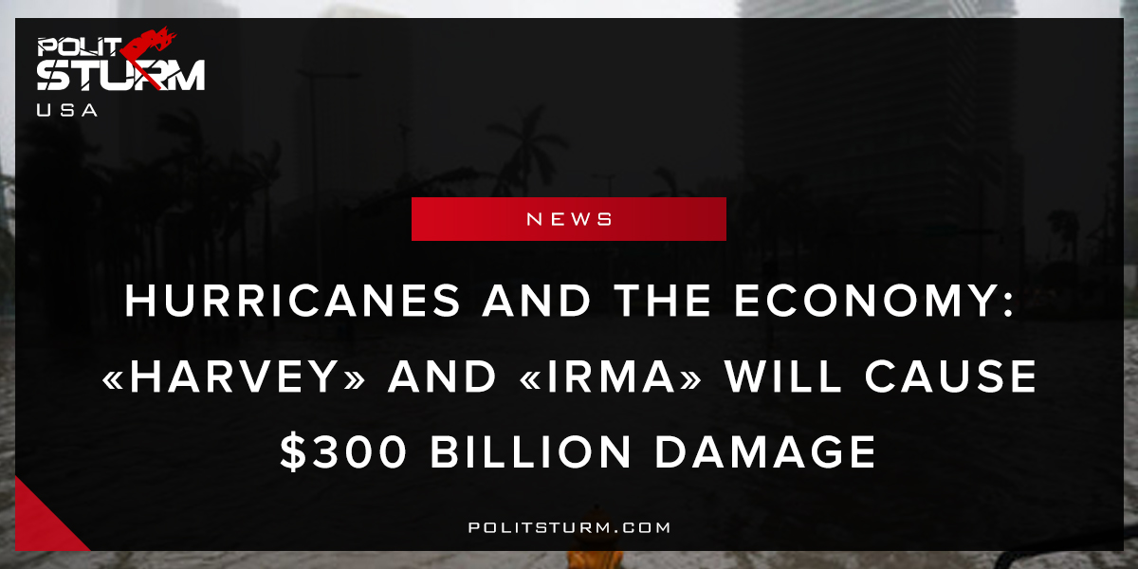

Original article
2017-09-12
1 min read

The devastation of hurricanes «Harvey» and «Irma» have now been commented on by America’s financial press. It is estimated that these hurricanes will case roughly $300 billion in damage. It is also estimated that these two hurricanes will slow down the growth of America’s Gross Domestic Product by ⅓, according to economist Avery Shenfield of CIBC Economics. These bourgeois economists are afraid that recent events will slow down the “economic recovery” that has been taking place over the last nine years. While corporate profits and the stock market have grown tremendously since the last economic collapse, wages and incomes have stagnated for the mass of people.
The class of economic elites, the bourgeois class, is fearing a slowdown of their economy. They are unconcerned with the hundreds of thousands of people in Florida and Texas whose homes are destroyed. They do not express concern about the actual welfare of the population, ravaged by the recent hurricanes. Homes have been destroyed, while at the same time less than half of people in Florida have flood insurance. In the wake of the crisis people without insurance are unable to rebuild their homes and “recover” like the stock market or profits. The market has a way of giving to those that have ( the bourgeoisie) , at the expense of everyone else. How long will we let this absurdity continue?
Source 1, Source 2

Original article

