Harvard Ignores Harassment Allegations Against Professor
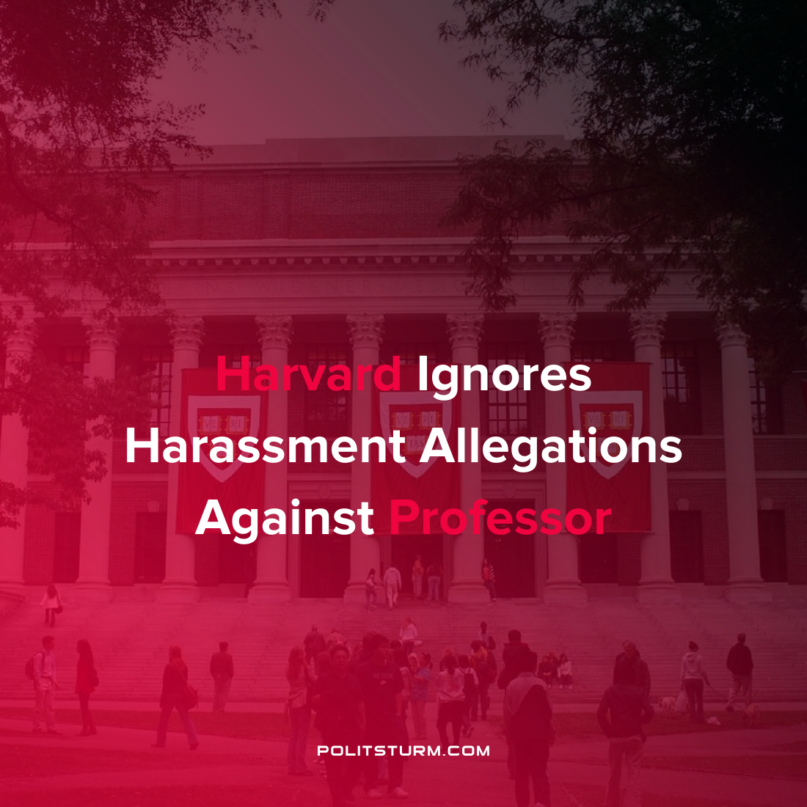

Original article
2022-02-12
2 min read

In efforts to cover-up serious sexual assault and harassment accusations made by students against anthropology professor of African Studies John Comaroff, Harvard University acquired the private medical records of one of the victims.
“What I can say is, Harvard induced somebody else to not follow the HIPAA regulations”, revealed one lawyer to the media outlet Gawker.
Harvard has refused to state the process by which they gained access to the private therapy notes, usually covered by confidentiality laws, but it is clear that they were sent to the accused professor through established formal channels. The following quote from the legal complaint details the chilling events:
In 2020, ODR (Harvard’s Office of Dispute Resolution) contacted (the victim’s) psychotherapist, a private therapist unaffiliated with Harvard, and obtained the psychotherapy notes from her sessions with (the victim). ODR did not obtain (the victim)’s consent for the release of those records. After obtaining the notes without (the victim)’s consent, ODR then withheld the full notes from (the victim), redacting swaths of the notes and refusing to disclose the redacted portions even as ODR’s investigator grilled her about the redacted contents during an interview.

ODR then provided the notes to Professor Comaroff as part of its draft report. Professor Comaroff, in turn, deployed the notes to gaslight (the victim), claiming that she must have imagined that he sexually harassed her because she was experiencing post-traumatic stress disorder — a condition that she developed as a direct result of his conduct.
The victims, now suing Harvard, clearly understand that these actions were intentionally provided by the university to be “used in service of Prof. Comaroff’s campaign of professional blacklisting.”
After several women reported the criminal misconduct to school administration, the professor retaliated against them in order to coerce their silence as the investigation began. Seemingly, his tactics had worked for years as Harvard buried numerous previous accusations against him.
Further intimidating the victims was the university’s petition, signed by 38 faculty Harvard professors, which protested the punishment of a single year of unpaid leave against the accused Comaroff on the grounds that he was “an excellent colleague”.
The lawsuit against Comaroff asserts that Harvard protected the professor and ignored any indication of wrongdoing because his reputation and influence make him a “valuable asset”. Harvard, which has a $52.3 billion endowment, is more concerned with protecting its business interests and prestige than the safety and wellbeing of the students who attend the university.
Sources: 1, 2, 3 4

Original article

