Harris Announces Investments in Central America
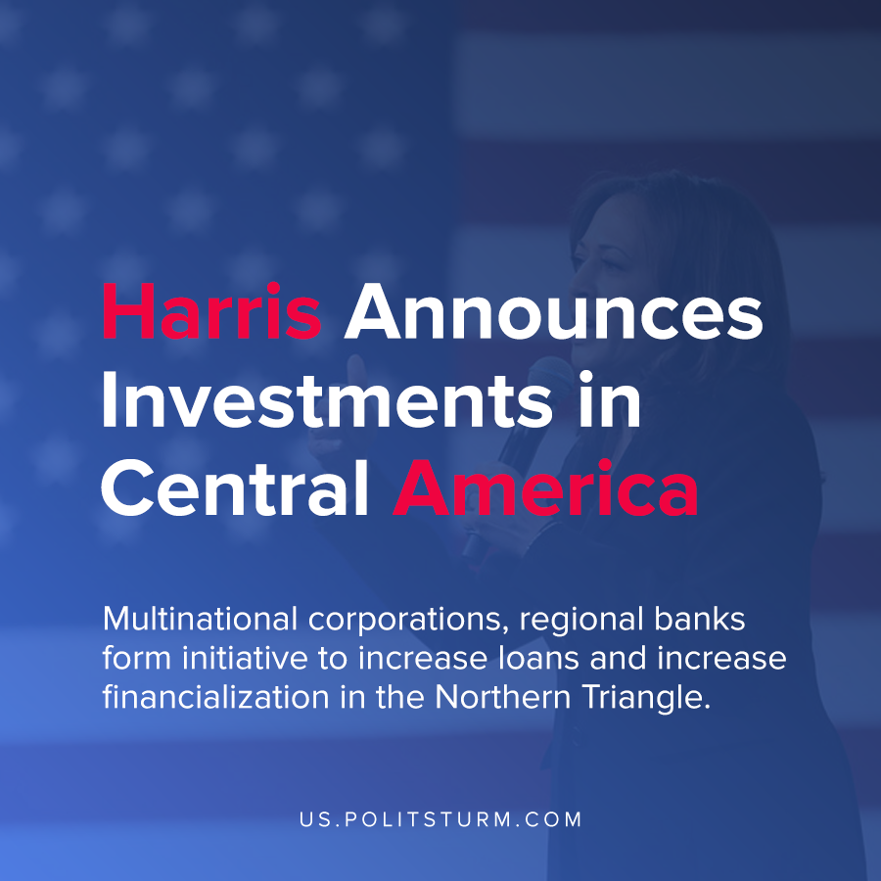

Original article
2021-05-26
1 min read

Kamala Harris launched a new “Call To Action” for the private sector to increase investment in the Northern Triangle which includes Guatemala, Honduras and El Salvador. The initiative included major U.S. businesses such as Mastercard and Microsoft, the World Economic Forum and others.
The stated goal of the initiative is “to help send a signal of hope to the people of the region and sustainably address the root causes of migration by promoting economic opportunity”.
The logic underpinning the initiative implies that the U.S. government and private partnerships in cooperation will stabilize the business environment and increase capital flows to the Northern Triangle increasing investment and thereby employment.
There are also regional banks such as Davivienda and Bancolombia which as part of the initiative are increasing the credit extended and intend “to increase investment and improve living conditions, and strengthen ties to their local communities”.
It is apparent that the benefits of such an initiative will flow to large corporations and regional banks. The Marxist-Leninist understanding of imperialism demonstrates that under capitalism a large flow of money capital becomes concentrated in a few countries. The accumulated capital then is lent with the intent of extracting surplus value and the further accumulation of capital. The flow of capital to Central America and increasing financialization will not resolve the poverty and uneven development in the region, however, it is simply another opportunity for the capitalists to profit .
Source : 1 , 2

Original article

