12.5 Million UK Households Excluded From Economic Growth
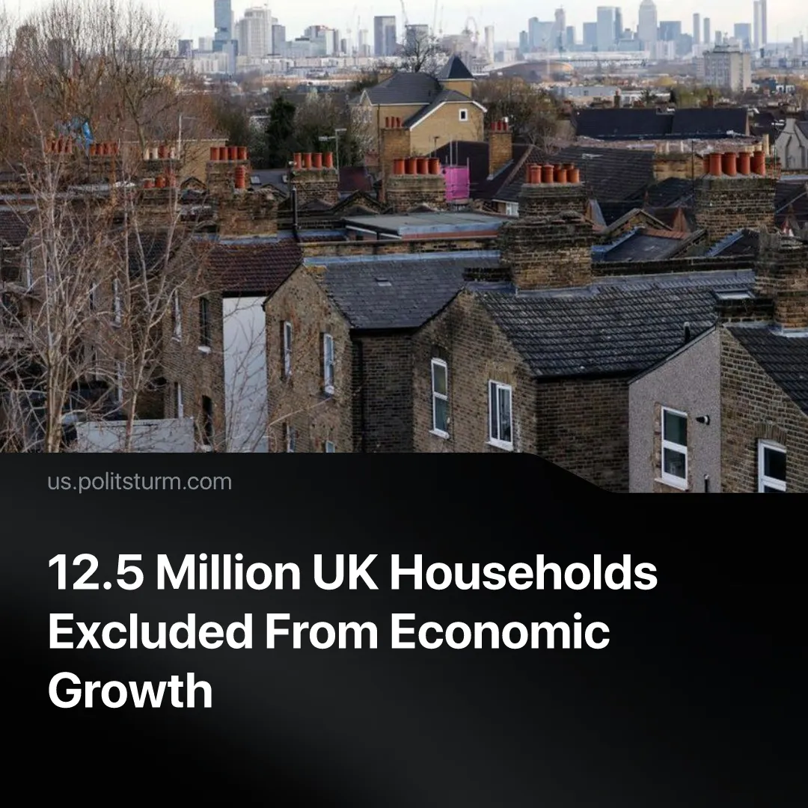

Original article
2026-09-12
1 min read

Nearly half of all UK households gain nothing from economic growth. Under socialism, growth was centred around improving living standards.
Details. A major PwC (a global corporate auditing firm) economic report shows that 12.5 million UK households, or 46% of the country, gain nothing from national economic growth. It showed that newly generated wealth ends up overwhelmingly concentrated in London and the South East, with other regions reporting that they do not feel the benefit of economic growth .
► Capitalist governments treat GDP, measuring total goods and services produced, as the primary metric of economic growth, alongside business investments and job opportunities. The study instead focused on workers' spending power, tracking the actual cash left after housing costs and taxes.
► Prime Minister Andy Burnham is pitching his former Greater Manchester mayoral strategy of "devolution" as a national fix for geographic inequality. Part of the plan is to take £150 million of public money and hand it to private companies in the “north”, attempting to stimulate regional economies by heavily subsidizing capitalist growth.
Context. Even if economic growth translated directly into better living conditions, workers would see little benefit. UK growth has stagnated around 1% annually, and this meagre growth, which still ends up being tens of billions in new wealth, overwhelmingly appropriated by capitalist class.
► British workers are instead trapped in a severe cost-of-living crisis, with 7.1 million going without essentials, and the bottom 40% seeing their real earnings decrease. High rents, food and energy prices are paired with rising unemployment, with workers also bearing the brunt of militarisation costs. Meanwhile, capitalist profits climbed past £170.7 billion in the second quarter.
► This slow growth contrasts with the massive economic expansion seen in historical socialist economies. Instead of hoarding wealth for the bourgeoisie, socialist growth was directly connected to the improvement of living conditions. Surging production directly funded higher living standards, such as in the Soviet Union between 1951 and 1954, when a 33% jump in industrial productivity was immediately matched by a 37% increase in workers' real wages and shorter working hours.

Original article

