Gulf States Aligned With US in Iran Conflict
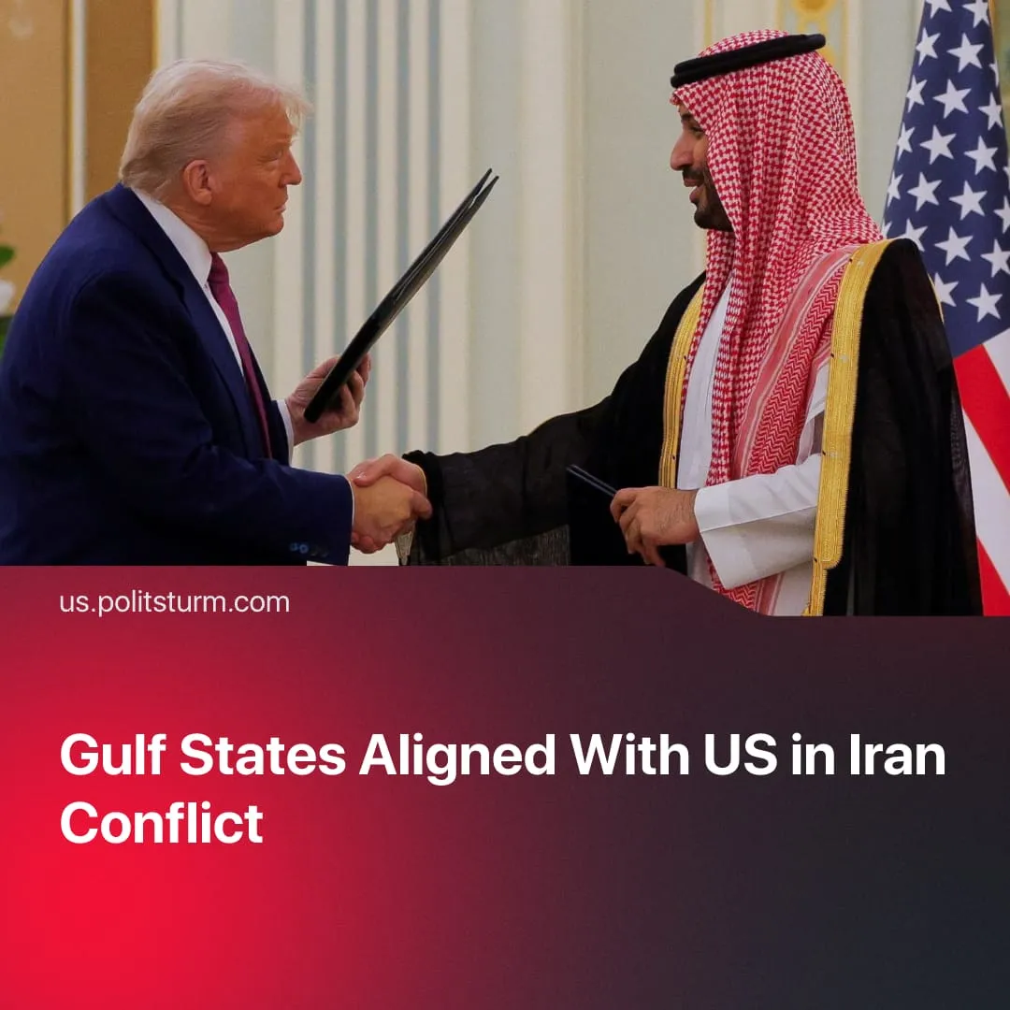

Original article
2026-04-18
1 min read

Gulf states deepened their partnership with the US during the Iran War, reversing previous attempts to become autonomous.
Details. Gulf Arab states (the UAE, Saudi Arabia, Kuwait and others) are reconnecting with the USA, acknowledging their reliance on American imperialism’s control over trade routes and military power amid Iran’s attacks. In the past, some Gulf states had aligned with efforts by other Sunni Muslim countries to form an imperialist bloc independent from the US.
► After the US-brokered ceasefire, UAE fighter jets allegedly bombed oil refineries in Iran for the first time, which responded by launching 7 retaliatory attacks across the Gulf states. Previously, Gulf states had discussed the possibility of joining the US-Israeli offensive campaign, but hid this behind a facade of defensive “neutrality".
► The US now plans to directly support the Saudi Arabian nuclear program by providing enrichment technologies that may enable development of atomic weapons, signing a “pathway” agreement in April. Saudi Arabia designated American firms as preferred partners for nuclear business, as part of its recent $1 trillion deal to expand ties with the USA.
► Two other regional powers, who aligned with previous Saudi moves to reduce dependency on the USA, are more cautious. Pakistan took a middle path by leading Islamabad Accord ceasefire talks while deploying military jets to deter Iran. Turkey used similar neutral rhetoric: closing airspace to US combat flights and condemning "violation” of Iranian sovereignty, while also labelling Tehran’s attacks on the Gulf “unacceptable".
Context. Israeli imperialism is trying to expand its regional power in the Middle East, to create a counterweight for the Turkish-led imperialist bloc that includes Saudi Arabia and Pakistan. After Washington allowed Israel’s attack on Qatar in 2025, Gulf states had explored alternatives to reliance on the USA, aware of American favouritism for their rival.
► Since both blocs currently share the same opponent – Iran – and both still depend on the US, their struggle has paused for now. However, the long-term trend remains directed towards further division, amid increasing US tensions with NATO. American capitalists have a profitable interest to align more closely with Israel while distancing themselves from countries like Turkey.

Original article

