Gorbachev: The Death of the Renegade
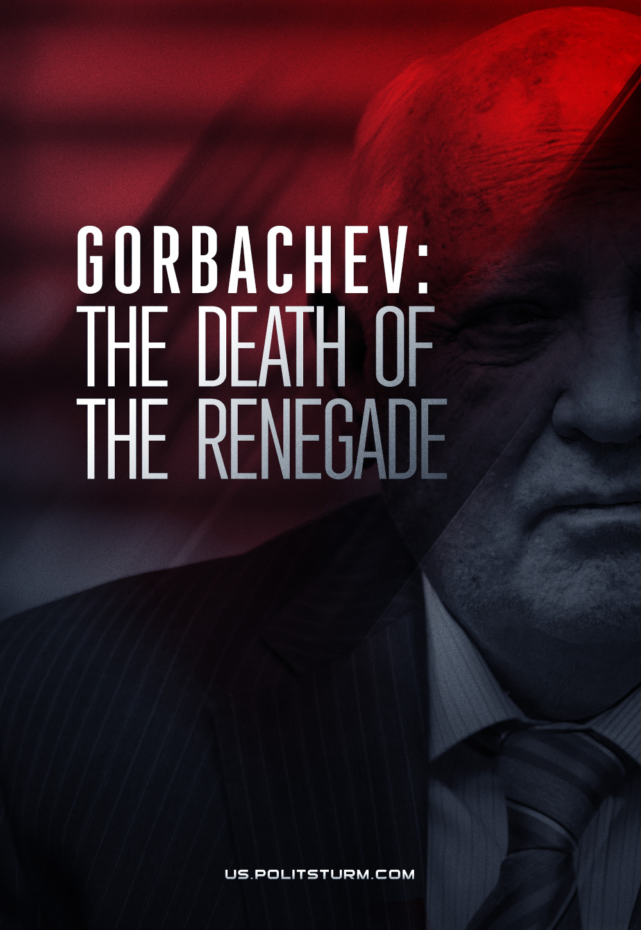

Original article
2022-08-31
3 min read

On August 30, 2022, a man died whose name is pronounced with hatred by millions of people who lived in that country for which he was responsible, and under whose leadership showed the greatest irresponsibility.
The appearance of such a man as Mikhail Gorbachev at the head of the Soviet state was a natural consequence of the deepening of revisionist counter-revolutionary tendencies in the Communist Party and in the Soviet Union as a whole, and the weakening of the dictatorship of the proletariat.
Repeating the actions of the Hungarian and Czechoslovak revisionists in many cases, succumbing to the deceit of the imperialists and disarming at the feet of the capitalist powers, the leadership of the USSR headed by Gorbachev created favorable conditions for the growth of counter-revolutionary elements within the country and the entire world socialist system.
This process culminated in a counter-revolution at the turn of the 1980s-1990s, which led to the liquidation of the socialist camp, the establishment of the dictatorship of the bourgeoisie in the former socialist countries, the complete destruction of the USSR, ethnic conflicts, poverty and the death of millions of people and the triumph of reaction for many decades.
It is indicative that the criminal activity of Mikhail Gorbachev in relation to socialism was duly appreciated by the leaders of the capitalist countries. Like most other revisionists in other republics of the former USSR, Gorbachev was no longer needed by the bourgeoisie. Like Gorbachev, almost all the other renegades of socialism settled down: they received warm seats in private companies, in the leadership of bourgeois parties or governments.
Having provided the “first and last president of the USSR” with a comfortable life at the expense of many others, the capitalists threw him into the dustbin of history. For the past 30 years, and after his death, they sang false praises ceaselessly to him as a man who “peacefully ended the Cold War”, “opened the way to a free Europe”, etc. These words sound all the more false and hypocritical since the defeat of the forces of socialism was accompanied by unprecedented violence and conflict, the victims of which numbered in the hundreds of millions.
In our time, the forces of reaction are inflaming ongoing wars and dragging the world into new conflict. The example of Gorbachev’s leadership is a cruel reminder to all communists of the importance of following Marxist-Leninist theory, the importance of a merciless struggle against opportunism and the revision of Marxism, and the importance of involving the masses in the government of the country. But most importantly, this page in the history of world socialism has become an eternal example of the price that communists and all working people have to pay for mistakes and defeat in the class struggle.

Original article

