Google Workers Fired Amidst Attempt to Organize
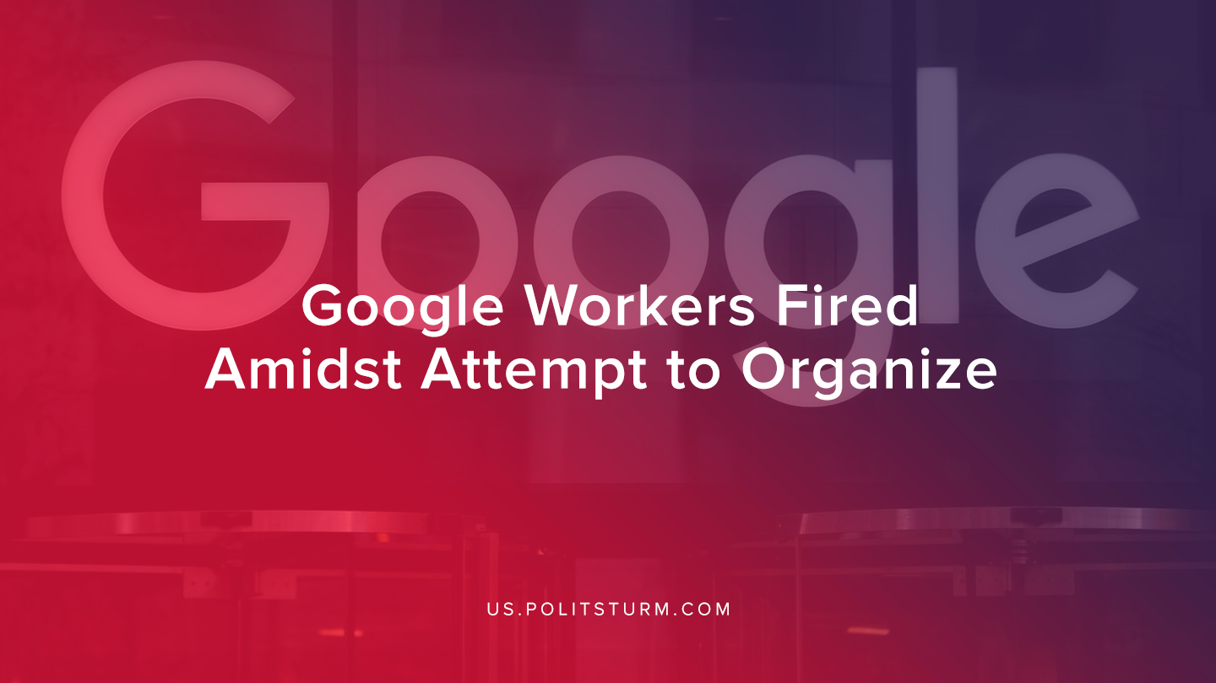

Original article
2019-12-07
1 min read

Google fired four employees who were critical of the company’s practices and were engaged in labor organizing. The workers contest the claims made by Google that they were fired for leaking sensitive documents to the press.
In their criticism of the company, the workers cited Google’s cooperation with Customs and Border Protection, the development of drone technology with the Department of Defense, the unfair treatment of temporary workers and contractors, among other grievances.
The workers are adamant that their termination was a result of their work to lawfully organize Google employees.
The workers have stated that they are going to be filing an Unfair Labor Practice with the National Labor Relations Board to see if Google acted unlawfully.
In this instance, we can see the clear divergence of interests between Google and its employees. The workers attempt to organize were swiftly opposed by Google and the organizers were fired. While the workers attempt to organize Googles employees is admirable and commendable, it is necessary to organize using Marixst-Leninst principles and theory to achieve success.
Google has demonstrated that it will act swiftly and forcibly to protect its class interests, and the workers must do the same.
Sources: 1 ,2

Original article

