Google Underpays Thousands of Workers
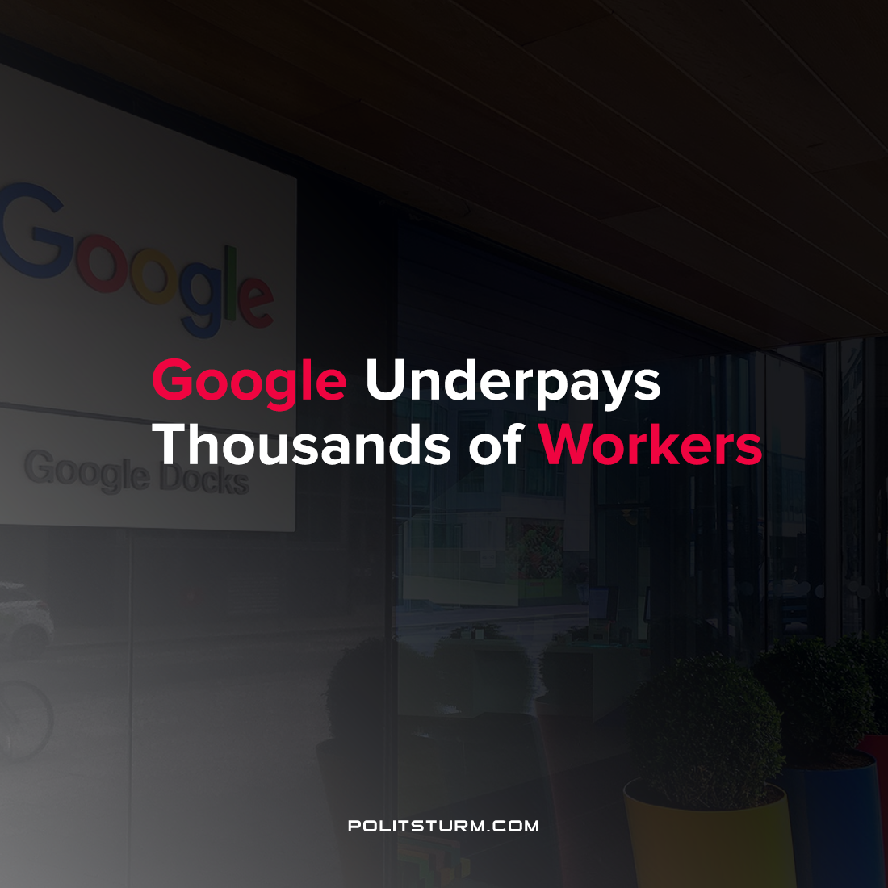

Original article
2021-09-11
1 min read

According to an article published by The Guardian, Google has illegally underpaid thousands of its employees across several countries. Executives at the company were aware of the underpayments, and attempted to cover up the problem as evidenced by internal documents and emails.
According to the laws of the countries in which the violations occurred, Google was not able to pay lower wage rates to temporary workers who were doing the same work as its full-time employees. The estimates for the amount of wages withheld to temporary employees had they complied with local laws is $100 million.
Google employs a large number of workers in its “extended workforce” who are temporary workers, contractors and vendors who are not directly employed by the company. It is estimated that Google employs 100,000 of such workers.
It should be noted that Google reported a net income of $18.5 billion in the second quarter of 2021 and their CEO Sundar Pichai boasted that they “benefited from excellent execution across the board by our teams”.
This example is just one of many where the capitalist class even fails to pay its workers wages in accordance with the capitalist laws which already allow for massive profitability. On the one hand, the private owners and major shareholders reap massive profits from their social position. On the other hand, the workers who perform the labor necessary for the functioning of the enterprise are super-exploited to the chagrin of the capitalists. Only the elimination of the dictatorship of the bourgeoisie and the institution of the dictatorship of the proletariat will eliminate the exploitation of man by man and the massive transfer of wealth from the producers to the idle rich.
Sources: 1 , 2

Original article

