Google Employees Form Tech Union
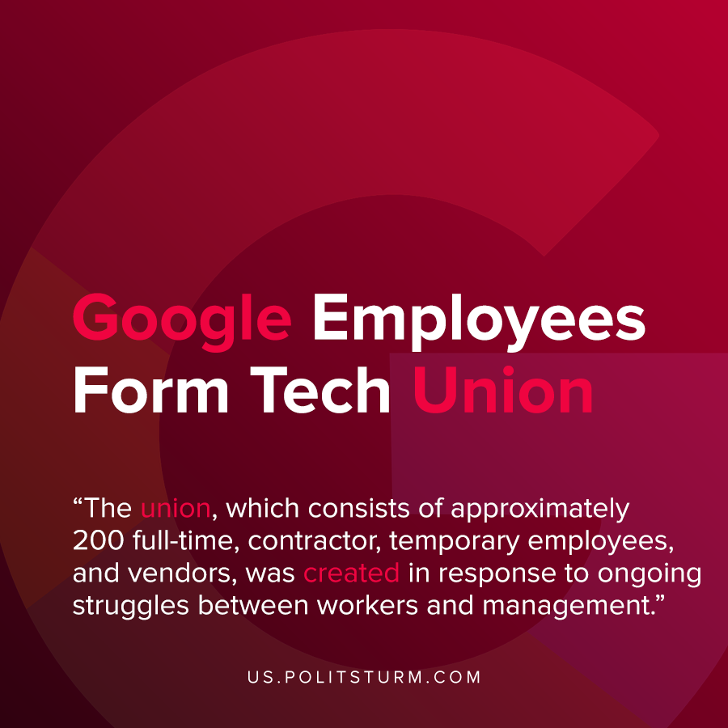

Original article
2021-01-06
1 min read

Hundreds of Alphabet workers formed a union with the support of the Communications Workers of America (CWA). The union, which consists of approximately 200 full-time, contractor, temporary employees, and vendors, was created in response to ongoing struggles between workers and management.
The union specifically cites Google’s historical discriminatory behavior and harassment towards its employees. It also cited the fact that Alphabet has contracted with the U.S. Department of Defense to use artificial intelligence technology for war and contracting with U.S. police departments amidst ongoing protests of police brutality.
“This is historic—the first union at a major tech company by and for all tech workers,” said Dylan Baker, Software Engineer. “We will elect representatives, we will make decisions democratically, we will pay dues, and we will hire skilled organizers to ensure all workers at Google know they can work with us if they actually want to see their company reflect their values.”
While the formation of the union is laudable and historic, the union’s program unfortunately does not criticize capitalism merely the excessively egregious behavior of the company. Under the rule of capital, it is impossible to have a truly democratic workplace and achieve the ideals that the union is fighting for. True democracy and the elimination of imperialism is only possible by abolishing capitalism through the rule of the dictatorship of the proletariat and the abolition of wage labor and capital.
Sources: 1 , 2

Original article

