Google Contract Workers Outnumber Direct Employees
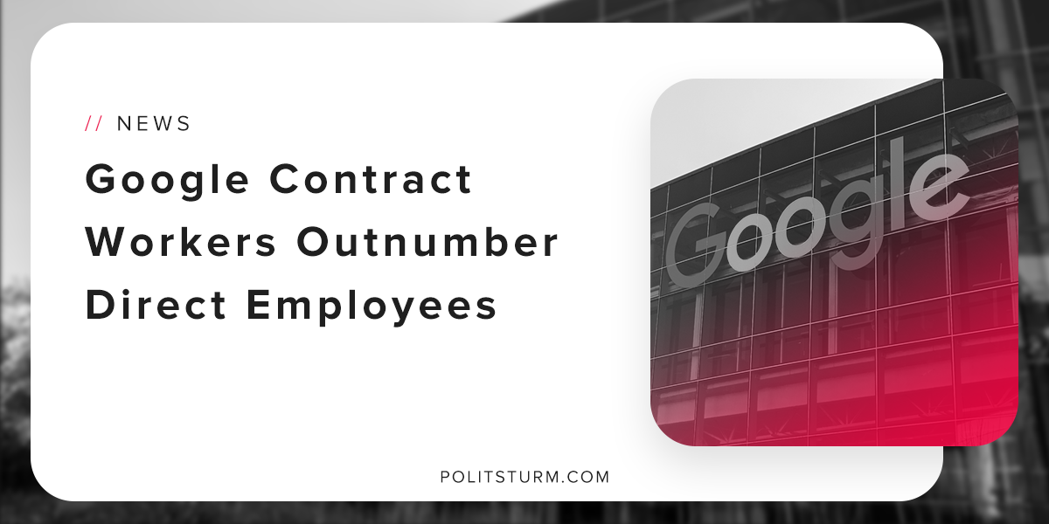

Original article
2018-10-28
1 min read

For the first time in Google’s 20 year history, the number of contractual workers has eclipsed the number of direct employees. In the most recent financial reports, Google’s parent company Alphabet reported increased revenues of 21% from the third quarter of 2017.
Google has resorted to using contractual workers rather than full-time employees in order to reduce the number of benefits given to workers. Contract workers are not eligible for the same health-care or retirement benefits that direct employees receive.
In this way, the company is able to reduce their labor costs and boost short-term profitability at the expense of the working class.
The capitalist economic system puts the capitalist class and the working class in direct opposition. Reduced benefits are a positive outcome for the owners of capital who will receive increased profits.
By contrast, the working class is forced to work more precarious jobs, dubbed the “gig-economy”, in order to make ends meet.
The employer is not required to provide even basic necessities for its workers. As a result, the workers are forced to rely on state programs if they are even available.
The capitalist system allows the owners of capital to privately own the means of production and benefit from the insufficient wages and benefits given to working people. For as long as the government serves the interests of the capitalist class the owners of capital will continue to siphon off the unpaid labor of the working class and gorge themselves on the tremendous profits.
https://politsturm.com/trump-promotes-budget-cuts-across-the-board/
Sources: 1 2

Original article

