Global Armed Conflicts Hit 75-Year High
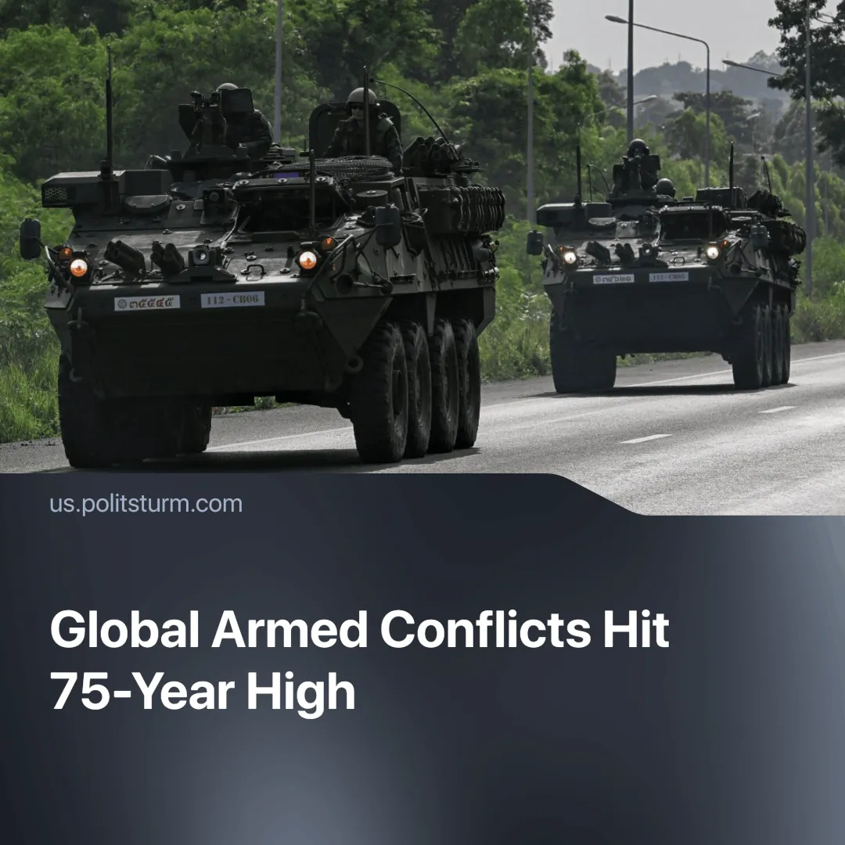

Original article
2025-08-04
2 min read

The world experiences the highest number of wars since World War 2. Communists are at risk.
Details. The Peace Research Institute Oslo (PRIO) reports 61 active state-based armed conflicts across 36 countries in 2024 — the most in over 75 years.
► Africa experienced 28 conflicts, Asia 17, the Middle East 10, Europe 3, and the Americas 2. Nearly 740,000 battle‑related deaths occurred between 2021 and 2024, with 129,000 in 2024 alone — making it the fourth-deadliest year since the end of the Cold War, driven largely by casualties in Ukraine and Gaza.
► Early 2025 clashes — including the India-Pakistan Kashmir conflict, US-Israeli strikes on Iran and the Cambodia-Thailand skirmishes — show the trend is continuing.
► These brief, high‑intensity operations ended quickly, either after achieving limited objectives or under pressure from other powers seeking to prevent wider escalation.
Context. The world is experiencing another crisis of the capitalist system. In 2024, EU industrial output fell by 2.4% as Germany, its largest economy, remained in recession. In China, producer prices dropped for over 33 consecutive months, and chronic overcapacity forced major solar firms to lay off a third of their workforce.
► Global overproduction of goods and capital with a lack of markets, stagnation of labour productivity, collapse of global supply chains and rising debts of both governments and the private sector – all this cannot be resolved without the redistribution of markets, sources of raw materials and zones of influence, that is, through wars.
► There is an intensive arms race and militarisation of economies. America, China, Russia, the European Union and other imperialist states and blocs have sharply increased the volume of their military budgets. Arms concerns are becoming the locomotive of capital investments. Global military spending surged to $2.7 trillion in 2024, up 9.4% from the previous year and the steepest rise since the Cold War.
► Old international structures are weakening. The UN, OSCE, WTO and START are being ignored. The US and NATO are violating the norms they created, and the imperialists who oppose them are increasingly challenging the global situation that emerged after America's victory in the Cold War.
Important to Know. Modern imperialism mirrors its “classical” phase of the late 19th and early 20th centuries, when finance capital carved up the world through frequent wars.
► The battlefields of the new division of the world have already been formed as proxy conflicts in Eastern Europe, the Middle East and South-East Asia. Proxy wars are more profitable for major powers, as they are cheaper and allow for the simultaneous waging of several conflicts.
► Inflation, unemployment, rapidly deteriorating quality of life and the ecological crisis are reflected in the growth of popular discontent. The authorities need conflicts to maintain their positions: capitalists suppress discontent, justify repression and utilise some of the surplus labour through wars.
► Communism, being the most consistent ideology in support of peace, is the top priority target of repression in bourgeois states. Communists were recently banned in the Czech Republic. A mass spread of such laws in all EU countries should be expected. As a major conflict approaches, the bourgeoisie will continue its militarisation, fascization, stifling opposition sentiments and suppressing the working class.

Original article

