German Residents Reject the Church
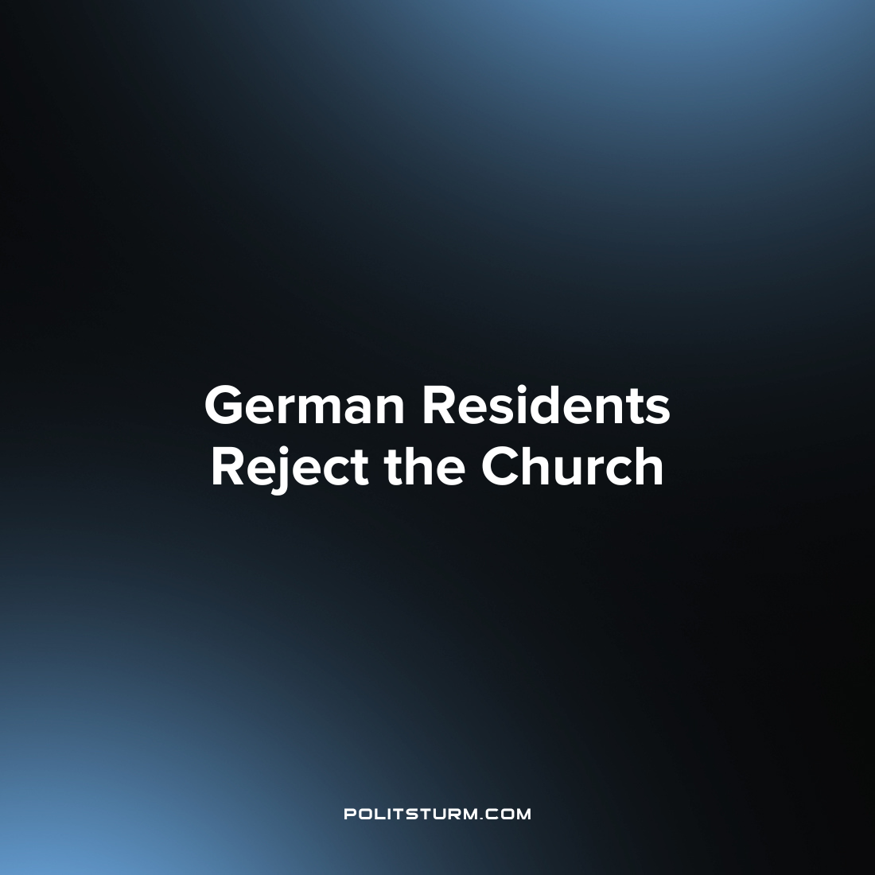

Original article
2023-09-06
1 min read

More and more people in Germany are abandoning the church — less than half of the population belong to any of the major Christian churches operating in the country.
According to the results of a representative poll by the YouGov Institute of Public Opinion, nearly three quarters of German residents — 74% — consider the church tax obsolete. Only 13% of respondents consider the tax necessary.
The German Conference of Bishops reported that the Catholic Church in Germany received €6.8 billion in taxes in 2022. The Evangelical Church received €6.2 billion.
It is noted that currently Germans are leaving the church en masse. Last year, half a million people left the Catholic Church, and 380 thousand left the Protestant church. Currently, the majority of German residents do not belong to any of the main Christian churches.
In modern society, the church, like other similar organizations, exists only for the purpose of controlling the working masses, instilling idealism, which is characterized by conservatism. Religions urge humbly to endure and pray in the hope that the problems will be solved by themselves. Churches, like business representatives, are engaged in extracting profits from the population. For example, by introducing a church tax, collecting donations and selling all kinds of religious attributes.
Karl Marx revealed the essence of religion more than 150 years ago:
"Religion is the sigh of an oppressed creature, the heart of a heartless world, the spirit of soulless orders. Religion is the Opium of the People."
(K. Marx, "Towards a Critique of Hegel's Philosophy of Law", 1843)
Source: 1

Original article

