German Pilots Threaten Another Strike
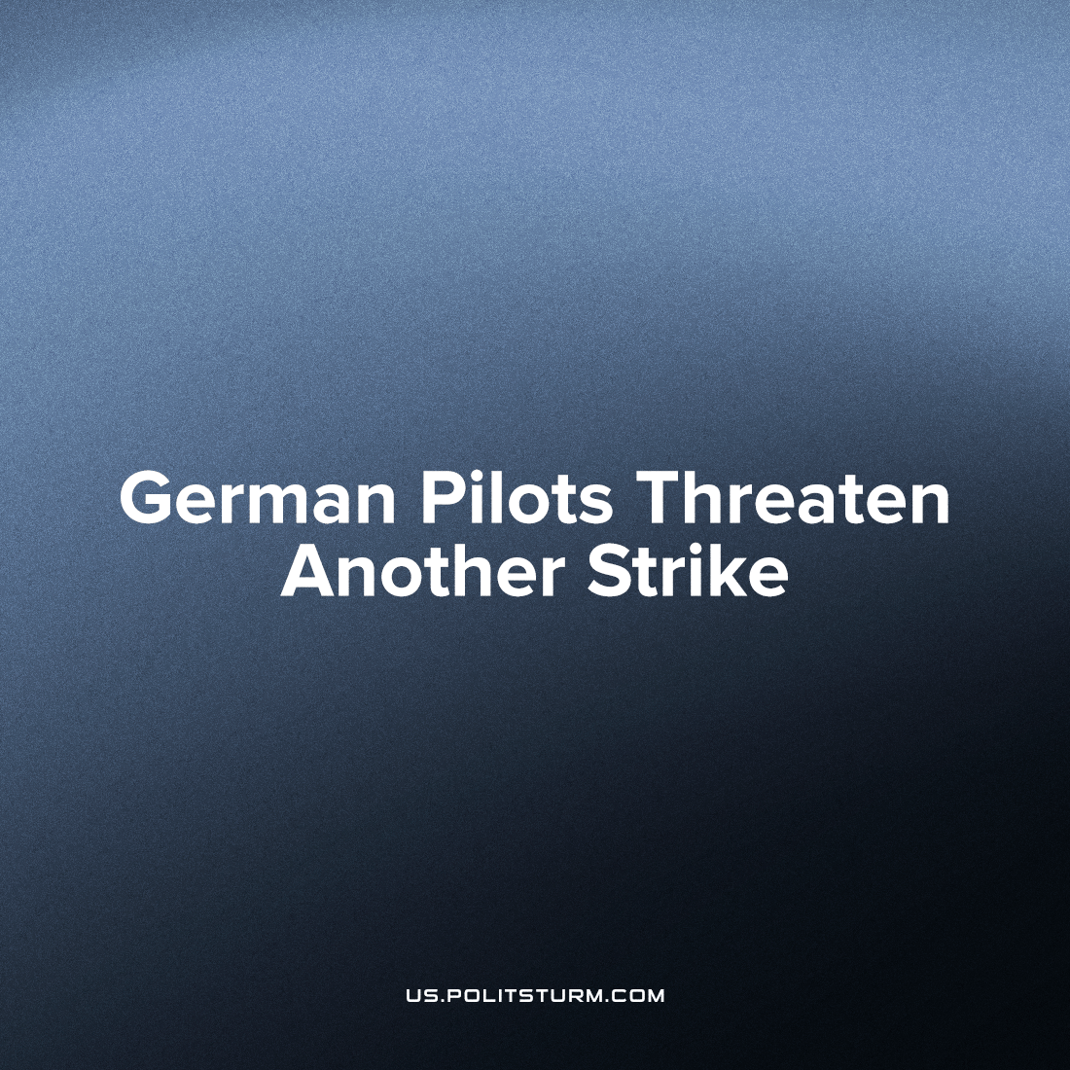

Original article
2023-04-13
2 min read

A second wave of the conflict between the German national airline Lufthansa and its pilots and aircraft engineers union Vereinigung Cockpit has renewed, in a dispute which flared up last year [1] and again earlier this year. Negotiations between the company and the union have not brought results, so the likelihood of a strike has risen. At the moment, a memorandum has been signed between the air carrier's corporate management and the employees' bargainers, which “froze the conflict”. But this agreement ends in June. In case of a failure of negotiations, the union is prepared to take decisive action.
The goal of the trade union is a new collective agreement that will provide union members with better rates and career opportunities.
The previous strike led to the mass cancellation of flights and affected about 130 thousand passengers - only a fraction of Lufthansa's many millions of travellers per month. To calm the mood, management raised pilot's basic salary by 980 euros in two stages, a 5.5-to-20-percent increase depending on the level of income. According to the airline, as a result of the strike, the company suffered damage of 32 million euros [2], despite the billions made in growth from a previous 2021 Covid-19 low of 9 billion euros in revenue to 22 billion in 2022.
Corporate takes in enormous revenues with the workers hands, and still blames them when blocked union negotiations force them to fight to earn a small part of it. With the aggravation of the crisis of capitalism, the class struggle is also becoming more acute. Even in the critical sectors of the economy, the sharply increased inflation is felt by the working class, but not the owning class, and therefore it is necessary to unite as the proletarian class and fight comprehensively for better living conditions. The problem of the capitalist system is that the working class is forced to constantly fight for the conditions of an “acceptable” existence, and capitalism destroys the results of the struggle over and over again. The only way out is to establish a more just social system, socialism, where the whole society is aimed at satisfying human needs instead of those of a privileged stratum of millionaires and billionaires.
Source: 1, 2

Original article

