Gaza Media Coverage Hits Lowest Level Since Conflict Began
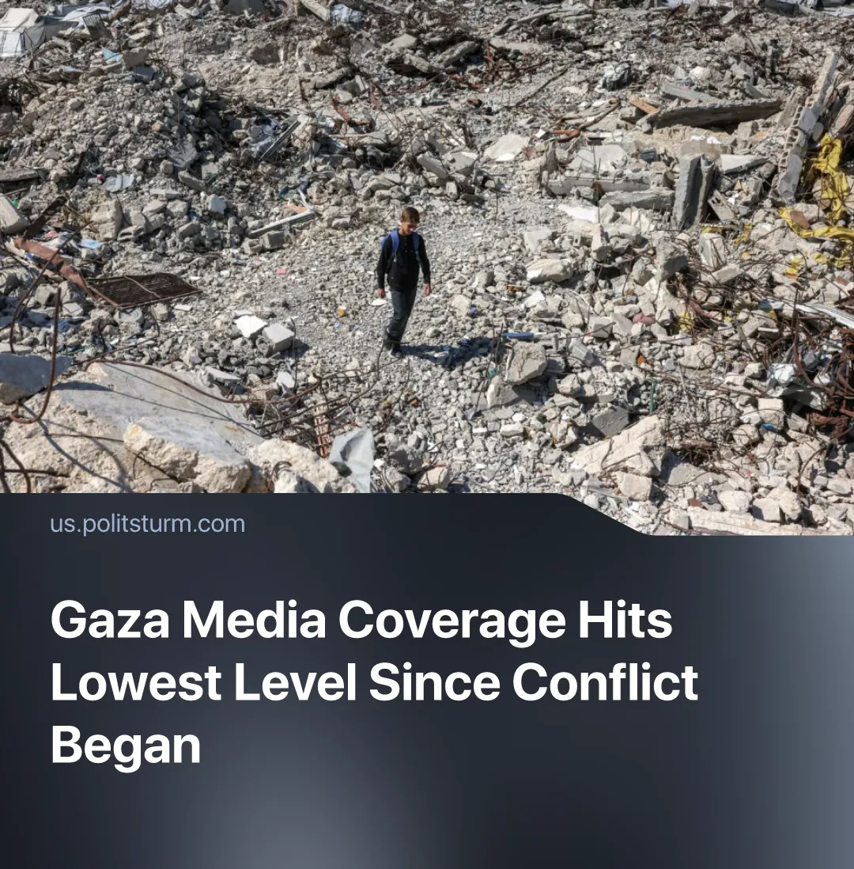

Original article
2026-10-21
1 min read

Western media coverage of Gaza has hit its lowest level since October 2023, despite continued Israeli attacks. This coincides with US media consolidation, deepening global crises, and the weakening and institutionalisation of the pro-Palestine movement.
Details. On 12 October 2025, US President Donald Trump declared an end to the conflict in Gaza. By autumn 2026, media coverage had fallen threefold, and now approximately elevenfold from its October 2023 peak.
► Despite declining attention, Israeli military operations and the humanitarian crisis in Gaza continue. At least 1,640 people have been killed and 5,116 wounded during the ceasefire period, while 67% of the population suffers from acute food insecurity. Destruction and forced displacement continue.
Context. US media ownership has also become more concentrated. The Ellison family's $110 billion acquisition of Warner Bros. Discovery brings CNN, CBS News and The Free Press under monopoly ownership. Following changes to TikTok's US ownership, with 3 American investors holding the majority stake, pro-Palestinian journalists have reported account restrictions.
► Larry Ellison, Oracle's co-founder and a longtime Trump ally, has donated $16.6 million to Friends of the Israel Defense Forces. The Ellison family's expanded media empire, approved by the US state, placed major news outlets under the control of capitalists with close ties to the US state and an interest in its foreign policy.
► Deepening economic crisis and escalating conflicts elsewhere have increasingly competed with Gaza for public attention. US-China trade disputes remain unresolved, while conflict in the Middle East continues to expand and European governments accelerate militarisation despite worsening living conditions.
► Meanwhile, the pro-Palestine movement has weakened after failing to halt Israeli military operations. The movement has increasingly been institutionalised through European governments' symbolic condemnations and bourgeois left-wing and independent politicians channeling support for Palestine into electoral gains. Demonstrations have since declined in size and focus has shifted to militarisation and the cost-of-living crisis.

Original article

