Friedrich Engels — 200 Year Birthday Anniversary
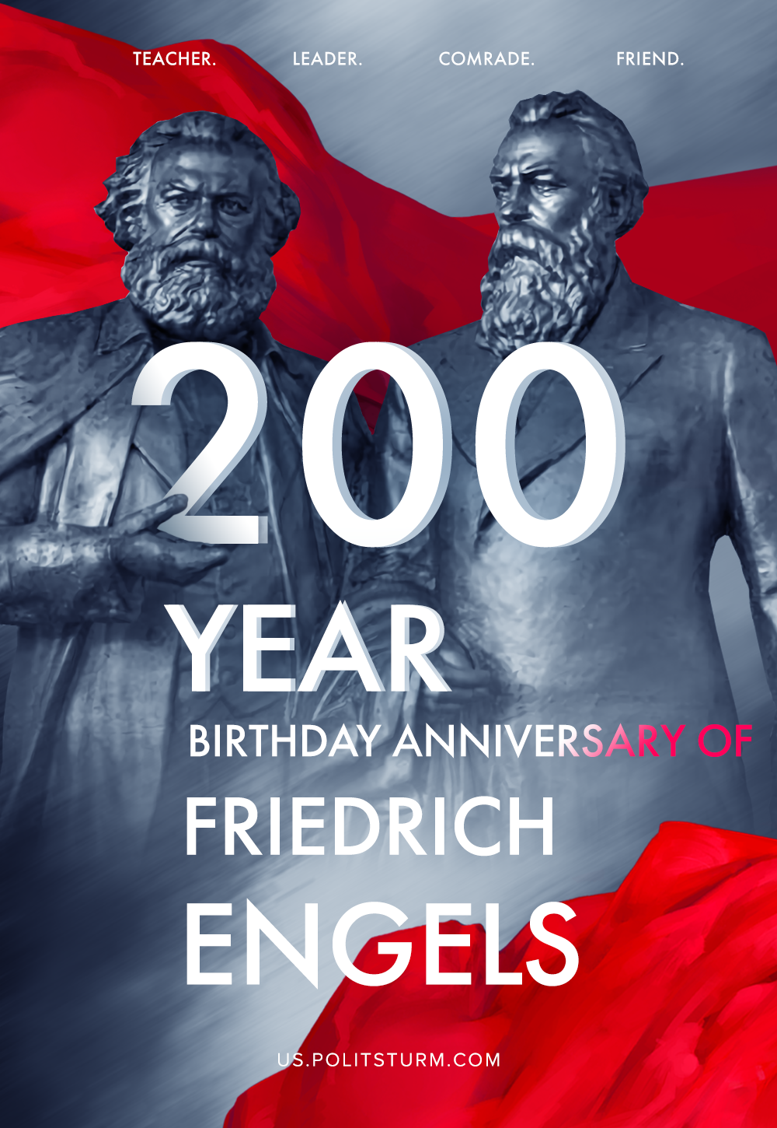

Original article
2020-11-28

200 years ago, on November 28, 1820, Friedrich Engels was born — one of the founders of Marxism, leader and teacher of the international proletariat, friend and associate of Karl Marx.

Original article

