French Workers' Unemployment Benefits are Being Reduced
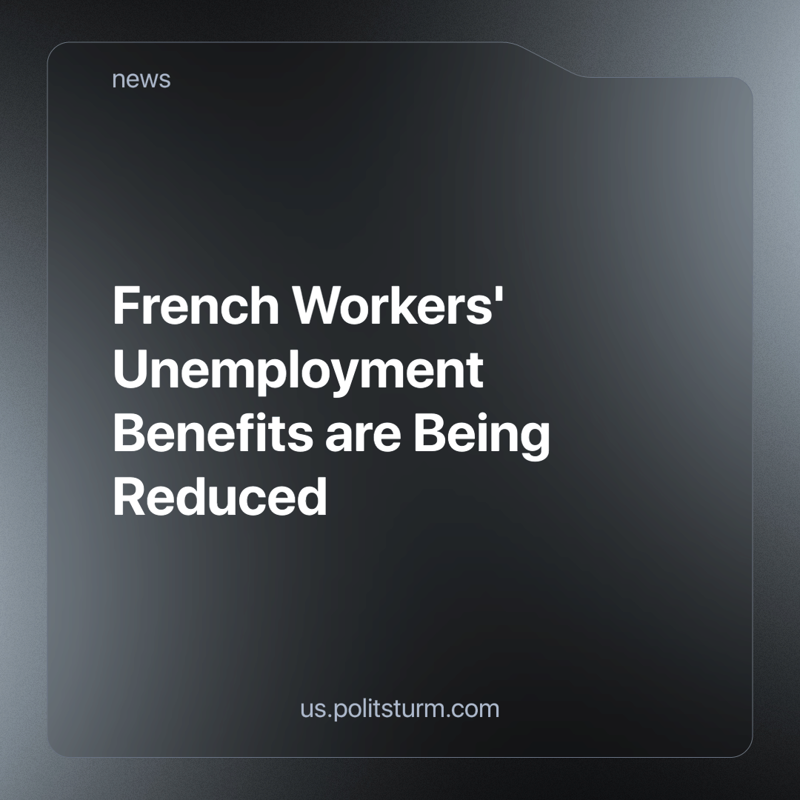

Original article
2024-04-04
1 min read

On March 27, the French Prime Minister announced that France plans to limit unemployment benefits as part of a new reform. This reform involves reducing the period of payment of benefits to 12 months from the current 18 (another plus 6 months if there is a shortage of jobs; a total of 24).
According to Reuters, President Macron's government believes that previous efforts to limit benefits are insufficient. The French state budget has not saved enough at the expense of the working class. Therefore, the government is considering detailing the reform before the summer in order to implement it in the autumn.[1]
At the same time, the Prime Minister himself tells us, that an increase in the tax on excess profits of energy companies may be an option to increase tax revenues and solve the problem of the French budget deficit. But of course, they won't do that. These are just empty words to make it appear that the capitalist government also fairly arbitrates all interests in society - including the workers.
The following fact can give an understanding of how good workers' rights currently are in France – on Monday, employees of public transport, hospitals, and museums said they were ready to go on strike during the Summer Olympic Games in Paris. According to trade unions, workers' working conditions are constantly deteriorating, their standard of living is falling, and wages are not keeping pace with inflation. At the same time, the workload of employees will increase significantly during the Olympic Games. [2]
Another example of the class struggle, where the bourgeoisie nationalizes expenses and privatizes excess profits. The working class of France must realize its independent class interests. They need a Communist party that will begin, in addition to the workers' struggle for their economic interests, to wage a class struggle in the political sphere. Without this, the working class is doomed to suffer defeat after defeat in the ongoing class war.
Sources: 1, 2

Original article

