French Prime Minister Bypasses Parliament to Increase Military Spending
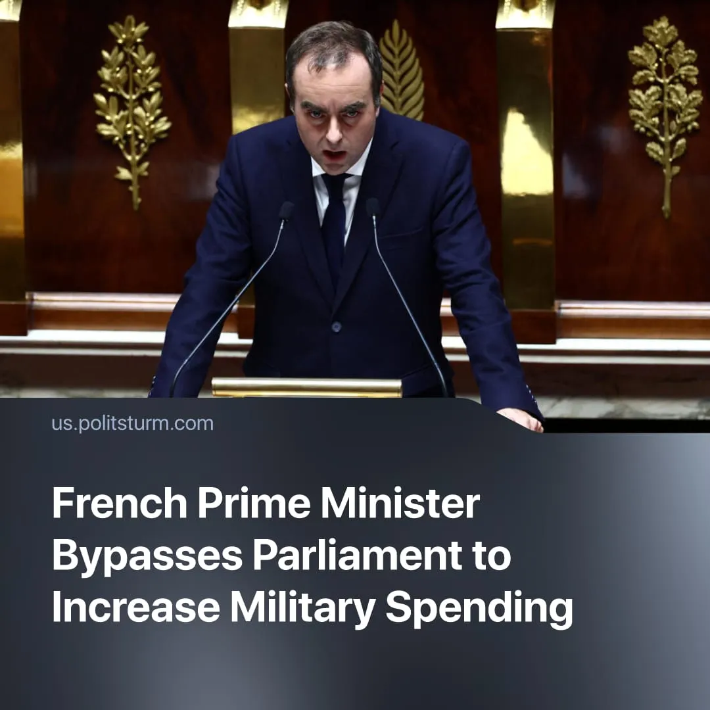

Original article
2026-02-16
1 min read

French Prime Minister bypassed parliament to add €6.7 billion to military spending.
Details. France has passed its delayed military spending bill, granting an additional €6.7 billion to the Defence Ministry, citing Russia, cyberattacks, and terrorism as potential urgent threats.
► Prime Minister Lecornu invoked special constitutional powers (Article 49.3) to pass the bill without a parliamentary vote, breaking his prior public promise not to use these powers. Under the Constitution, this forced passage automatically allows parliament to table a no-confidence motion.
► Lecornu’s minority government survived two no-confidence votes, with the centre-left “Socialist Party” abstaining in exchange for concessions, such as €1 lunches for university students, breaking from their former allies in the opportunist “New Popular Front.”
Context. This move occurred amid severe political instability in France. The government has nearly collapsed six times in the past two years, with the latest prime minister briefly attempting to resign before being persuaded to remain in office.
► Each cabinet has attempted unpopular austerity measures, such as a planned €44 billion in public spending cuts, which resulted in massive strikes and the former PM’s resignation. The far-right has been emboldened by the government's instability, calling for new elections.
► The EU has been rapidly militarising as inter-imperialist contradictions intensify and the United States becomes increasingly unreliable. Throughout 2025, EU governments promoted war hysteria and pursued large military budget increases and spending cuts. France has been a particularly extreme example, introducing a “voluntary” conscription program for men aged 18–25.

Original article

