French Government Collapses Again
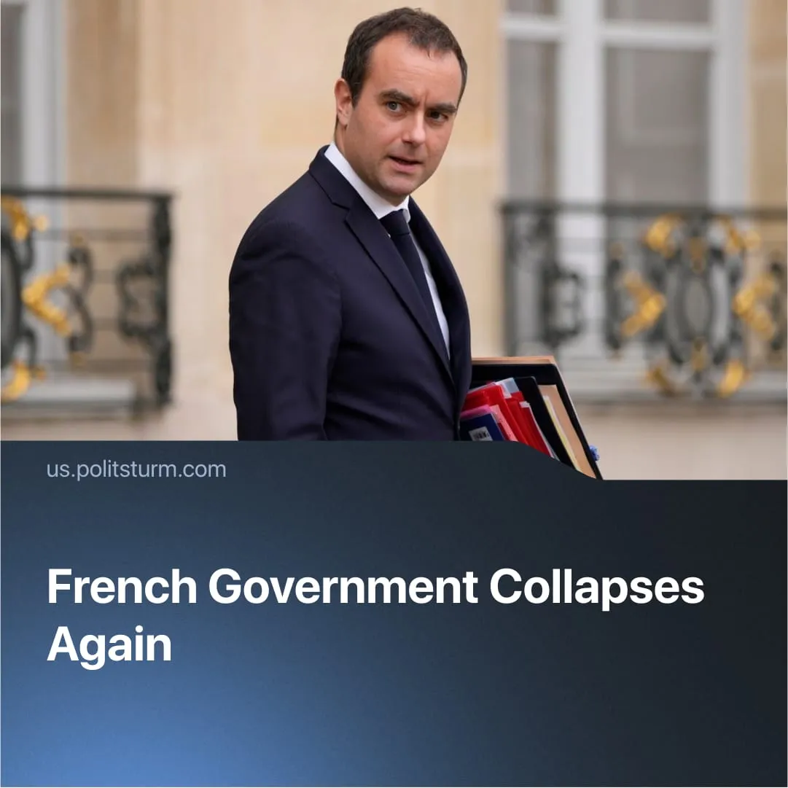

Original article
2025-10-09
1 min read

France has seen its sixth government collapse in just two years. The latest Prime Minister resigned before even forming a cabinet.
Details. Sébastien Lecornu resigned after only 26 days as prime minister, following backlash over his decision to appoint the former finance minister Bruno Le Maire as minister of the armed forces — despite pledging to “break” with past unpopular cabinets.
► Shortly after, President Macron gave Lecornu 48 hours to determine whether talks with political parties could produce a “stability plan” for France. After failing to reach such a deal, Macron announced he would appoint a new prime minister — for the seventh time in his term.
Context. As previously reported, France’s political system remains in deep crisis. In just two years, six cabinets have collapsed, each unable to reconcile further austerity with social stability, and historically, unstable governments have been a persistent weak point of French liberal democracy
► Every cabinet under Macron has attempted to impose unpopular austerity and labour “reforms.” Lecornu’s predecessor, François Bayrou, planned to scrap two public holidays and cut €44 billion from public spending. Such measures, combined with collapsing purchasing power and rising poverty — 650,000 people fell into poverty last year — have fuelled mass protests and strikes of nearly 800,000 workers.

Original article

